**Advanced Software Engineering Course Project 1st Semester 2024/2025**

**Supervised by: Prof. Amjad Hudaib**



**Project No : 3**

|  |  |  |  |
| --- | --- | --- | --- |
| **Student Name** | **Student ID** | **Section** | **No.** |
| **Mohammad zamil** | **0229752** | 1 | **34** |
| **Motasem Al-Adwan** | **0215387** | 1 | 9 |
| **Mahmoud Awwad** | **0225682** | 1 | **26** |
| **Abdulrahman alnsour** | **0216191** | 1 | **10** |

Table of Contents

Acknowledgement 8

Summary 8

1.Chapter One(Introduction) 11

1.1 Overview 11

1.2 The purpose of This project 11

1.2.1 background of the business 11

1.2.2 problem definition 12

1.2.3 Issues with existing systems 12

1.3 Main Objectives 12

1.4 Main Motivations 13

1.5 Constraints 14

1.6 Similar Systems/Projects 14

1.7 Project Organization 16

2. Chapter Two (Project Management) 18

2.1 Feasibility Study 18

2.1.1 Technical Feasibility 18

2.1.2 Operational Feasibility 19

2.1.3 Legal Feasibility 20

2.2 The Needed Hardware and Software 21

2.3 The Schedule and The Estimated Time 22

2.3.1 Schedule 22

2.3.2 Pert Diagram 23

3. Chapter Three (Project Specification) 24

3.1 Stakeholders 24

3.2 Data Gathering Techniques 25

3.2.1 Interview 25

3.2.2 Asking Business Expert 26

3.2.3 Survey 26

3.3 Functional Requirements 28

3.4 Non-Functional Requirements 34

3.5 Domain Requirements 35

3.6 Requirements Analysis and the Architecture Design 36

3.6.1 Requirements analysis 36

3.6.2 The Architecture Design 39

3.6.3 Sub-System analysis 42

4. Chapter Four (Project Design) 45

4.1 Class Diagram 45

4.1.1 Classes and Their Responsibilities 46

4.2 Use-Case Diagram 52

4.2.1 Use Case Diagram for Development Team 52

4.2.2 Use Case Diagram for Pet Clinics 58

4.2.3 Use Case Diagram for Pet Owners 72

4.2.4 Use Case Diagram for Veterinarians 102

4.2.5 Use Case Diagram for Regulatory Authority 106

5. Chapter Five (Project Implementation) 118

5.1 Website Application 118

5. Chapter Six (Project Testing) 123

6.1 Test Cases 123

6.2 Test Methodologies 124

Appendix A : 125

Interview Script : 125

References 128

Table Of Figures

Figure 1 Pert Diagram .......................................................................................... 23

Figure 2 Survey for the Software .......................................................................... 27

Figure 3 The Architecture Design ......................................................................... 39

Figure 4 Class Diagram ......................................................................................... 45

Figure 5 Use Case Diagram ST1 : Development Team ........................................... 52

Figure 6 SD For Secure Login ................................................................................ 54

Figure 7 SD For Admin Dashboard ........................................................................ 55

Figure 8 SD For Update Section ............................................................................ 57

Figure 9 Use Case Diagram ST2 : Pet Clinics ......................................................... 58

Figure 10 SD For Clinic Directory .......................................................................... 59

Figure 11 SD For Clinic Information ...................................................................... 61

Figure 12 SD For Service Listing ............................................................................ 62

Figure 13 SD For Promotion Page ......................................................................... 64

Figure 14 SD For Profile Updates .......................................................................... 65

Figure 15 SD For Clinic Performance .................................................................... 66

Figure 16 SD For Staff Contact .............................................................................. 67

Figure 17 SD For Interaction History ..................................................................... 68

Figure 18 SD For Report Generation ..................................................................... 70

Figure 19 SD For Update Section .......................................................................... 71

Figure 20 Use Case Diagram ST3 : Pet Owners ..................................................... 72

Figure 21 SD For Sign Up ...................................................................................... 74

Figure 22 SD For Login.......................................................................................... 75

Figure 23 SD For Log Out ...................................................................................... 77

Figure 24 SD For Password Recovery .................................................................... 79

Figure 25 SD For Language Support ..................................................................... 80

Figure 26 SD For Clinic Directory .......................................................................... 81

Figure 27 SD For Appointment Booking ............................................................... 83

Figure 28 SD For Basic Search .............................................................................. 84

Figure 29 SD For Filtering ..................................................................................... 85

Figure 30 SD For Notifications .............................................................................. 86

Figure 31 SD For View Clinic Details ..................................................................... 87

Figure 32 SD For Appointment History ................................................................. 88 Figure 33 SD For Contact Form ............................................................................. 89

Figure 34 SD For Health Records .......................................................................... 90

Figure 35 SD For Emergency Contact Listing......................................................... 91

Figure 36 SD For Health Tips ................................................................................ 92

Figure 37 SD For SMS Notifications ...................................................................... 93

Figure 38 SD For Manual Calendar ....................................................................... 94

Figure 39 SD For Feedback System ....................................................................... 95

Figure 40 SD For Review and Rating ..................................................................... 97

Figure 41 SD For FAQ Page ................................................................................... 98

Figure 42 SD For Feedback Form ........................................................................ 100

Figure 43 SD For Email Communication ............................................................. 101

Figure 44 Use Case Diagram ST4 : Veterinarians ................................................ 102

Figure 45 SD For Clinic Information Display ........................................................ 103

Figure 46 SD For Appointment Booking ............................................................. 104

Figure 47 SD For Staff Contact Information ........................................................ 105

Figure 48 Use Case Diagram ST5 : Regulatory Authorities .................................. 106

Figure 49 SD For Audit Trial ................................................................................ 107

Figure 50 SD For Legal Information .................................................................... 108

Figure 51 SD For User Activity Log ...................................................................... 109

Figure 52 SD For Clinic Performance Report ....................................................... 110

Figure 53 SD For Report Generation ................................................................... 111

Figure 54 SD For Language Support ................................................................... 112

Figure 55 SD For Secure Login ............................................................................ 113

Figure 56 SD For Clinic Directory ........................................................................ 114

Figure 57 SD For Service Listing .......................................................................... 115

Figure 58 SD For Notifications ............................................................................ 116

Figure 59 SD For Email Notifications.................................................................. 117

Figure 60 Login Page .......................................................................................... 118

Figure 61 Sign Up Page ....................................................................................... 119

Figure 62 Home Page ......................................................................................... 119

Figure 63 About Us Page .................................................................................... 120

Figure 64 Clinics Page ......................................................................................... 121

Figure 65 Contact Page ...................................................................................... 121

Figure 66 Reservations Page .............................................................................. 122

Figure 67 Profile Page ........................................................................................ 122 Table Of Tables

Table 1 Hardware and Software Requirements .................................................... 21

Table 2 Project schedule ...................................................................................... 22

Table 3 System Stakeholder.................................................................................. 24

Table 4 Functional Requirements ......................................................................... 28

Table 5 Non-Functional Requirements ................................................................. 34

Table 6 Domain Requirements ............................................................................. 35

Table 7 Component Analysis ................................................................................ 40

Table 8 Use Case Secure Login ............................................................................. 53

Table 9 Use Case Admin Dashboard ..................................................................... 54

Table 10 Use Case Update Section ....................................................................... 56

Table 11 Use Case Clinic Directory ....................................................................... 59

Table 12 Use Case Clinic Information ................................................................... 60

Table 13 Use Case Service Listings ........................................................................ 61

Table 14 Use Case Promotion Page ...................................................................... 62

Table 15 Use Case Profile Updates ....................................................................... 64

Table 16 Use Case Clinic Performance .................................................................. 65

Table 17 Use Case Staff Contact ........................................................................... 66

Table 18 Use Case Interaction History .................................................................. 67

Table 19 Use Case Report Generation .................................................................. 69

Table 20 Use Case Update Section ....................................................................... 70

Table 21 Use Case Sign Up ................................................................................... 73

Table 22 Use Case Log In ...................................................................................... 74

Table 23 Use Case Log Out ................................................................................... 76

Table 24 Use Case Password Recovery ................................................................. 77

Table 25 Use Case Language Support ................................................................... 79

Table 26 Use Case Clinic Directory ....................................................................... 81

Table 27 Use Case Appointment Booking ............................................................. 82

Table 28 Use Case Basic Search ............................................................................ 83

Table 29 Use Case Filtering .................................................................................. 84

Table 30 Use Case Notifications ........................................................................... 85

Table 31 Use Case View Clinic Details ................................................................... 86

Table 32 Use Case Appointment History .............................................................. 87 Table 33 Use Case Contact Form .......................................................................... 88

Table 34 Use Case Health Records........................................................................ 89

Table 35 Use Case Emergency Contact Listing ...................................................... 90

Table 36 Use Case Health Tips .............................................................................. 91

Table 37 Use Case SMS Notifications .................................................................... 92

Table 38 Use Case Manual Calender .................................................................... 93

Table 39 Use Case Feedback System .................................................................... 94

Table 40 Use Case Review and Rating .................................................................. 95

Table 41 Use Case FAQ Page ................................................................................. 97

Table 42 Use Case Feedback Form ....................................................................... 99

Table 43 Use Case Email Communication ........................................................... 100

Table 44 Use Case Clinic Information Display ..................................................... 103

Table 45 Use Case Appointment Booking ........................................................... 104

Table 46 Use Case Staff Contact Information ...................................................... 105

Table 47 Use Case Audit Trail ............................................................................. 107

Table 48 Use Case Legal Information .................................................................. 108

Table 49 Use Case User Activity Log ................................................................... 109

Table 50 Use Case Clinic Performance Reports ................................................... 110

Table 51 Use Case Report Generation ................................................................ 111

Table 52 Use Case Language Support ................................................................. 112

Table 53 Use Case Secure Login ......................................................................... 113

Table 54 Use Case Cinic Directory ...................................................................... 114

Table 55 Use Case Service Listings ...................................................................... 115

Table 56 Use Case Notifications ......................................................................... 116

Table 57 Use Case Email Communication ........................................................... 117

# Acknowledgement

Dear Prof. Amjad Hudaib,

On behalf of the VetVogue Team, we extend our heartfelt gratitude for your invaluable guidance and support throughout the development of this project. Your expertise and dedication have been instrumental in enhancing our understanding of software engineering principles and methodologies.

Your mentorship has not only provided us with the technical knowledge necessary to design and implement a comprehensive system but also inspired us to approach challenges with innovation and perseverance. We deeply appreciate the time and effort you have invested in supporting our learning journey and fostering our growth as future engineers.

Thank you for equipping us with the skills and confidence to address real-world problems in the field of software development. We are honored to have had the opportunity to learn from you and are sincerely grateful for your unwavering commitment to our success.

With the deepest appreciation,

The VetVogue Team

# Summary

**Project Overview**:

VetVogue is an innovative platform designed to simplify and enhance pet care management in Jordan. This comprehensive system connects pet owners with veterinary clinics while addressing key challenges like appointment scheduling, medical record tracking, and service discovery. The platform also supports pet adoption and provides an online store for essential pet supplies, fostering a holistic pet care experience.

**Target Audience**:

The platform is tailored to serve pet owners, veterinary clinics, and veterinarians in Jordan. By prioritizing user-friendly features and localized solutions, VetVogue aims to cater to the unique needs of the Middle Eastern pet care ecosystem.

**Project Goals**:

1. **Streamline Veterinary Care**: Simplify appointment scheduling and clinic management for users and clinics.
2. **Promote Pet Adoption**: Encourage the adoption of homeless pets through a dedicated platform.
3. **Enhance Accessibility**: Provide an integrated system for managing medical records, accessing services, and booking appointments.
4. **Support Vulnerable Pets**: Allocate all platform profits to charitable initiatives aiding street animals in need.

**Platform Features**:

* **Appointment Booking**: A seamless and efficient system for scheduling veterinary appointments.
* **Health Records Management**: Enable pet owners to track their pets' medical histories and vaccination schedules.
* **Clinic Directory**: Allow users to search and filter clinics based on location, services, and ratings.
* **Pet Adoption Listings**: A feature to connect potential adopters with pets in need of homes.
* **Online Store**: An integrated e-commerce platform for pet supplies.
* **Notifications and Reminders**: Keep users informed about appointments and health-related alerts.

**Deliverables**:

* A user-centric website with a responsive and intuitive design.
* Comprehensive documentation detailing system architecture, requirements, and design.
* High-fidelity mockups and functional prototypes for core platform features.
* A robust backend supporting key functionalities like user management, scheduling, and data storage.

VetVogue aspires to not only simplify pet care for users but also create a meaningful social impact by improving the lives of street animals and promoting responsible pet ownership.

# 1.Chapter One(Introduction)

## 1.1 Overview

VetVogue aims to make pet ownership easier and more accessible in Jordan by providing a platform that connects pet owners with veterinary services and simplifies pet care management. Our platform allows users to book appointments, search for clinics offering specific services, and manage their pets' health records. Additionally, we offer pet adoption listings and an online store for essential pet supplies. By addressing common challenges, VetVogue promotes responsible pet ownership and enhances the overall pet care experience in the region.

All of VetVogue’s profits will be directed to charity, supporting initiatives that help street animals who lack owners or caretakers, ensuring that even the most vulnerable pets receive the care and attention they deserve.

## 1.2 The purpose of This project

**VetVogue** aims to make pet care simpler, more accessible, and convenient for pet owners in Jordan. Whether it's booking a vet appointment, adopting a pet, or buying pet essentials, our platform is designed to meet all the needs of both pet owners and clinics. More than just a service, VetVogue has a deeper purpose: improving the lives of street pets by using part of our income to support them, ensuring that every pet gets the care it deserves.

### 1.2.1 background of the business

The idea for **VetVogue** came from seeing how hard it can be for pet owners in Jordan to find and access the services their pets need. As more people in Jordan welcome pets into their homes, they need a modern, easy-to-use platform that connects them to veterinary care. Currently, many clinics don’t offer online services, making it challenging to book appointments, track health records, or find the right care. VetVogue fills this gap, giving pet owners the tools to manage their pets’ health efficiently while supporting street pets in need.

### 1.2.2 problem definition

Pet owners often face challenges like long waiting times to book vet

appointments, difficulty finding clinics that offer specific services, and no easy way to track their pets' medical histories. In addition, the process of adopting a pet or finding a clinic for vaccination or care is often complicated and scattered. These issues not only affect pet owners but can lead to delays in crucial care for pets. VetVogue seeks to solve these problems by offering a platform where everything related to pet care like appointments, medical records, adoption, and supplies can be managed easily in one place.

### 1.2.3 Issues with existing systems

In Jordan, some clinics like **First Pet Veterinary Clinic** and **PetMed** are already offering online services, but these platforms still fall short in providing a fully integrated experience. They offer basic features like appointment booking and consultations but don’t address the broader needs of pet owners, such as tracking medical records or providing a seamless adoption process. Globally, platforms like **PetsApp** and **PetDesk** are more advanced but aren't tailored to the unique needs of pet owners and clinics in Jordan. These systems don't integrate local veterinary networks, and they often overlook the importance of adoption services and regional challenges. VetVogue aims to offer a solution that not only matches the capabilities of global platforms but also improves upon them by focusing on the specific needs of the Jordanian market and giving back to street pets through charity.

## 1.3 Main Objectives

•Make Veterinary Care More Accessible:

Help pet owners quickly find and book appointments with veterinary clinics, reducing the time and effort needed to access quality care for their pets.

•Simplify Clinic Operations:

Streamline the administrative processes for veterinary clinics, allowing them to operate more efficiently and rely less on staff for appointment scheduling and client communications.

•Save Pets’ Lives Through Adoption:

Facilitate the pet adoption process by providing a platform where people can easily find pets in need of homes, making adoption more accessible and saving the lives of street animals.

•Offer a One-Stop Pet Supplies Store:

Create an online store where pet owners can conveniently buy essentials such as food, toys, and accessories, with a fair commission (5-15%) aligned with global standards.

•Help Pet Owners Manage Health Records:

Make it easier for pet owners to track their pets' medical records, upcoming appointments, and vaccination schedules through personalized pet profiles, ensuring pets receive timely care.

## 1.4 Main Motivations

•Save Pets' Lives:

Many pet owners find it challenging to keep up with their pets' healthcare needs. Our platform aims to make it easier for them to manage their pets' health, ultimately improving the well-being of pets across Jordan.

•Support Street Pets:

We are not aiming to make a significant profit from this project. Instead, all proceeds will go toward helping street pets that lack shelter, providing them with care and resources to improve their lives.

•Promote Pet Adoption:

By facilitating the adoption process and connecting potential adopters with pets in need of homes, we aim to encourage more people to adopt pets and reduce the number of homeless pets.

## 1.5 Constraints

•Service Constraints:

One of the main challenges we may face is connecting with veterinary clinics across Jordan, as many of them currently lack a significant online presence. This could limit the availability of certain features on our platform, such as real-time appointment booking or specific vaccine searches. Additionally, managing a diverse range of service, like appointment booking, vet searches, pet adoption, shopping, and pet profiles, will require careful planning and coordination to prevent service overload or disruptions.

•Time Constraints:

Given the variety of services we plan to offer; it will be crucial to prioritize the development of each feature in order to meet our project deadlines. By focusing on delivering core functionalities to a high standard, we can ensure the platform is launched within the available timeframe without compromising on quality.

•Budget Constraints:

As university students working on this project, we are operating with limited financial resources and no external funding. This could affect our ability to fully meet all customer expectations, especially in terms of platform functionality, performance, and scalability. However, we are committed to finding cost-effective solutions that will still provide a valuable service to pet owners and clinics.

## 1.6 Similar Systems/Projects

In Jordan:

[•First Pet Veterinary Clinic](https://firstpetclinic.com/) (Abdoun, Amman):

This clinic has an online presence and offers veterinary services, grooming, and appointment scheduling through their digital platform. They aim to support pet health and wellness by integrating in-clinic services with online accessibility, allowing pet owners to easily manage their pets’ care.

[•PetMed](https://petmedjo.com/en) (St. Ibrahim Al-Qattan, Amman):

PetMed provides a range of services, including online consultations, grooming, hospitalization, and vaccinations. Their user-friendly website allows pet owners to access all their services remotely, ensuring easy management of their pets’ health and wellness. PetMed also offers boarding and sheltering services for cats and dogs.

Globally:

[•PetsApp:](https://petsapp.com/)

A comprehensive platform that allows pet owners to book appointments, chat with veterinarians, receive reminders, and make digital payments. PetsApp also helps clinics manage their daily operations while keeping pet owners connected with their veterinary services.

[•PetDesk:](https://www.petguide.com/)

This app not only offers telemedicine but also helps pet owners keep track of appointments, medications, and health records. If a veterinary clinic is part of the PetDesk network, users can book virtual consultations, making it a useful tool for both clinics and pet owners to stay organized.

## 1.7 Project Organization

The success of **VetVogue** relies on a well-structured project organization that ensures all tasks are clearly defined and efficiently managed. We’ve established a framework that encompasses the roles and responsibilities of each team member, clear communication channels, and structured processes to ensure the smooth execution of the project.

• **Roles and Responsibilities**

Each member of the team has specific duties to ensure the project’s success:

**Project Manager:** Responsible for overseeing the project, setting timelines, and ensuring that deliverables meet our objectives. This role will be handled collaboratively among all team members to ensure shared ownership and accountability.

**Web Developers:** All team members will manage both the front-end and back-end development, ensuring that the platform is functional, user-friendly, and meets technical standards.

**Stakeholders:** Our primary stakeholders include veterinary clinics, pet owners.

**External Partners:** We aim to collaborate with local veterinarians and animal shelters, integrating their services into our platform to provide a seamless user experience.

* **Communication**

To ensure everyone stays aligned, we will establish regular check-ins through online communication platforms such as Notion and Microsoft Teams. Clear, consistent communication will help us share progress, identify issues early, and stay on track. Additionally, we continuously gather data and upload our work to the project’s email drive to ensure all documents and updates are easily accessible to the entire team.

* **Processes and Methodologies**

We plan to follow an Agile methodology to manage the development and execution of the project. This will allow us to break the project down into manageable phases, regularly review progress, and make adjustments as needed. Sprints (Scrum Terminology) will be scheduled to ensure timely delivery of features, starting with core functions like appointment booking and pet profiles.

* **Resources**

We have limited resources, given that we are university students with no external funding. To overcome this, we’ll focus on using open-source tools and platforms that fit within our budget while still delivering a professional-quality product. Time management will be key, as we aim to balance our academic responsibilities with project deadlines.

* **Risk Management**

Potential risks include service overload due to the broad range of features we plan to offer and challenges connecting with clinics that have limited digital infrastructure. To mitigate these risks, we’ll prioritize features based on user demand and clinic availability, ensuring a smooth platform launch. Additionally, we will have contingency plans in place to address any technical issues or delays.

# 2. Chapter Two (Project Management)

## 2.1 Feasibility Study

The feasibility study for VetVogue aims to assess the practicality of developing and implementing the platform, taking into consideration the technical, economic, operational, and scheduling aspects of the project.

### 2.1.1 Technical Feasibility

* **Website Development:**

To create a user-friendly platform, we will develop a website where pet owners can book appointments, search for veterinary clinics, and access services such as pet adoption and an online store. The frontend will be built using modern frameworks like React to ensure a responsive and intuitive interface. The backend will manage crucial functionalities like user authentication, session management, and real-time data processing, likely through Node.js or Django.

* **Database Management:**

we'll need a database to store information about clinics, services offered, available appointment slots, and user bookings.

* **Compliance and Regulations:**

Given the nature of the services offered, VetVogue will adhere to local laws and regulations in Jordan governing veterinary practices. It will also ensure compliance with international data privacy standards, such as GDPR(General Data Protection Regulation), to protect users' sensitive personal and medical information. Clear consent will be obtained from users for storing and processing their data, ensuring full transparency and compliance.

* **Scalability:**

As VetVogue grows, we will implement scalable server infrastructure to ensure that the platform can handle increasing traffic and expanding services without performance issues. The website will be designed to support growth in both the number of users and clinics, with future potential for regional expansion.

* **Security and Privacy:**

Protecting user privacy and data security is a key focus for VetVogue. Sensitive medical information will be securely stored with restricted access. Role-based access controls will ensure that only authorized personnel, such as veterinarians or pet owners, can view or edit medical records.

* **User Interface and Experience:**

A seamless user experience is crucial for VetVogue. The platform will be designed to be intuitive and easy to navigate, enabling pet owners to access services such as appointment booking and pet health tracking with ease. The website will also be optimized for different devices, ensuring that users can engage with VetVogue across desktops, tablets, and mobile phones.

• **Testing and Validation:**

Before launch, VetVogue will undergo rigorous testing to ensure that all core features, including appointment booking and pet profile management, function correctly. Usability testing will be conducted to verify that the platform is easy to use, with continuous improvements made based on user feedback to ensure a smooth experience.

### 2.1.2 Operational Feasibility

* **Customer Acceptance:**

We will actively collect feedback from pet owners and veterinary clinics to ensure VetVogue aligns with their needs. This valuable input will guide us in enhancing the platform, making it intuitive and useful for all users.

* **Engaging Stakeholders:**

Building strong partnerships with veterinary clinics and animal welfare groups is crucial for VetVogue’s success. Their support will not only expand our services but also strengthen our efforts to help street pets through charitable contributions.

* **Risk Management:**

To ensure smooth operations, we’ll identify potential risks such as technical challenges or clinic partnerships and establish emergencies plans to manage them effectively.

* **User Training and Support:**

We will provide clear guidance and responsive support to ensure users can easily navigate the platform, fostering a positive experience and boosting their confidence in using our services.

* **Maintenance and Updates:**

Regular maintenance and updates will keep VetVogue relevant and functional, adapting to user feedback and ensuring we deliver accurate and up-to-date services.

* **Reliability:**

Our platform is designed for reliability and durability, consistently offering seamless access to veterinary services and pet health management tools, regardless of the number of users or system demands.

### 2.1.3 Legal Feasibility

* **Data Privacy and Protection:**

As VetVogue involves user registration, storing personal data (e.g., pet details, medical records, and appointment histories), and potentially payment processing, ensuring compliance with data privacy laws is crucial. This will include adhering to regional data protection regulations like Jordan's Data Protection Laws, as well as broader laws such as the GDPR if you're dealing with international users.

* **Data Usage and Ownership:**

Since VetVogue will collect sensitive data about pets and their owners, it’s essential to clearly define how this data will be used, who owns it, and how it will be handled. Ensuring transparency with users about how their information is stored and used, is important for building trust.

## 2.2 The Needed Hardware and Software

*Table 1 Hardware and Software Requirements*

|  |  |  |  |  |  |
| --- | --- | --- | --- | --- | --- |
|  | **Description** | **Quantity** | **Unit Price**  **(JD)** | **Total Price** | **Note** |
| **HW1** | **Web Servers** | **1** | **3,000** | **3000** |  |
| **HW 2** | **PCs** | **5** | **600** | **3000** |  |
| **HW 3** | **Security Infrastructure** | **1** | **700** | **700** |  |
| **HW 4** | **Laptop** | **2** | **500** | **1000** |  |
|  |  |  |  |  |  |
| **SW1** | **Web Development** |  | **11,000** | **11,000** |  |
| **SW2** | **Payment**  **Gateway**  **Integration** |  | **3,000** | **3,000** |  |
| **SW3** | **Quality Assurance (QA)** |  | **4,000** |  |  |
| **Total** |  |  |  | **21,700** |  |

## 2.3 The Schedule and The Estimated Time

### 2.3.1 Schedule

*Table 2 Project schedule*

|  |  |  |  |  |  |
| --- | --- | --- | --- | --- | --- |
| **Task ID** | **Description** | **Duration**  **Time**  **(WD)** | **Dependency** | **Responsible Resources**  **Partner/s, Staff** | |
| **T1** | Requirements  Analysis | 5 days | ---- | **Mahmoud , Abdulrahman , Motasem**  **Mohammad** |  |
| **T2** | Information  Gathering and planning. | 7 days | T1 (m1) | **Mahmoud , Abdulrahman , Motasem**  **Mohammad** |  |
| **T3** | Writing Functional and nonfunctional  Requirements | 5 days | T2 (m2) | **Mahmoud , Abdulrahman , Motasem**  **Mohammad** |  |
| **T4** | Training | 10 days |  | **Mahmoud , Abdulrahman , Motasem**  **Mohammad** | Figma,  Lucidchart, and Word |
| **T5** | Design and  Development | 30 days | T4, T3 (m3) | **Mahmoud , Abdulrahman , Motasem**  **Mohammad** | Node.js. react |
| **T6** | Testing | 5 days | T5(m4) | **Mahmoud , Abdulrahman , Motasem**  **Mohammad** |  |
| **T7** | Documentation | 7 days | T6(m5) | **Mahmoud , Abdulrahman , Motasem**  **Mohammad** |  |
| **T8** | Launch and marketing | 7 days | T6 (m5) | **Mahmoud , Abdulrahman , Motasem**  **Mohammad** |  |

### 2.3.2 Pert Diagram

**Figure 1** represents the PERT (Program Evaluation Review Technique) diagram for the VetVogue project. It outlines the sequence of tasks necessary to complete the project, illustrating their dependencies and the estimated durations in working days. The critical path in this diagram includes tasks T4 (Training), T5 (Design and Development), T6 (Testing), and T7 (Documentation). This series of dependent tasks forms the longest path through the project, totaling between 58 and 65 working days. It is crucial to ensure these tasks are completed on time, as any delays in this critical path could impact the entire project’s completion. Close monitoring and management of these tasks are essential to meet the project's timeline.

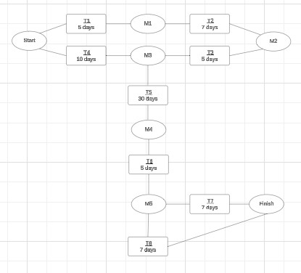

*Figure 1 Pert Diagram*

# 

# 3. Chapter Three (Project Specification)

## 3.1 Stakeholders

The stakeholder refers to “a person, group or company that is directly or indirectly involved in the project and who may affect or get affected by the outcome of the project”.

*Table 3 System Stakeholder*

|  |  |  |
| --- | --- | --- |
| **ST ID** | **Stakeholder** | **Description** |
| **ST1** | **Clinic Administrator** | The admin user who manages Eagle's Vet Clinic operations. Responsible for managing products, orders, appointments, hotel reservations, users/pets, and viewing analytics. Has full access to the admin dashboard. |
| **ST2** | **Pet Owners (Registered Users)** | Customers who register accounts to use the system. They can book appointments, reserve hotel rooms, manage pet profiles, track orders, view medical records, and shop for products. |
| **ST3** | **Guest Users** | Visitors who use the system without registration. They can browse the VetVoge marketplace, view clinic information, browse shop products, view pet adoption listings, and place orders as guests. |

## 3.2 Data Gathering Techniques

### 3.2.1 Interview

We conducted interviews with pet clinic owners, veterinarians, and pet owners to gather detailed insights about the challenges they face in managing pet healthcare and services. These one-on-one discussions provided in-depth qualitative data, helping us understand pain points, expectations, and suggestions for improvement.

**Target Interview Groups:**

* **Pet Clinic Owners:** To understand the operational challenges they face, the current gaps in service offerings, and how technology could improve clinic management and patient care.
* **Veterinarians:** To gather insights into the medical aspects of pet care, the need for digital tools to track patient health, and their experiences with scheduling and client communication.
* **Pet Owners:** To learn about their experience with managing their pets' health, their pain points in accessing veterinary services, and their preferences for digital solutions like online booking and health tracking.

See Appendix A for more Information About Interview Script.

### 3.2.2 Asking Business Expert

To gain insights into the pet care and veterinary landscape in Jordan, we consulted business experts, including:

* **Veterinary Clinic Owners and Managers**: They shared challenges in managing appointments, clinic workflows, and the ideal features needed for an online platform.
* **Developers and Technology Experts**: They provided guidance on platform development, technology trends, and creating a user-friendly experience for both clinic staff and pet owners.

Their input helped shape the VetVogue platform to meet the needs of veterinary professionals and pet owners in Jordan, ensuring its success in the market.

### 3.2.3 Survey

In addition to interviews, we will use a survey to collect insights from a wider audience of potential VetVogue users. The survey will help us understand:

* User Preferences and Expectations: It will explore how pet owners currently book appointments with veterinary clinics, the features they desire in an online platform, and what they expect from a user-friendly experience.
* Feature Prioritization: By gathering user opinions on the importance of various platform features (such as online appointment scheduling, reminders, and medical history tracking), the survey will guide us in prioritizing the development of the most valuable functionalities.
* Continuous Feedback Loop: The survey will include open-ended questions to create an ongoing feedback loop, allowing us to continuously adapt VetVogue to meet user needs and improve the platform over time.

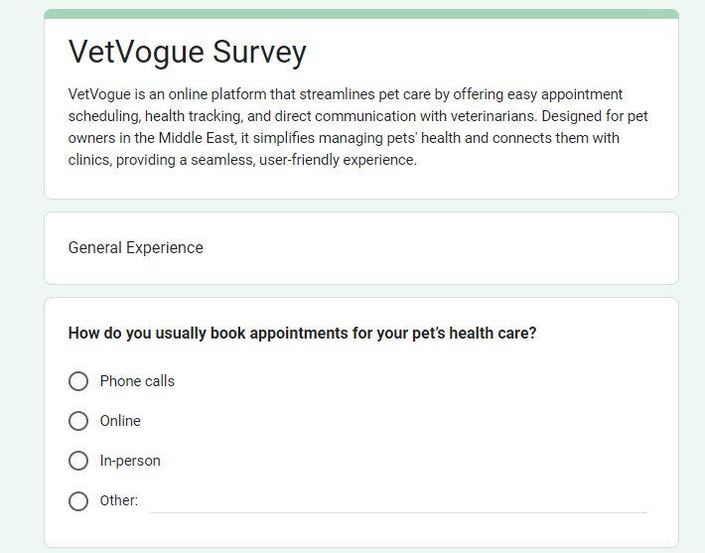

*Figure 2 Survey for the Software*

The complement of the Survey of the software appears on the [Survey Link.](https://forms.gle/Z2dNdzUL7mS9K6o67)

## 3.3 Functional Requirements

Functional requirements specify the functions or capabilities that a software system must perform. They describe what the system should do and define its behavior under specific conditions. Functional requirements generally detail the various functionalities, operations, and specific tasks that the software needs to accomplish to meet the user's needs or business objectives. The functional requirements are shown in the Table.

*Table 4 Functional Requirements*

|  |  |  |  |  |
| --- | --- | --- | --- | --- |
| FR IDDescription | | ST | PRIORITY | INCREMENT |
| **FR1** | The system shall display a welcome page at the root URL (`/`) that serves as the entry point to the VetVoge marketplace, featuring navigation to clinics, pet adoption, and shop sections. | ST3, ST2 | High | VetVoge Core |
| **FR2** | The system shall display clinic cards showing clinic name, location, specialties, description, and a link to the clinic's landing page. | ST3, ST2 | High | VetVoge Core |
| **FR3** | The system shall allow users to browse Eagle's Vet Clinic landing page with Hero section, Services, Staff, and Contact information. | ST3, ST2 | High | VetVoge Core |
| **FR4** | The system shall provide smooth scrolling navigation for anchor links within the VetVoge and clinic pages. | ST3, ST2 | High | VetVoge Core |
| **FR5** | The system shall allow guest users to post pets for adoption without requiring authentication, including pet name, description, phone number, area, and multiple photos. | ST4 | High | Pet Adoption |

|  |  |  |  |  |
| --- | --- | --- | --- | --- |
| **FR6** | The system shall display pet adoption listings with image carousel, clickable phone numbers, and full-size image modal for viewing all photos. | ST4, ST3 | High | Pet Adoption |
| **FR7** | The system shall upload adoption pet images to Cloudinary and store image URLs as JSON array in the database. | ST4 | High | Pet Adoption |
| **FR8** | the system shall allow users to browse shop products with category filtering, sorting options (newest, price, name) | ST3, ST2 | High | E-Commerce |
| **FR9** | The system shall display product details including name, description, price, multiple images in a gallery, stock status, and category information. | ST3, ST2 | High | E-Commerce |
| **FR10** | The system shall display cart item count in the header navigation for easy access. | ST3, ST2 | Medium | E-Commerce |
| **FR11** | The system shall provide a checkout process requiring customer name, phone, delivery method (home delivery or pickup), payment method (cash or click for delivery), and address information (if delivery). | ST3, ST2 | High | E-Commerce |
| **FR12** | The system shall support Jordanian governorate and area selection for delivery addresses. | ST3, ST2 | High | E-Commerce |
| **FR13** | The system shall pre-fill checkout forms with logged-in user's profile information (name, phone, address). | ST2 | Medium | E-Commerce |

|  |  |  |  |  |
| --- | --- | --- | --- | --- |
| **FR14** | The system shall create orders with status "pending" and immediately decrease product stock quantities. | ST2, ST1 | High | E-Commerce |
| **FR15** | The system shall restore product stock if an order is cancelled | ST1 | High | E-Commerce |
| **FR16** | The system shall prevent adding out-of-stock products to cart and display "Out of Stock" badges on product listings. | ST3, ST2 | High | E-Commerce |
| **FR17** | The system shall provide reorder functionality allowing users to quickly reorder previous purchases. | ST2 | Medium | E-Commerce |
| **FR18** | The system shall allow guest users to place orders without creating an account. | ST3 | High | E-Commerce |
| **FR19** | The system shall allow users to register accounts with name, email, password, and phone number, with validation for email format and password strength (min 8 chars, uppercase, lowercase, number). | ST2 | High | User Management |
| **FR20** | The system shall allow users to login with email and password | ST2 | High | User Management |
| **FR21** | The system shall store user session in localStorage and redirect users based on their role (user/admin). | ST2, ST1 | High | User Management |

|  |  |  |  |  |
| --- | --- | --- | --- | --- |
| **FR22** | The system shall provide logout functionality that clears localStorage and redirects to appropriate page. | ST2, ST1 | High | User Management |
| **FR23** | The system shall allow users to reset their password via email with a secure reset link | ST2 | High | User Management |
| **FR24** | The system shall allow users to change their password from their profile settings, requiring current password verification | ST2 | High | User Management |
| **FR25** | The system shall support account upgrade from phone-based accounts (admin-created) to full email/password accounts, preserving all existing data. | ST2 | High | User Management |
| **FR26** | The system shall prevent admin users from logging in through the regular user login page and redirect them to admin login. | ST1 | Medium | User Management |
| **FR27** | The system shall allow users to update their profile information including name, phone, governorate, area, and address. | ST2 | High | User Management |
| **FR28** | The system shall allow registered users to create pet profiles with name, species, gender, and optional fields (breed, birth date, color, photo, medical information) | ST2 | High | Pet Management |
| **FR29** | C The system shall auto-generate unique pet codes (PET-XXXXX format) for each registered pet. | ST2, ST1 | High | Pet Management |

|  |  |  |  |  |
| --- | --- | --- | --- | --- |
| FR30 | The system shall allow users to upload pet photos to Cloudinary and store URLs in the database. | ST2 | High | Pet Management |
| FR31 | The system shall display pet profiles with basic information and medical records (vaccinations, dewormings, clinic visits, weight history). | ST2, ST1 | High | Pet Management |
| FR32 | The system shall allow users and admins to add vaccination records including name, date, next due date, and notes. | ST2, ST1 | High | Pet Management |
| FR33 | The system shall allow users and admins to add clinic visit records including visit date, reason, diagnosis, treatment, prescriptions, notes, and next appointment date. | ST1, ST2 | High | Pet Management |
| FR34 | The system shall allow users to edit and delete their pet profiles with cascade deletion of related medical records. | ST2 | High | Pet Management |
| FR35 | The system shall allow admins to manage any pet profile, including editing information and adding medical records. | ST1 | High | Pet Management |
| FR36 | The system shall allow registered users to book veterinary appointments by selecting a pet, appointment date, time, reason, and optional notes. | ST2 | High | Appointments |
| FR37 | The system shall allow users to view their appointment history with filtering by status (upcoming, completed, cancelled). | ST2 | High | Appointments |
| FR38 | The system shall allow admins to view all appointments with pagination (50 per page), filtering by status and date range, and searching by customer name, phone, or pet name. | ST1 | High | Appointments |
| FR39 | The system shall allow admins to update appointment details including date, time, reason, and notes. | ST1 | High | Appointments |
| FR40 | The system shall allow admins to complete appointments by setting completion price, payment method, and updating status to "completed". | ST1 | High | Appointments |
| FR41 | The system shall allow admins to cancel appointments and update status to "cancelled". | ST1 | High | Appointments |
| FR42 | The system shall display appointment status with appropriate color coding (upcoming=blue, completed=green, cancelled=red). | ST2, ST1 | Low | Appointments |
| FR43 | The system shall display available hotel rooms by type (DOG, CAT, BIRD) with room status (AVAILABLE, OCCUPIED) and room numbers. | ST1, ST2 | High | Hotel |
| FR44 | The system shall check room availability for selected dates before allowing hotel bookings to prevent overlapping reservations. | ST1, ST2 | High | Hotel |
| FR45 | The system shall allow registered users to book hotel rooms by selecting pet, room type, check-in date, check-out date, pickup service option, dropoff service option, and optional notes. | ST2 | High | Hotel |
| FR46 | The system shall allow users to add extra services by name only (e.g., "bath"), with amounts to be set by admin at checkout. | ST2 | High | Hotel |
| FR47 | The system shall calculate and display booking cost breakdown showing nights, room rate (20 JOD/night), subtotal, pickup fee (5 JOD if selected), dropoff fee (5 JOD if selected), and total. | ST2 | High | Hotel |
| FR48 | The system shall create hotel reservations with status "booked" and immediately mark the room as "OCCUPIED". | ST2, ST1 | High | Hotel |
| FR49 | The system shall allow users to view their hotel reservations with filtering by status and display of pickup/dropoff options and extra services. | ST2 | High | Hotel |
| FR50 | The system shall allow admins to view hotel rooms by type on separate pages (dogs, cats, birds) with all reservations displayed for each room. | ST1 | High | Hotel |
| FR51 | The system shall allow admins to create reservations for any customer with owner name, phone, pet name, dates, and service options. | ST1 | High | Hotel |
| FR52 | The system shall allow admins to update reservation details including dates, pickup/dropoff options, extra services, and notes. | ST1 | High | Hotel |
| FR53 | The system shall allow admins to checkout reservations by calculating total nights, setting room rate, subtotal, pickup fee, dropoff fee, setting extra service amounts, calculating total, selecting payment method, updating status to "checked_out", and marking room as "AVAILABLE". | ST1 | High | Hotel |
| FR54 | The system shall display reservation details in a modal showing all booking information, cost breakdown, and payment information. | ST1, ST2 | High | Hotel |
| FR55 | The system shall allow admins to cancel reservations by updating status to "cancelled" and marking room as "AVAILABLE". | ST1 | Medium | Hotel |
| FR56 | The system shall provide an admin dashboard with tabbed interface (Products, Orders, Analytics, Owners, Appointments, Hotel) with tab persistence in localStorage. | ST1 | High | Admin Dashboard |
| FR57 | The system shall allow admins to create products with name, description, price, images, stock quantity, and category assignment, with auto-generation of product slugs. | ST1 | High | Admin Dashboard |
| FR58 | The system shall allow admins to view products list with pagination, sorting, and category filtering. | ST1 | High | Admin Dashboard |
| FR59 | The system shall allow admins to update products including all fields except ID, with slug regeneration if name changes. | ST1 | High | Admin Dashboard |
| FR60 | The system shall allow admins to delete products with confirmation. | ST1 | Medium | Admin Dashboard |
| FR61 | The system shall allow admins to view all orders with pagination (50 per page), filtering by status and date range. | ST1 | High | Admin Dashboard |
| FR62 | The system shall allow admins to update order status and add notes to orders. | ST1 | High | Admin Dashboard |
| FR63 | The system shall allow admins to view order details in a modal showing customer information, order items, delivery method, payment method, and order timeline. | ST1 | High | Admin Dashboard |
| FR64 | The system shall allow admins to view all users (regular users only, not admins) with search functionality. | ST1 | High | Admin Dashboard |
| FR65 | The system shall allow admins to create new user accounts with name, email, phone, password, governorate, area, and address. | ST1 | High | Admin Dashboard |
| FR67 | The system shall allow admins to view user details including profile, pets, orders, and appointments in a modal. | ST1 | High | Admin Dashboard |
| FR68 | The system shall allow admins to update user information including name, phone, governorate, area, and address. | ST1 | High | Admin Dashboard |
| FR69 | The system shall allow admins to delete users with cascade deletion of related data (pets, orders, appointments). | ST1 | High | Admin Dashboard |
| FR70 | The system shall allow admins to view all appointments with pagination, filtering, and search functionality, accessible via analytics card modal. | ST1 | High | Admin Dashboard |
| FR71 | The system shall allow admins to view all hotel reservations with filtering by type and status, accessible via analytics card modal. | ST1 | High | Admin Dashboard |
| FR72 | The system shall display analytics cards for Orders, Appointments, and Hotel Reservations with clickable modals showing full lists instead of tab navigation. | ST1 | High | Admin Dashboard |
| FR73 | The system shall track page views with session IDs for analytics, excluding admin pages from tracking. | ST3, ST2 | Medium | Analytics |
| FR74 | The system shall track product views when users view product detail pages for analytics. | ST3, ST2 | Medium | Analytics |
| FR75 | The system shall generate unique session IDs and store them in localStorage for user session tracking. | ST3, ST2 | Medium | Analytics |
| FR76 | The system shall calculate revenue analytics including order revenue (only completed orders), appointment revenue (only completed with price), and hotel revenue (only checked-out with total). | ST1 | High | Analytics |
| FR77 | he system shall display revenue timeline showing all revenue items (orders, appointments, hotel) with detailed breakdown in a modal. | ST1 | High | Analytics |
| FR78 | The system shall display payment breakdown for hotel reservations showing nights, room rate, subtotal, pickup fee, dropoff fee, extra services with amounts, and total. | ST1 | High | Analytics |
| FR79 | The system shall provide analytics statistics for orders (total, pending, completed, cancelled), appointments (total, upcoming, completed, cancelled), and hotel reservations (total, booked, checked-in, checked-out, cancelled). | ST1 | High | Analytics |
| FR80 | The system shall display top products by view count with product details and view statistics. | ST1 | Medium | Analytics |
| FR81 | The system shall calculate unique visitors count based on distinct session IDs. | ST1 | Medium | Analytics |
| FR82 | The system shall allow filtering analytics by time period (today, week, month, 3 months, year). | ST1 | Medium | Analytics |
| FR83 | The system shall validate user inputs using Zod schemas for authentication, signup, and orders. | ST2, ST1 | High | Security |
| FR84 | The system shall hash passwords using bcrypt with 12 rounds of salting for secure password storage. | ST2, ST1 | High | Security |
| FR85 | The system shall implement rate limiting on login attempts (5 attempts per 15 minutes per IP) to prevent brute force attacks. | ST2, ST1 | High | Security |
| FR86 | The system shall implement rate limiting on signup attempts (3 attempts per 10 minutes per IP) to prevent abuse. | ST2 | Medium | Security |
| FR87 | The system shall prevent user enumeration by returning the same error message for invalid email and invalid password | ST2 | High | Security |
| FR88 | The system shall sanitize user inputs to prevent XSS attacks by removing dangerous HTML tags and scripts. | ST2, ST3 | High | Security |
| FR89 | The system shall check for SQL injection patterns in user inputs and reject suspicious queries. | ST2, ST3 | High | Security |
| FR90 | The system shall implement basic CSRF protection through origin checking for state-changing operations (POST, PUT, DELETE). | ST2, ST3 | High | Security |

## 3.4 Non-Functional Requirements

Non-functional requirements (NFRs) represent the aspects of a system that describe its operation, capabilities, and constraints, which are not directly related to the system's functionalities or specific behavior’s. These requirements usually specify the quality attributes, performance expectations, security measures, usability factors, and other characteristics that define how the system should perform rather than what it should do.

The non-functional requirements are shown in the Table…

*Table 5 Non-Functional Requirements*

|  |  |  |  |
| --- | --- | --- | --- |
| **NFR-ID DESCRIPTION PRIORITY NOTE** | | | |
| **NFR1** | Performance: The platform should load within 3 seconds to ensure a seamless user experience. | High | Guarantees the system can handle high traffic and provide a smooth user experience even during busy times. |
| **NFR2** | Security: Implement user authentication (username and password) and rolebased access control to  restrict access to sensitive areas of the system. | High | Ensures that only authorized users(pet owners/clinics/veterinarians) can access certain features and data, providing a basic level of security. |
| **NFR3** | Usability: The user interface should be simple to understand and easy to use with a maximum of 3 clicks to access primary features. | Medium | Enhances user satisfaction and reduces the learning curve for new users. |
| **NFR4** | integration with External  Services: The platform should seamlessly  integrate with external  services, such as payment gateways and delivery APIs. | Medium | Ensures the system can handle essential external interactions without complex configurations. |
| **NFR5** | Scalability: The system should be able to handle increasing numbers of  users and data without  significant performance degradation. | High | Necessary for upcoming growth. |

## 3.5 Domain Requirements

Domain requirements refer to the specific needs, constraints, rules, and conditions that are unique to the domain or industry in which a software system is being developed. A "domain" in this context refers to the area or field of application for the software.

*Table 6 Domain Requirements*

|  |  |  |
| --- | --- | --- |
| **DR ID** | **Requirement** | **Description** |
| **DR1** | Appointment Scheduling System | The system must allow users to book, reschedule, and cancel appointments online. |
| **DR2** | Pet Medical Records Management | The system should store, update, and retrieve pet medical histories and records. |
| **DR6** | User Role Management | Support different user roles (e.g., vet, admin, pet owner) with appropriate permissions. |
| **DR8** | Compliance with Local Pet Health Laws | Ensure the platform adheres to the regulations governing veterinary practices in the region. |

## 3.6 Requirements Analysis and the Architecture Design

### 3.6.1 Requirements analysis

The requirement analysis for the VetVogue project identifies and categorizes functional requirements (FRs) into five core subsystems. These subsystems are designed to meet the project’s objectives and create a smooth, functional platform for users. ;;

Marketplace Browsing Subsystem

Goal (G1): Provide users with an intuitive marketplace platform to discover veterinary clinics and access clinic information.

Functional Requirements:

- FR1: Welcome Page Display

- FR2: Clinic Cards Display

- FR3: Clinic Landing Page Browsing

- FR4: Smooth Scrolling Navigation

Pet Adoption Subsystem

Goal (G2): Enable public platform for posting and viewing pets available for adoption without requiring authentication.

Functional Requirements:

- FR5: Post Pets for Adoption

- FR6: Display Adoption Listings

- FR7: Upload Adoption Images

E-Commerce Subsystem

Goal (G3): Provide a comprehensive online shopping experience for pet products with cart management, checkout, and order processing.

Functional Requirements:

- FR8: Browse Shop Products

- FR9: Display Product Details

- FR10: Display Cart Item Count

- FR11: Checkout Process

- FR12: Jordanian Address Selection

- FR13: Pre-fill Checkout Forms

- FR14: Create Orders

- FR15: Restore Product Stock

- FR16: Prevent Out-of-Stock Additions

- FR17: Reorder Functionality

- FR18: Guest Order Placement

User Management Subsystem

Goal (G4): Ensure users can securely create, manage, and access their accounts with proper authentication and profile management.

Functional Requirements:

- FR19: User Registration

- FR20: User Login

- FR21: Store User Session

- FR22: User Logout

- FR23: Password Reset

- FR24: Change Password

- FR25: Account Upgrade

- FR26: Prevent Admin Login from User Page

- FR27: Update Profile Information

Pet Management Subsystem

Goal (G5): Allow users and admins to create, manage, and track comprehensive pet profiles with medical records.

Functional Requirements:

- FR28: Create Pet Profiles

- FR29: Auto-generate Pet Codes

- FR30: Upload Pet Photos

- FR31: Display Pet Profiles

- FR32: Add Vaccination Records

- FR33: Add Clinic Visit Records

- FR34: Edit and Delete Pet Profiles

- FR35: Admin Pet Management

Appointment Management Subsystem

Goal (G6): Facilitate a seamless appointment booking and management process for users and administrators.

Functional Requirements:

- FR36: Book Veterinary Appointments

- FR37: View Appointment History

- FR38: Admin View All Appointments

- FR39: Update Appointment Details

- FR40: Complete Appointments

- FR41: Cancel Appointments

- FR42: Display Appointment Status

Hotel Booking Subsystem

Goal (G7): Provide comprehensive pet hotel booking system with room management, availability checking, and reservation processing.

Functional Requirements:

- FR43: Display Available Hotel Rooms

- FR44: Check Room Availability

- FR45: Book Hotel Rooms

- FR46: Add Extra Services

- FR47: Calculate Booking Cost

- FR48: Create Hotel Reservations

- FR49: View Hotel Reservations

- FR50: Admin View Hotel Rooms

- FR51: Admin Create Reservations

- FR52: Admin Update Reservations

- FR53: Admin Checkout Reservations

- FR54: Display Reservation Details

- FR55: Admin Cancel Reservations

Admin Dashboard Subsystem

Goal (G8): Provide administrators with comprehensive management interface for all system operations including products, orders, users, and reservations.

Functional Requirements:

- FR56: Admin Dashboard Interface

- FR57: Create Products

- FR58: View Products List

- FR59: Update Products

- FR60: Delete Products

- FR61: View All Orders

- FR62: Update Order Status

- FR63: View Order Details

- FR64: View All Users

- FR65: Create User Accounts

- FR67: View User Details

- FR68: Update User Information

- FR69: Delete Users

- FR70: View All Appointments (Modal)

- FR71: View All Hotel Reservations (Modal)

- FR72: Display Analytics Cards

Analytics and Reporting Subsystem

Goal (G9): Provide comprehensive analytics, tracking, and reporting capabilities for business insights and revenue analysis.

Functional Requirements:

- FR73: Track Page Views

- FR74: Track Product Views

- FR75: Generate Session IDs

- FR76: Calculate Revenue Analytics

- FR77: Display Revenue Timeline

- FR78: Display Payment Breakdown

- FR79: Provide Analytics Statistics

- FR80: Display Top Products

- FR81: Calculate Unique Visitors

- FR82: Filter Analytics by Time Period

Security Subsystem

Goal (G10): Ensure system security through input validation, authentication security, rate limiting, and protection against common attacks.

Functional Requirements:

- FR83: Validate User Inputs

- FR84: Hash Passwords

- FR85: Rate Limit Login Attempts

- FR86: Rate Limit Signup Attempts

- FR87: Prevent User Enumeration

- FR88: Sanitize User Inputs

- FR89: Check for SQL Injection

- FR90: CSRF Protection

### 3.6.2 The Architecture Design

The architecture design outlines how each subsystem interacts to form a cohesive, efficient platform. It ensures seamless communication between the user management, appointment scheduling, clinic information, content management, and security systems. Each subsystem is interconnected to ensure a smooth user experience.

*Figure 3 The Architecture Design*

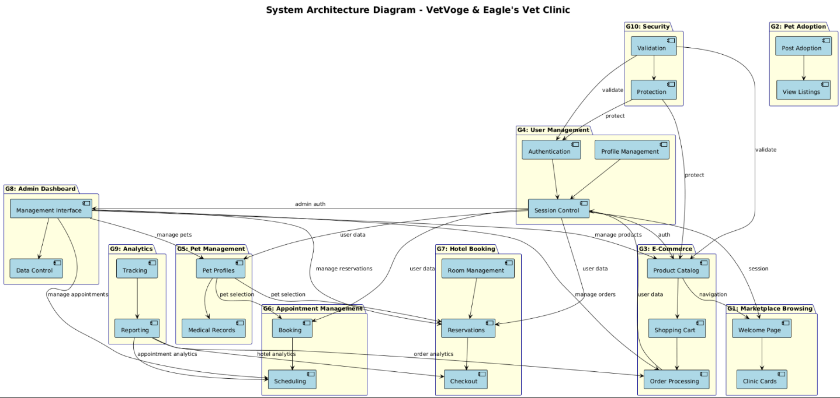

# 4. Chapter Four (Project Design)

## 4.1 Class Diagram

In the VetVogue project's class diagram, the primary classes include "User," "Clinic," "Pet Owner," and "Appointment System." The "User" class represents the platform's end-users, such as pet owners, veterinarians, and clinic administrators, each with distinct roles and permissions. The "Clinic" class models the veterinary clinics, including their details, services, and available veterinarians. The "Pet" class links to users (pet owners) and contains information like pet profiles, medical history, and vaccination records. The "Appointment System" serves as the central controller that facilitates interactions between users and clinics by managing appointment scheduling, cancellations, and notifications. Relationships are defined between these classes, such as pet owners booking appointments for their pets via the Appointment System, clinics offering time slots managed through the system, and the system ensuring seamless coordination among users, clinics, and pets to deliver an efficient and user-friendly experience.

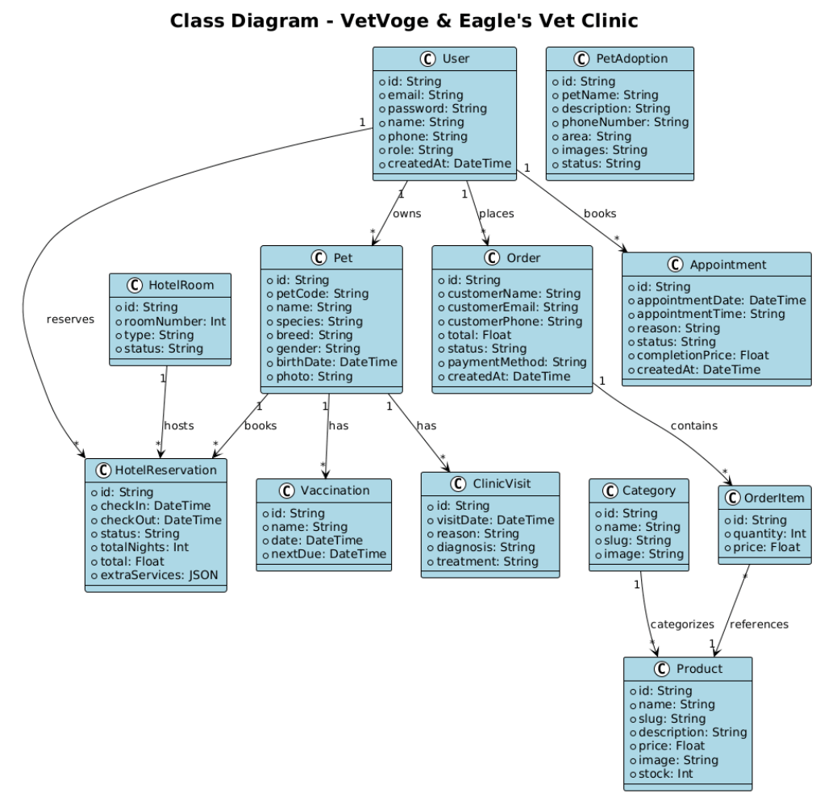

*Figure 4 Class Diagram*

The class diagram for VetVogue provides a clear representation of the system's core classes and their relationships. It highlights the structural framework of the platform, focusing on user management, appointment scheduling, clinic details,

, and administrative functions. This diagram is integral to understanding how different components of the system interact, ensuring seamless operations and an efficient user experience.

### 4.1.1 Classes and Their Responsibilities

Classes and Their Responsibilities

VetVoge & Eagle's Vet Clinic System

1. User

Attributes:

- `id`: Unique identifier for each user (String, primary key)

- `email`: Email address associated with the account (String, unique)

- `password`: User's password for access control (String, hashed)

- `name`: User's full name (String, optional)

- `phone`: User's phone number (String, optional)

- `role`: User role (String, default: "user", values: "user" or "admin")

- `governorate`: User's governorate in Jordan (String, optional)

- `area`: User's area within governorate (String, optional)

- `address`: User's street address (String, optional)

- `createdAt`: Account creation timestamp (DateTime)

- `updatedAt`: Last update timestamp (DateTime)

Methods:

- `signUp()`: Allows a user to create a new account with email, password, name, and phone

- `signIn()`: Logs a user into the platform using email and password

- `signOut()`: Logs a user out of the platform and clears session

- `resetPassword()`: Allows a user to reset their password via email

- `changePassword()`: Allows a user to change their password from profile settings

- `updateProfile()`: Updates user profile information (name, phone, address)

- `upgradeAccount()`: Upgrades phone-based account to full email/password account

2. Pet

Attributes:

- `id`: Unique identifier for each pet (String, primary key)

- `userId`: Foreign key to User who owns the pet (String)

- `petCode`: Unique pet code (String, unique, format: PET-XXXXX)

- `name`: Pet's name (String)

- `species`: Pet species (String, e.g., "Dog", "Cat", "Bird")

- `breed`: Pet breed (String, optional)

- `gender`: Pet gender (String)

- `birthDate`: Pet's birth date (DateTime, optional)

- `color`: Pet's color/markings (String, optional)

- `photo`: URL to pet's photo (String, optional)

- `allergies`: Known allergies (String, optional)

- `medications`: Current medications (String, optional)

- `medicalHistory`: General medical history (String, optional)

- `surgicalHistory`: Surgical procedures history (String, optional)

- `chronicConditions`: Chronic health conditions (String, optional)

- `createdAt`: Profile creation timestamp (DateTime)

- `updatedAt`: Last update timestamp (DateTime)

Methods:

- `createPet()`: Creates a new pet profile for a user

- `updatePet()`: Updates pet profile information

- `deletePet()`: Deletes pet profile and cascade deletes related records

- `uploadPhoto()`: Uploads pet photo to Cloudinary

- `generatePetCode()`: Auto-generates unique pet code

3. Product

Attributes:

- `id`: Unique identifier for each product (String, primary key)

- `name`: Product name (String)

- `slug`: URL-friendly product identifier (String, unique)

- `description`: Product description (String)

- `price`: Product price in JOD (Float)

- `image`: Product image URLs (String, comma-separated)

- `stock`: Available stock quantity (Int, default: 0)

- `categoryId`: Foreign key to Category (String)

- `createdAt`: Product creation timestamp (DateTime)

- `updatedAt`: Last update timestamp (DateTime)

Methods:

- `createProduct()`: Creates a new product with all details

- `updateProduct()`: Updates product information

- `deleteProduct()`: Deletes product from catalog

- `updateStock()`: Updates product stock quantity

- `decreaseStock()`: Decreases stock when order placed

- `restoreStock()`: Restores stock when order cancelled

- `generateSlug()`: Auto-generates URL-friendly slug from name

- `uploadImages()`: Uploads product images to Cloudinary

4. Category

Attributes:

- `id`: Unique identifier for each category (String, primary key)

- `name`: Category name (String, unique)

- `slug`: URL-friendly category identifier (String, unique)

- `image`: Category image URL (String, optional)

- `createdAt`: Category creation timestamp (DateTime)

- `updatedAt`: Last update timestamp (DateTime)

Methods:

- `createCategory()`: Creates a new product category

- `updateCategory()`: Updates category information

- `deleteCategory()`: Deletes category (cascade to products)

- `getProducts()`: Retrieves all products in this category

---

5. Order

Attributes:

- `id`: Unique identifier for each order (String, primary key)

- `userId`: Foreign key to User (String, optional, null for guest orders)

- `customerName`: Customer's full name (String)

- `customerEmail`: Customer's email (String)

- `customerPhone`: Customer's phone number (String)

- `customerAddress`: Delivery address (String)

- `deliveryMethod`: Delivery method (String, values: "delivery" or "pickup")

- `paymentMethod`: Payment method (String, default: "cash", values: "cash" or "click")

- `total`: Total order amount in JOD (Float)

- `status`: Order status (String, default: "pending", values: "pending", "completed", "cancelled")

- `notes`: Additional order notes (String, optional)

- `createdAt`: Order creation timestamp (DateTime)

- `updatedAt`: Last update timestamp (DateTime)

Methods:

- `createOrder()`: Creates a new order with items

- `updateStatus()`: Updates order status (pending/completed/cancelled)

- `addNotes()`: Adds notes to order

- `calculateTotal()`: Calculates total order amount

- `processOrder()`: Processes order and decreases stock

- `cancelOrder()`: Cancels order and restores stock

6. OrderItem

Attributes:

- `id`: Unique identifier for each order item (String, primary key)

- `orderId`: Foreign key to Order (String)

- `productId`: Foreign key to Product (String)

- `quantity`: Quantity ordered (Int)

- `price`: Unit price at time of order (Float)

Methods:

- `createOrderItem()`: Creates order item linking product to order

- `calculateSubtotal()`: Calculates subtotal (quantity × price)

7. Appointment

Attributes:

- `id`: Unique identifier for each appointment (String, primary key)

- `userId`: Foreign key to User (String, optional, null for guest appointments)

- `ownerName`: Pet owner's name (String, optional)

- `ownerPhone`: Pet owner's phone (String, optional)

- `petId`: Foreign key to Pet (String, optional)

- `petName`: Pet's name (String, optional)

- `appointmentDate`: Scheduled appointment date (DateTime)

- `appointmentTime`: Scheduled appointment time (String)

- `reason`: Reason for appointment (String)

- `status`: Appointment status (String, default: "upcoming", values: "upcoming", "completed", "cancelled", "no-show")

- `notes`: Additional notes (String, optional)

- `completionPrice`: Price charged upon completion (Float, optional)

- `completionPaymentMethod`: Payment method used (String, optional)

- `createdAt`: Appointment creation timestamp (DateTime)

- `updatedAt`: Last update timestamp (DateTime)

Methods:

- `createAppointment()`: Creates a new appointment booking

- `updateAppointment()`: Updates appointment details (date, time, reason, notes)

- `completeAppointment()`: Marks appointment as completed with price and payment method

- `cancelAppointment()`: Cancels appointment

- `updateStatus()`: Updates appointment status

8. HotelRoom

Attributes:

- `id`: Unique identifier for each room (String, primary key)

- `roomNumber`: Room number (Int)

- `type`: Room type for pet species (String, enum: "DOG", "CAT", "BIRD")

- `status`: Room status (String, enum: "AVAILABLE", "OCCUPIED", "CLEANING", "MAINTENANCE")

- `notes`: Room notes (String, optional)

- `createdAt`: Room creation timestamp (DateTime)

- `updatedAt`: Last update timestamp (DateTime)

Methods:

- `createRoom()`: Creates a new hotel room

- `updateStatus()`: Updates room status

- `checkAvailability()`: Checks if room is available for given dates

- `setOccupied()`: Marks room as occupied

- `setAvailable()`: Marks room as available

9. HotelReservation

Attributes:

- `id`: Unique identifier for each reservation (String, primary key)

- `roomId`: Foreign key to HotelRoom (String)

- `userId`: Foreign key to User (String, optional)

- `ownerName`: Pet owner's name (String)

- `ownerPhone`: Pet owner's phone (String)

- `petId`: Foreign key to Pet (String, optional)

- `petName`: Pet's name (String)

- `checkIn`: Check-in date and time (DateTime)

- `checkOut`: Check-out date and time (DateTime)

- `status`: Reservation status (String, default: "booked", values: "booked", "checked_in", "checked_out", "cancelled")

- `notes`: Additional notes (String, optional)

- `pickup`: Whether pickup service is requested (Boolean, default: false)

- `dropoff`: Whether dropoff service is requested (Boolean, default: false)

- `totalNights`: Total number of nights (Int, optional)

- `roomRate`: Rate per night in JOD (Float, optional, default: 20)

- `subtotal`: Base room cost (Float, optional)

- `pickupFee`: Pickup service fee (Float, optional, default: 5)

- `dropoffFee`: Dropoff service fee (Float, optional, default: 5)

- `extraServices`: Additional services (JSON, optional, format: [{reason: String, amount: Float}])

- `total`: Total reservation cost (Float, optional)

- `paymentMethod`: Payment method used (String, optional)

- `checkedOutAt`: Checkout timestamp (DateTime, optional)

- `createdAt`: Reservation creation timestamp (DateTime)

- `updatedAt`: Last update timestamp (DateTime)

Methods:

- `createReservation()`: Creates a new hotel reservation

- `updateReservation()`: Updates reservation details

- `checkIn()`: Marks reservation as checked-in

- `checkout()`: Completes checkout with pricing and payment details

- `cancelReservation()`: Cancels reservation and frees room

- `calculateCost()`: Calculates total cost (nights × rate + fees + services)

- `checkAvailability()`: Checks room availability for dates

- `addExtraService()`: Adds extra service to reservation (name only, admin sets amount)

10. PetAdoption

Attributes:

- `id`: Unique identifier for each adoption post (String, primary key)

- `petName`: Name of pet available for adoption (String)

- `description`: Description of pet (String)

- `phoneNumber`: Contact phone number (String)

- `area`: Area location in Jordan (String)

- `images`: JSON array of image URLs (String, stored as JSON string)

- `status`: Post status (String, default: "active", values: "active", "adopted", "removed")

- `createdAt`: Post creation timestamp (DateTime)

- `updatedAt`: Last update timestamp (DateTime)

Methods:

- `createPost()`: Creates a new pet adoption post

- `updatePost()`: Updates adoption post information

- `uploadImages()`: Uploads pet images to Cloudinary

- `markAdopted()`: Marks pet as adopted

- `removePost()`: Removes post from listings

---

11. Vaccination

Attributes:

- `id`: Unique identifier for each vaccination record (String, primary key)

- `petId`: Foreign key to Pet (String)

- `name`: Vaccination name (String)

- `date`: Vaccination date (DateTime)

- `nextDue`: Next vaccination due date (DateTime, optional)

- `notes`: Additional notes (String, optional)

- `createdAt`: Record creation timestamp (DateTime)

- `updatedAt`: Last update timestamp (DateTime)

Methods:

- `addVaccination()`: Adds vaccination record to pet

- `updateVaccination()`: Updates vaccination record

- `deleteVaccination()`: Deletes vaccination record

- `getNextDue()`: Calculates next vaccination due date

12. ClinicVisit

Attributes:

- `id`: Unique identifier for each clinic visit (String, primary key)

- `petId`: Foreign key to Pet (String)

- `visitDate`: Date of clinic visit (DateTime)

- `reason`: Reason for visit (String)

- `diagnosis`: Diagnosis made (String, optional)

- `treatment`: Treatment provided (String, optional)

- `prescriptions`: Prescriptions given (String, optional)

- `notes`: Additional notes (String, optional)

- `nextAppointment`: Next scheduled appointment (DateTime, optional)

- `createdAt`: Record creation timestamp (DateTime)

- `updatedAt`: Last update timestamp (DateTime)

Methods:

- `addClinicVisit()`: Adds clinic visit record to pet

- `updateClinicVisit()`: Updates clinic visit record

- `deleteClinicVisit()`: Deletes clinic visit record

- `scheduleNextAppointment()`: Sets next appointment date

.

*4.1.1.1 Inheritance Relationships*

Class Relationships - Simple Summary

Main Relationships

User → owns many Pets

User→ places many Orders

User → books many Appointments

User → makes many HotelReservations

Category → contains many Products

Product → appears in many OrderItems

Order → contains many OrderItems

Pet → has many Vaccinations

Pet → has many ClinicVisits

Pet → has many HotelReservations

HotelRoom→ hosts many HotelReservations

HotelReservation → belongs to one HotelRoom

HotelReservation → belongs to one User (optional)

HotelReservation → belongs to one Pet (optional)

Appointment→ belongs to one User (optional)

Appointment → belongs to one Pet (optional)

Relationship Types

## 4.2 Use-Case Diagram

### 4.2.2 Use Case Diagram for Pet Clinics

**Stakeholder 2 : Pet Clinics admins**

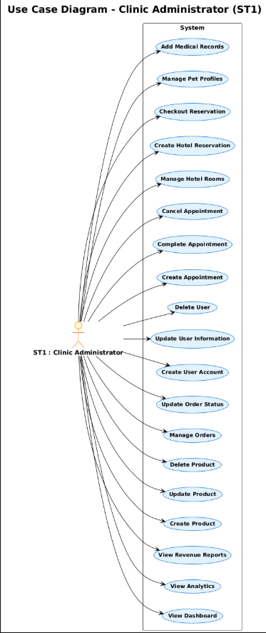 *Figure 9 Use Case Diagram ST2 : Pet Clinics*

*4.2.2.1 Use Case Scenarios and Sequence Diagrams for Administrator*

|  |  |
| --- | --- |
| **Use Case Name : View Dashboard** | |
| **Actor** | Clinic Administrator (ST1) |
| **Description** | The administrator accesses the main admin dashboard interface with tabbed navigation (Products, Orders, Analytics, Owners, Appointments, Hotel) and views key metrics and statistics. |
| **Data** | Tab selection stored in localStorage, active tab state, dashboard metrics data (counts, statistics), user session information |
| **Stimulus** | Administrator navigates to `/admin/dashboard` or clicks on the admin dashboard link after login |
| **Response** | System displays the admin dashboard with the persisted tab selected (from localStorage if available, default to 'products'), shows analytics cards, and provides access to all management functions through tab navigation |
| **Comments** | Tab persistence is maintained across page refreshes using localStorage. Dashboard provides overview of system status and quick access to all administrative functions. |

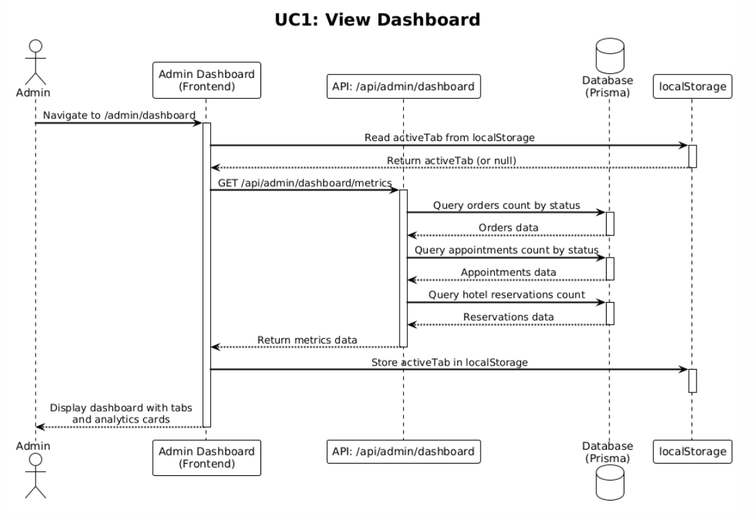

|  |  |
| --- | --- |
| **Use Case Name : View Analytics** | |
| **Actor** | Clinic Administrator (ST1) |
| **Description** | The administrator views comprehensive business analytics including revenue reports, statistics, and tracking data through the Analytics tab and analytics cards on the dashboard. |
| **Data** | Analytics data (revenue, statistics, visitor counts, page views, product views), time period filter selection, session IDs, order data, appointment data, hotel reservation data |
| **Stimulus** | Administrator clicks on the "Analytics" tab in the dashboard or clicks on analytics cards (Orders, Appointments, Hotel Reservations) |
| **Response** | System displays analytics information including revenue breakdown (orders, appointments, hotel), statistics (total counts by status), unique visitors count, top products by views, page view counts, and product view counts. System allows filtering by time period (today, week, month, 3 months, year) |
| **Comments** | Analytics excludes admin pages from tracking. Revenue calculations only include completed orders, completed appointments with price, and checked-out hotel reservations with total. Clicking analytics cards opens modals with full lists instead of tab navigation. |

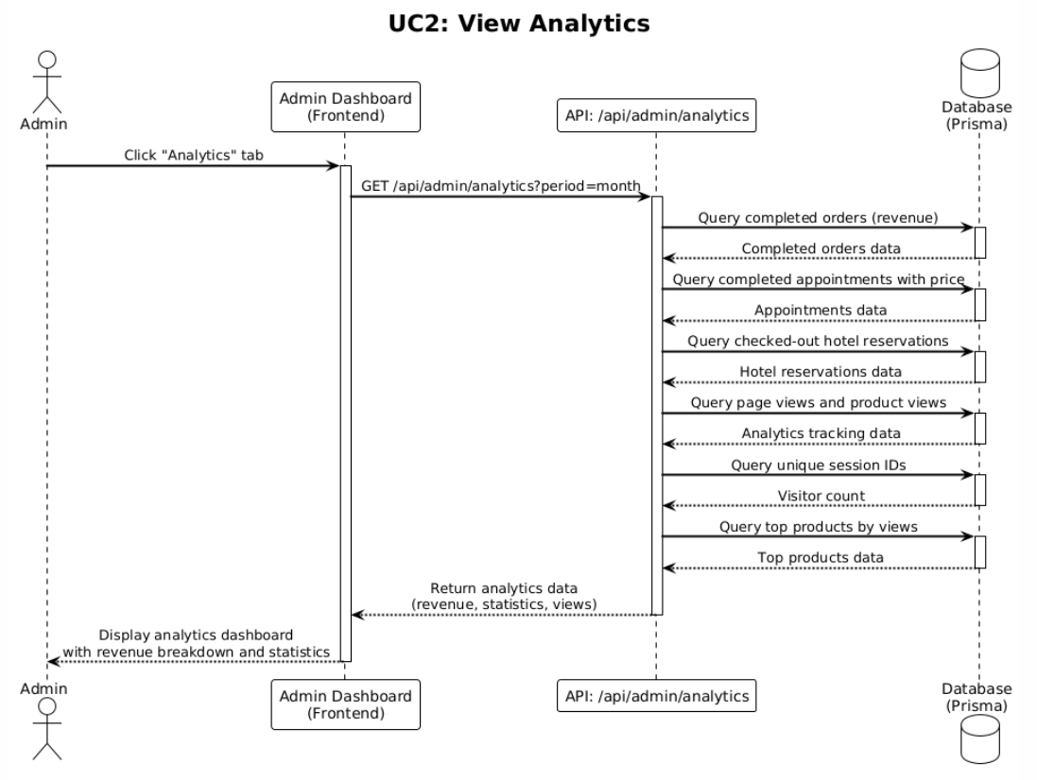

|  |  |
| --- | --- |
| **Use Case Name : View Revenue Reports** | |
| **Actor** | Clinic Administrator (ST1) |
| **Description** | The administrator views detailed revenue reports showing breakdown by source (orders, appointments, hotel) with timeline and detailed breakdown in modal view. |
| **Data** | Revenue data from orders (completed only), appointments (completed with price), hotel reservations (checked-out with total), date range filters, payment method information |
| **Stimulus** | Administrator clicks on "Revenue Timeline" or revenue-related sections in the Analytics tab |
| **Response** | System displays revenue timeline showing all revenue items (orders, appointments, hotel) with detailed breakdown in a modal. System shows payment breakdown for hotel reservations (nights, room rate, subtotal, pickup fee, dropoff fee, extra services with amounts, total). System allows filtering by time period |
| **Comments** | Pending orders are excluded from revenue calculations. Revenue is calculated separately for orders, appointments, and hotel, with total combined revenue displayed. |

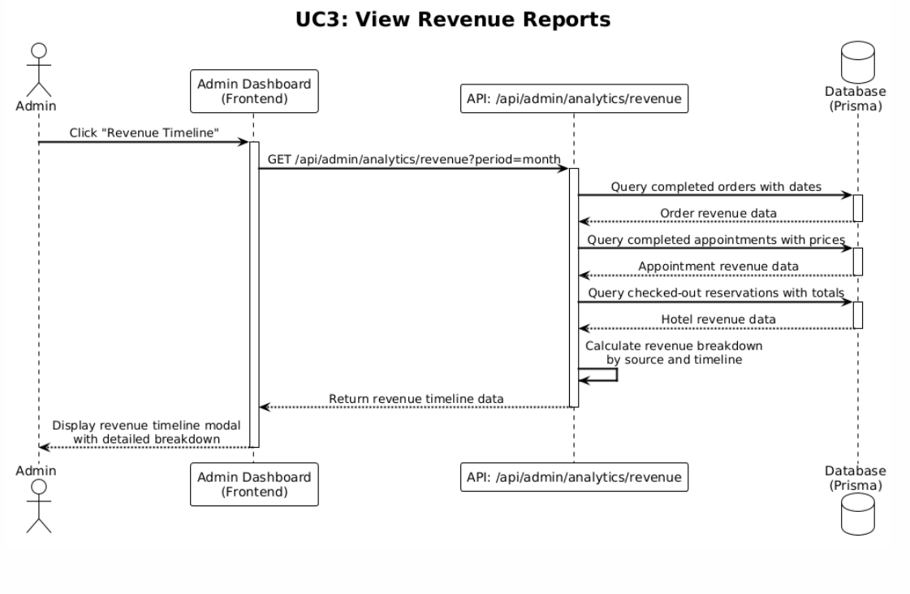

|  |  |
| --- | --- |
| **Use Case Name : Create Product** | |
| **Actor** | Clinic Administrator (ST1) |
| **Description** | The administrator creates a new product with name, description, price, images, stock quantity, and category assignment. The system auto-generates a product slug from the name. |
| **Data** | Product name, description, price (numeric), images (multiple files), stock quantity (integer), category selection, product slug (auto-generated) |
| **Stimulus** | Administrator navigates to product creation page, fills in product details form, uploads images, and clicks "Create Product" or "Save" button |
| **Response** | System validates input data, uploads images to Cloudinary, auto-generates slug from product name, creates product record in database, stores image URLs as comma-separated string, displays success message, and redirects to products list or refreshes product list |
| **comments** | Images are uploaded to Cloudinary with validation for file type (JPEG, JPG, PNG, WebP, GIF) and file size (max 5MB). Slug is generated by converting product name to lowercase and replacing spaces with hyphens. Product stock is initialized with the provided quantity |

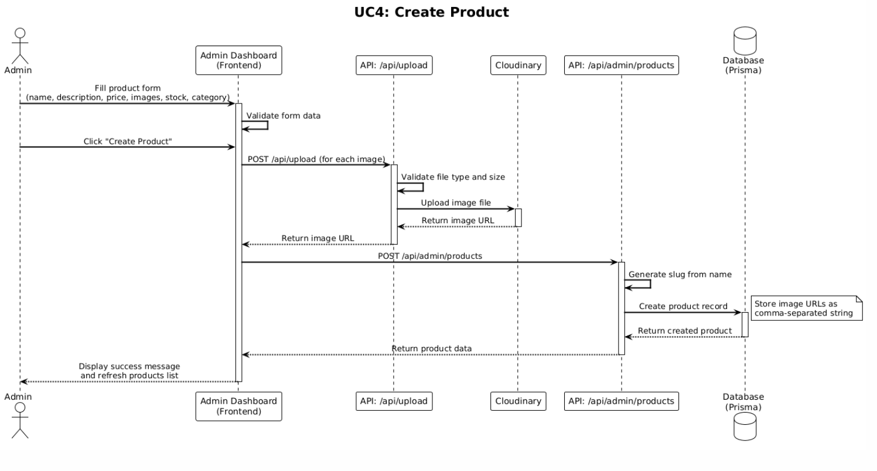

|  |  |
| --- | --- |
| **Use Case Name : Update Product** | |
| **Actor** | Clinic Administrator (ST1) |
| **Description** | The administrator updates an existing product's information including name, description, price, images, stock quantity, and category. If name changes, the slug is regenerated. |
| **Data** | Product ID, updated product name, description, price, images (new or existing), stock quantity, category, old product name (for slug comparison) |
| **Stimulus** | Administrator selects a product to edit, modifies product details in the edit form, optionally uploads new images, and clicks "Update Product" or "Save Changes" button |
| **Response** | System validates input data, checks if product name changed, regenerates slug if name changed, uploads new images to Cloudinary if provided, updates product record in database, updates image URLs, displays success message, and refreshes product information in the UI |
| **comments** | Product ID cannot be changed. If new images are uploaded, old images can be replaced or added to existing ones. Slug regeneration ensures URLs remain consistent. Stock quantity can be updated to reflect inventory changes. |

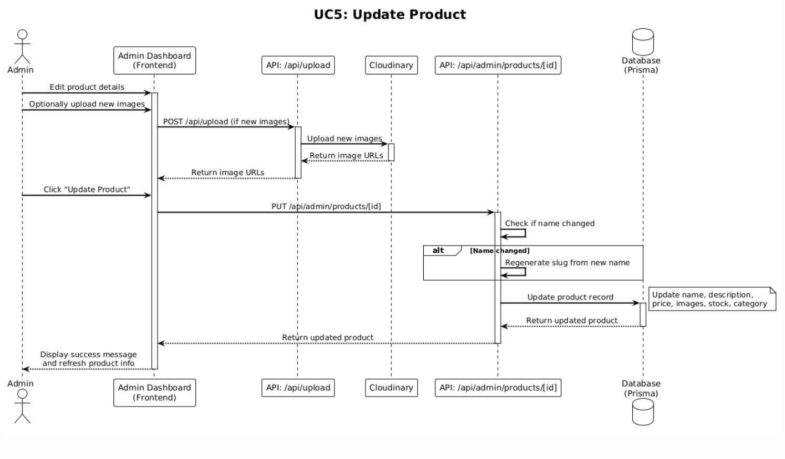

|  |  |
| --- | --- |
| **Use Case Name : Delete Product** | |
| **Actor** | Clinic Administrator (ST1) |
| **Description** | The administrator deletes a product from the system after confirmation. The product and its associated data are permanently removed. |
| **Data** | Administrator clicks "Delete" button for a product, confirms deletion in the confirmation dialog |
| **Stimulus** | Administrator navigates to `/admin/dashboard` or clicks on the admin dashboard link after login |
| **Response** | System displays confirmation dialog with product name, waits for confirmation, deletes product record from database, removes product from product list, displays success message, and refreshes product list view |
| **Comments** | Deletion should be confirmed to prevent accidental removal. Products that are referenced in orders should be handled appropriately (either prevented from deletion or marked as deleted while preserving order history). |

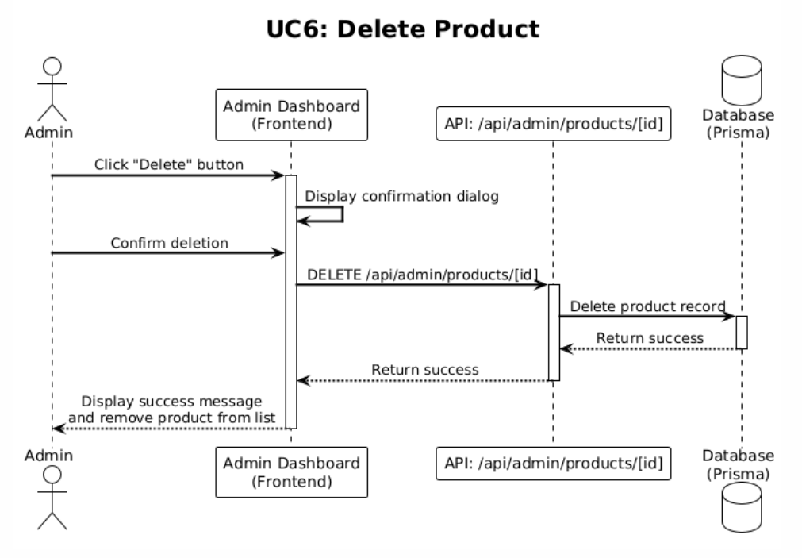

|  |  |
| --- | --- |
| **Use Case Name : Manage Orders** | |
| **Actor** | Clinic Administrator (ST1) |
| **Description** | The administrator views all orders with pagination, filtering, and manages order status and details through the Orders tab in the dashboard. |
| **Data** | Orders list, pagination settings (50 per page), status filter (pending/completed/cancelled), date range filter, order details (items, customer, address, payment method) |
| **Stimulus** | Administrator clicks on the "Orders" tab in the dashboard, applies filters (status, date range), selects an order to view details |
| **Response** | System displays paginated list of orders (50 per page), allows filtering by status and date range, shows order details in modal (customer information, order items, delivery method, payment method, order timeline), and provides options to update order status and add notes |
| **Comments** | Orders are displayed with pagination for performance. Order status changes trigger stock management (restore stock if cancelled, decrement if reactivated). Order timeline shows status changes and timestamps. |

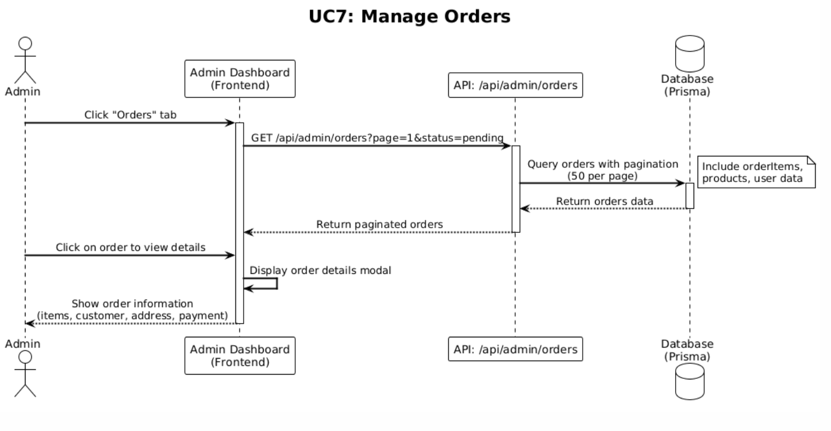

|  |  |
| --- | --- |
| **Use Case Name : Update Order Status** | |
| **Actor** | Clinic Administrator (ST1) |
| **Description** | The administrator updates the status of an order (pending, completed, cancelled) and optionally adds notes. Stock quantities are adjusted based on status changes. |
| **Data** | Order ID, new status (pending/completed/cancelled), optional notes, current order status, order items with quantities |
| **Stimulus** | Administrator selects an order, changes the status dropdown, optionally adds notes, and clicks "Update Status" or "Save Changes" button |
| **Response** | System validates status change, updates order status in database, adds notes if provided, adjusts product stock (restores stock if status changed to cancelled, decrements stock if status changed from cancelled to active), updates order timeline, displays success message, and refreshes order list |
| **Comments** | Stock management is critical: cancelled orders restore product stock, and reactivated orders decrease stock again. Order notes are stored for record-keeping and customer communication. |

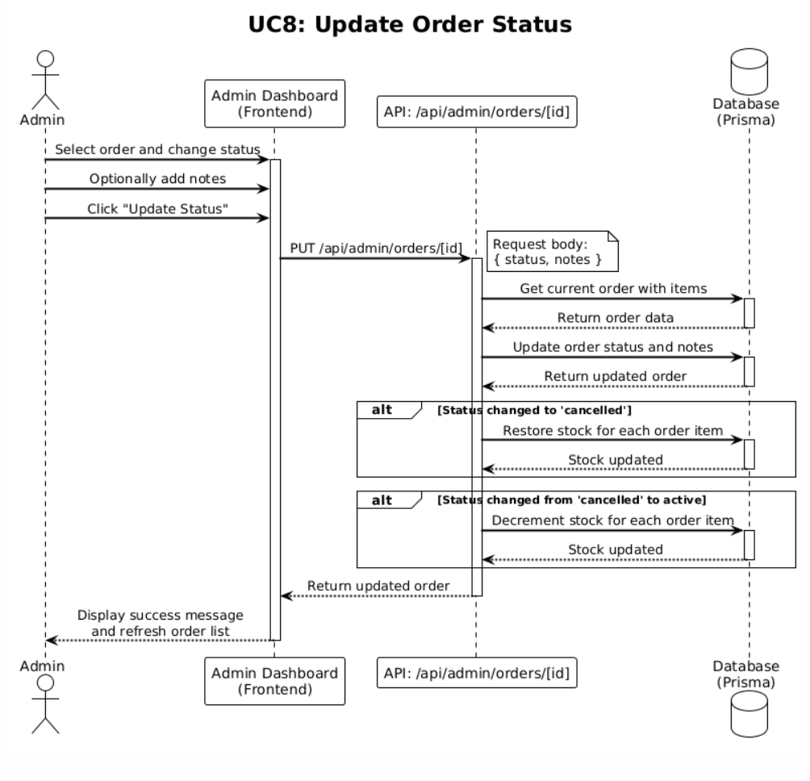

|  |  |
| --- | --- |
| **Use Case Name : Create User Account** | |
| **Actor** | Clinic Administrator (ST1) |
| **Description** | The administrator creates a new user account with name, email, phone, password, governorate, area, and address. This allows creating accounts for customers who don't register themselves. |
| **Data** | User name, email, phone number, password (hashed with bcrypt), governorate, area, address, user role (default: 'user') |
| **Stimulus** | Administrator navigates to Owners tab, clicks "Create User" or "Add New User" button, fills in user details form, and clicks "Create Account" or "Save" button |
| **Response** | System validates input data (email format, password strength), hashes password with bcrypt (12 rounds), creates user record in database, displays success message, adds new user to users list, and refreshes users list view |
| **Comments** | Password must meet strength requirements (min 8 chars, uppercase, lowercase, number). Email must be unique. Created accounts can later be upgraded to full accounts by users if needed. Phone-based accounts can be upgraded by users. |

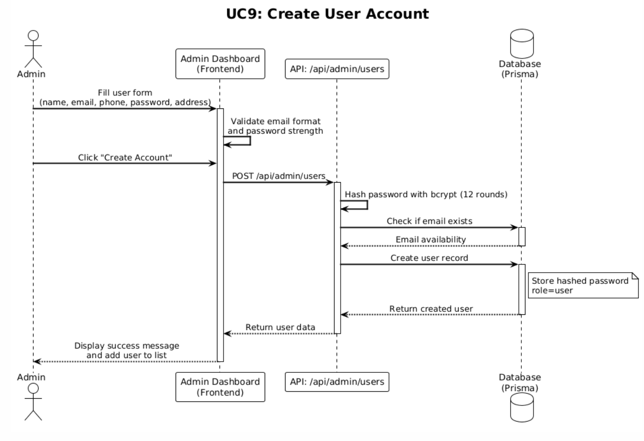

|  |  |
| --- | --- |
| **Use Case Name : Update User Information** | |
| **Actor** | Clinic Administrator (ST1) |
| **Description** | The administrator updates a user's profile information including name, phone, governorate, area, and address. |
| **Data** | User ID, updated name, phone number, governorate, area, address, existing user data |
| **Stimulus** | Administrator selects a user from the users list, clicks "Edit" button, modifies user information in the edit form, and clicks "Update User" or "Save Changes" button |
| **Response** | System validates input data, updates user record in database, displays success message, refreshes user information in the UI, and updates user details in any related views |
| **Comments** | Email and password updates may require separate flows for security reasons. Address information is used for order delivery and appointment records |

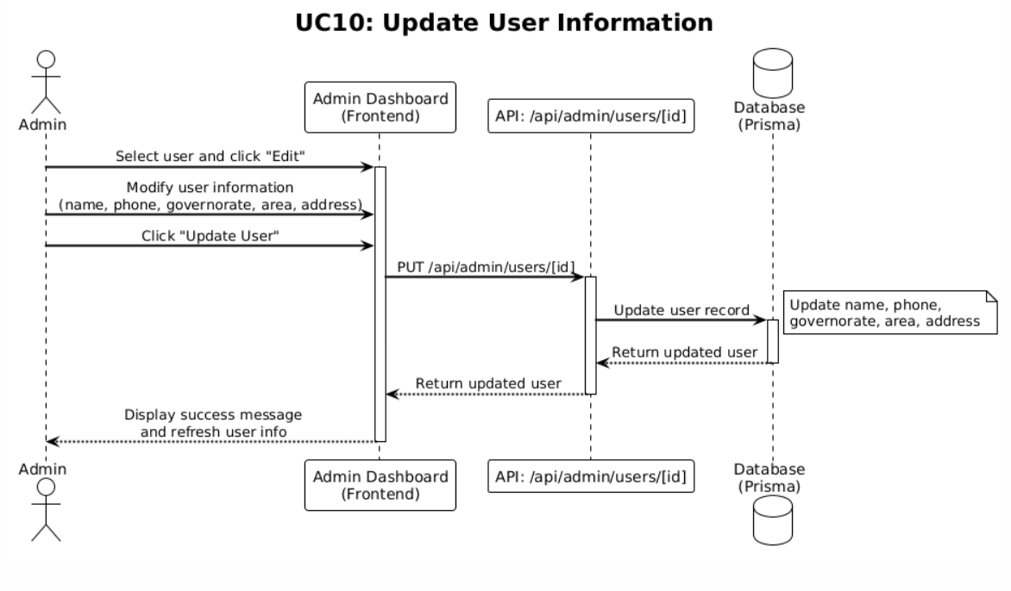

|  |  |
| --- | --- |
| **Use Case Name : Delete User** | |
| **Actor** | Clinic Administrator (ST1) |
| **Description** | The administrator deletes a user account with cascade deletion of related data including pets, orders, and appointments. |
| **Data** | User ID, user name (for confirmation display), related data (pets, orders, appointments) |
| **Stimulus** | Administrator selects a user, clicks "Delete" button, confirms deletion in the confirmation dialog |
| **Response** | System displays confirmation dialog with user name, waits for confirmation, performs cascade deletion (removes user, pets, orders, appointments, medical records), removes user from users list, displays success message, and refreshes users list view |
| **Comments** | Cascade deletion ensures data integrity. Deletion should be confirmed to prevent accidental removal. Consider soft delete or archival for important historical data. Admin users cannot be deleted through this interface |

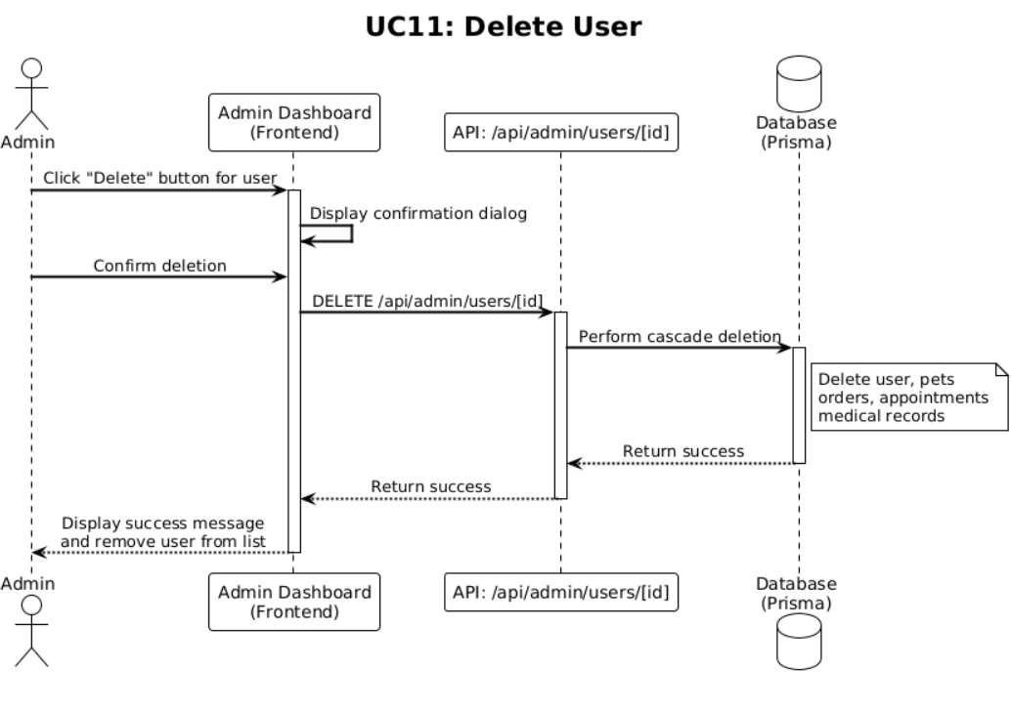

|  |  |
| --- | --- |
| **Use Case Name : Create Appointment** | |
| **Actor** | Clinic Administrator (ST1) |
| **Description** | Owner name, owner phone, pet ID (if user's pet) or pet name, appointment date, appointment time, reason, optional notes, user ID (if registered user) |
| **Data** | User ID, user name (for confirmation display), related data (pets, orders, appointments) |
| **Stimulus** | Administrator navigates to Appointments tab, clicks "Create Appointment" or "New Appointment" button, fills in appointment details form, and clicks "Create Appointment" or "Save" button |
| **Response** | System validates input data, checks date/time availability if applicable, creates appointment record with status "upcoming", associates with user if user ID provided, displays success message, adds appointment to appointments list, and refreshes appointments view |
| **Comments** | Appointments can be created for both registered users (with user ID and pet ID) and guest users (with owner name, phone, and pet name). Appointment status is set to "upcoming" by default. |

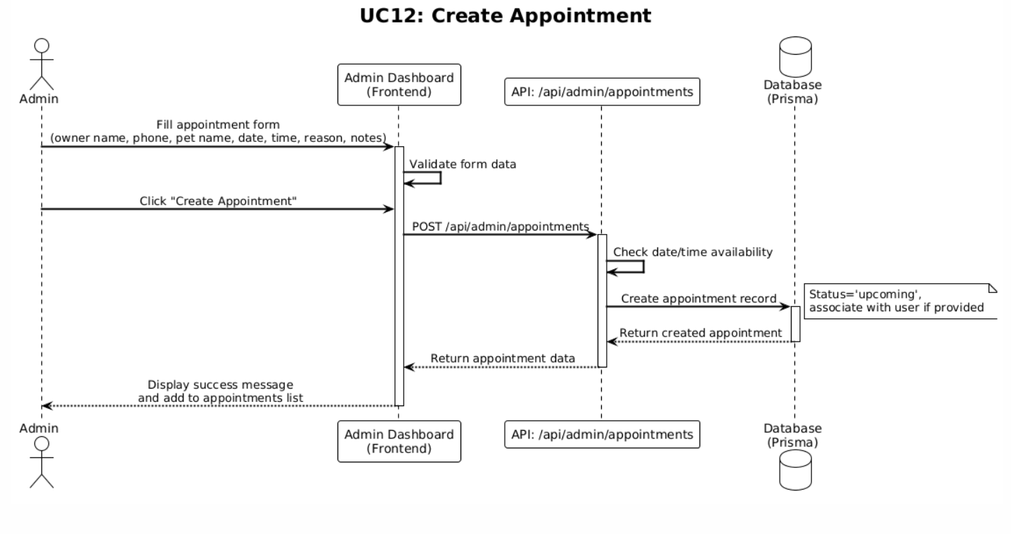

|  |  |
| --- | --- |
| **Use Case Name : Complete Appointment** | |
| **Actor** | Clinic Administrator (ST1) |
| **Description** | The administrator marks an appointment as completed by setting completion price, payment method, and updating status to "completed". |
| **Data** | Appointment ID, completion price (numeric), payment method (cash/click/other), current appointment status |
| **Stimulus** | Administrator selects an appointment, clicks "Complete Appointment" button, enters completion price and payment method, and clicks "Mark as Completed" or "Save" button |
| **Response** | System validates input data, updates appointment status to "completed", records completion price and payment method, updates appointment timestamp, displays success message, refreshes appointment in the list with completed status (green color coding), and includes appointment in revenue calculations |
| **Comments** | Completed appointments with price are included in revenue analytics. Payment method is recorded for financial reporting. Appointment cannot be edited after completion (may require separate workflow for corrections). |

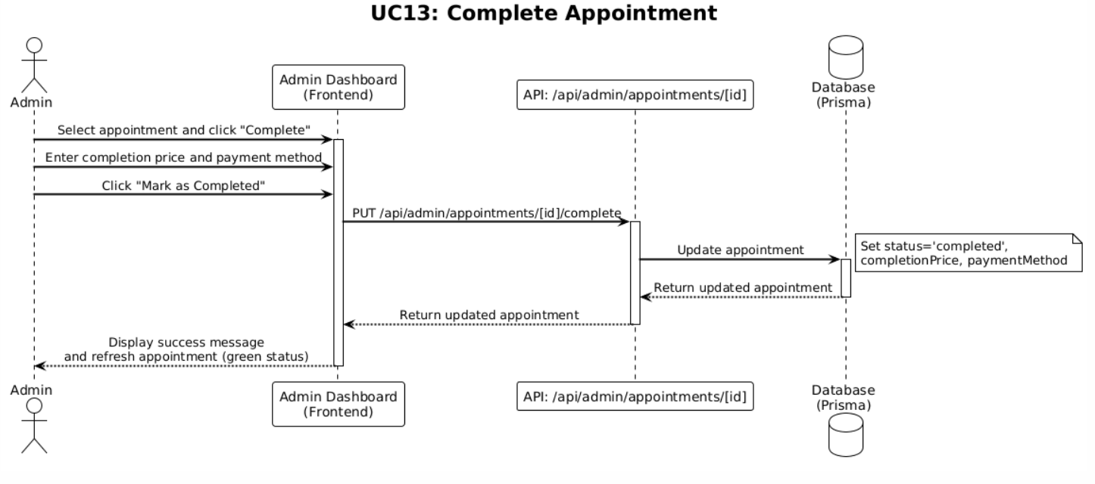

|  |  |
| --- | --- |
| **Use Case Name : Cancel Appointment** | |
| **Actor** | Clinic Administrator (ST1) |
| **Description** | The administrator cancels an appointment by updating its status to "cancelled". |
| **Data** | Appointment ID, current appointment status, optional cancellation reason |
| **Stimulus** | Administrator selects an appointment, clicks "Cancel Appointment" button, optionally enters cancellation reason, and confirms cancellation |
| **Response** | System updates appointment status to "cancelled", records cancellation timestamp, optionally saves cancellation reason, displays success message, refreshes appointment in the list with cancelled status (red color coding), and excludes appointment from upcoming appointments |
| **Comments** | Cancelled appointments are excluded from revenue calculations. Cancellation reason can be stored for record-keeping. Users can be notified of cancellation if needed. |

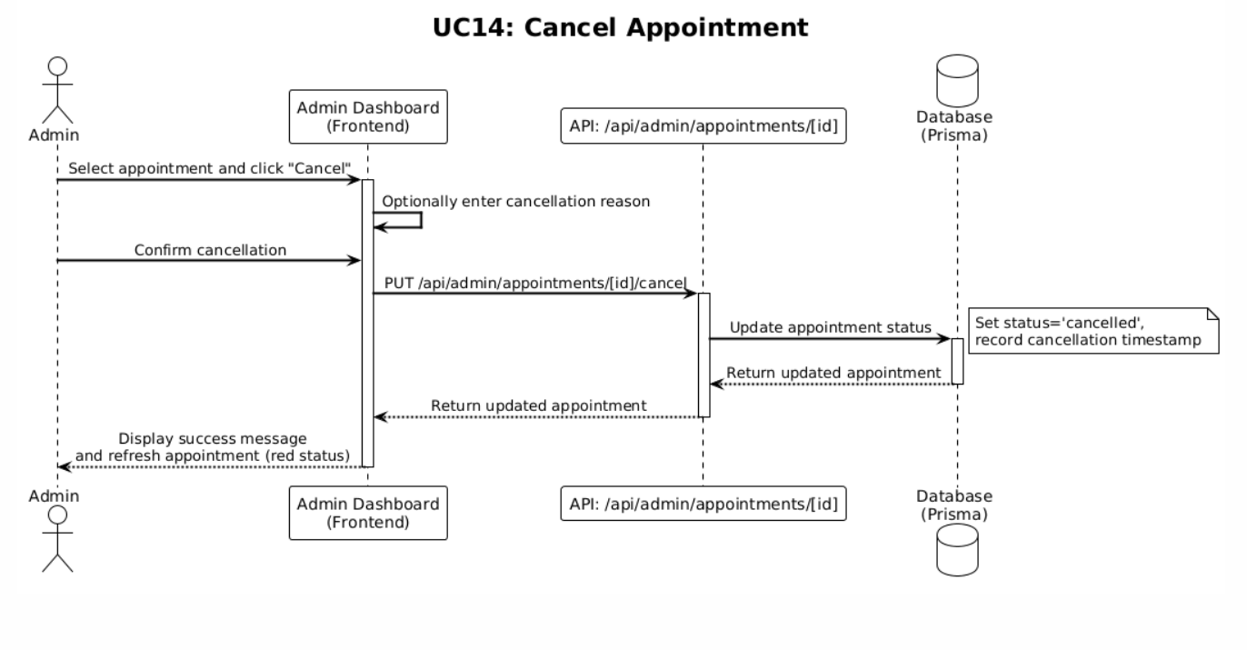

|  |  |
| --- | --- |
| **Use Case Name : Manage Hotel Rooms** | |
| **Actor** | Clinic Administrator (ST1) |
| **Description** | The administrator views and manages hotel rooms by type (DOG, CAT, BIRD) on separate pages, with all reservations displayed for each room. |
| **Data** | Hotel rooms list, room type filter (DOG/CAT/BIRD), room status (AVAILABLE/OCCUPIED/CLEANING/MAINTENANCE), room number, reservations for each room |
| **Stimulus** | Administrator clicks on the "Hotel" tab in the dashboard, selects room type filter (dogs, cats, birds), views rooms list |
| **Response** | System displays hotel rooms by selected type, shows room number and status for each room, displays all reservations for each room, allows creating new rooms, updating room status, and managing reservations |
| **Comments** | Rooms are organized by type for easier management. Each room shows its current status and associated reservations. Room status affects availability for new bookings. |

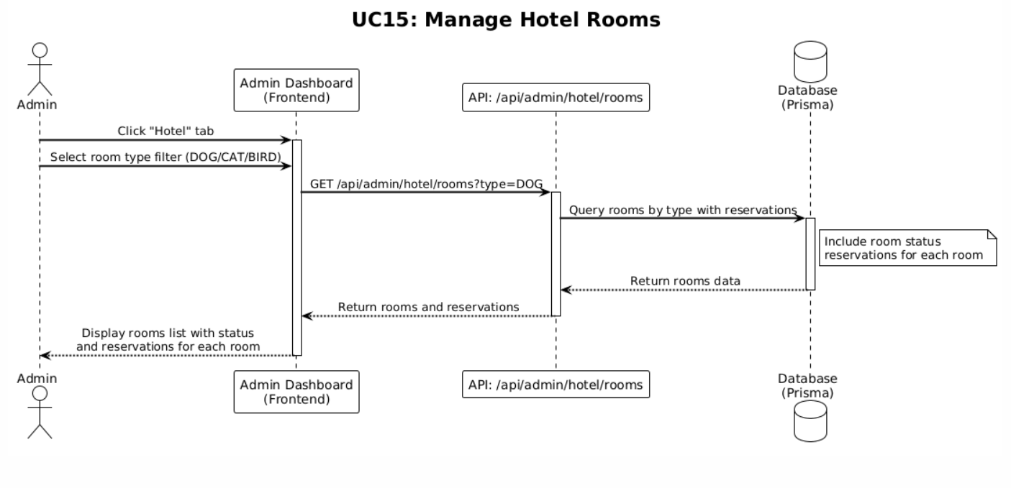

|  |  |
| --- | --- |
| **Use Case Name : Create Hotel Reservation** | |
| **Actor** | Clinic Administrator (ST1) |
| **Description** | The administrator creates a hotel reservation for any customer with owner name, phone, pet name, room selection, check-in date, check-out date, pickup/dropoff service options, and optional notes. |
| **Data** | Room ID, owner name, owner phone, pet name, check-in date, check-out date, pickup service (boolean), dropoff service (boolean), extra services (array of service names), optional notes, user ID (if registered user) |
| **Stimulus** | Administrator navigates to Hotel tab, selects a room or clicks "Create Reservation" button, fills in reservation details form, and clicks "Create Reservation" or "Save" button |
| **Response** | System validates input data, checks room availability for selected dates, creates reservation record with status "booked", marks room as "OCCUPIED", calculates booking cost breakdown, displays success message, adds reservation to reservations list, and refreshes hotel rooms view |
| **Comments** | Room availability is checked to prevent overlapping reservations. Room status is immediately updated to OCCUPIED. Extra services are added by name only; amounts are set by admin at checkout. Reservation status is set to "booked" initially. |

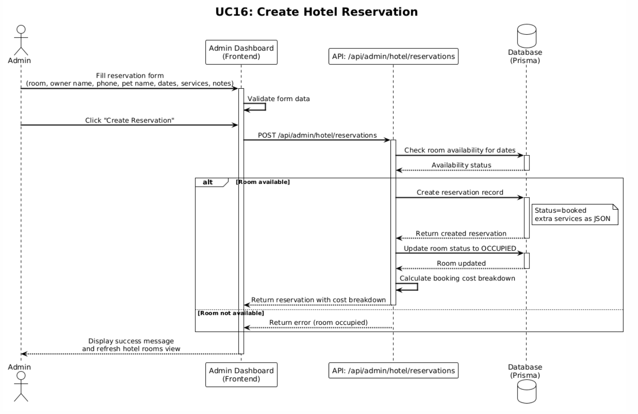

|  |  |
| --- | --- |
| **Use Case Name : Checkout Reservation** | |
| **Actor** | Clinic Administrator (ST1) |
| **Description** | The administrator completes a hotel reservation checkout by calculating total nights, setting room rate, subtotal, pickup fee, dropoff fee, setting extra service amounts, calculating total, selecting payment method, updating status to "checked_out", and marking room as "AVAILABLE". |
| **Data** | Reservation ID, check-in date, check-out date, room rate (default: 20 JOD/night), pickup fee (default: 5 JOD if selected), dropoff fee (default: 5 JOD if selected), extra services with amounts, payment method, current reservation status |
| **Stimulus** | Administrator selects a reservation, clicks "Checkout" button, reviews cost breakdown, sets extra service amounts, selects payment method, and clicks "Complete Checkout" or "Save" button |
| **Response** | System calculates total nights, calculates subtotal (nights × room rate), adds pickup fee if applicable, adds dropoff fee if applicable, adds extra service amounts, calculates total, updates reservation status to "checked_out", records payment method, marks room as "AVAILABLE", records checkout timestamp, displays success message, refreshes reservation details, and includes reservation in revenue calculations |
| **Comments** | Checkout process completes the reservation lifecycle. Room becomes available for new bookings. Total calculation includes all fees and services. Checked-out reservations with total are included in revenue analytics. |

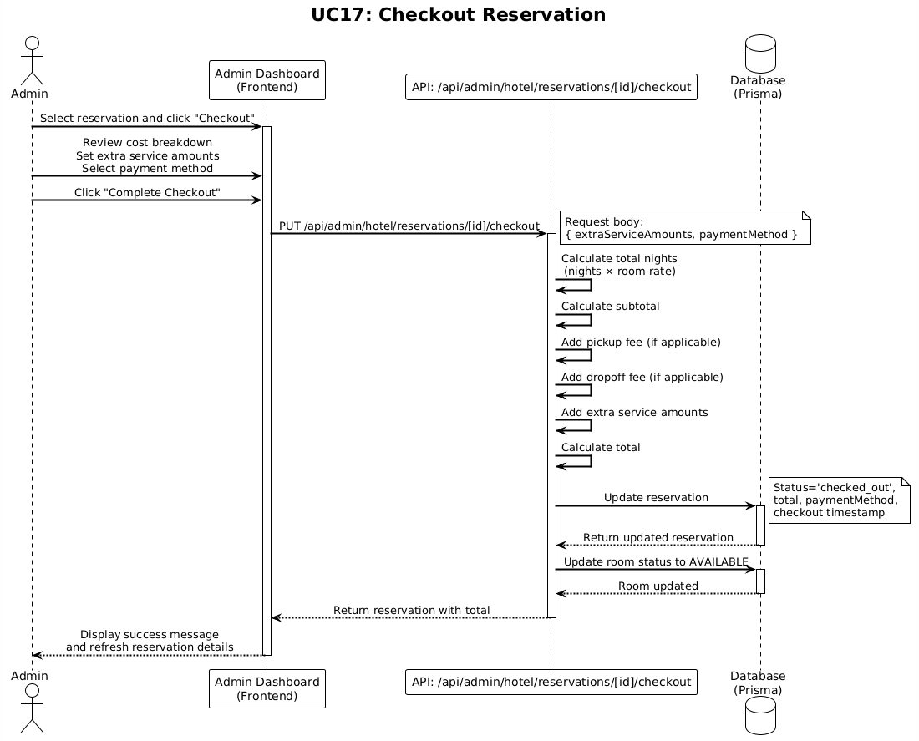

|  |  |
| --- | --- |
| **Use Case Name : Manage Pet Profiles** | |
| **Actor** | Clinic Administrator (ST1) |
| **Description** | The administrator views and manages any pet profile, including viewing details, editing information, and performing administrative actions on pets belonging to any user. |
| **Data** | Pet ID, pet information (name, species, breed, gender, birth date, color, photo), pet owner user ID, medical records data |
| **Stimulus** | Administrator navigates to user details, selects a pet, or accesses pet management through Owners tab, views pet profile |
| **Response** | System displays pet profile with all information, shows medical records (vaccinations, dewormings, clinic visits, weight history), provides options to edit pet information, add medical records, and delete pet, displays pet code (PET-XXXXX format) |
| **Comments** | Admin has full access to manage any pet profile in the system. This is useful for correcting information, adding medical records after appointments, or managing data for clinic operations. Pet deletion cascades to related medical records |

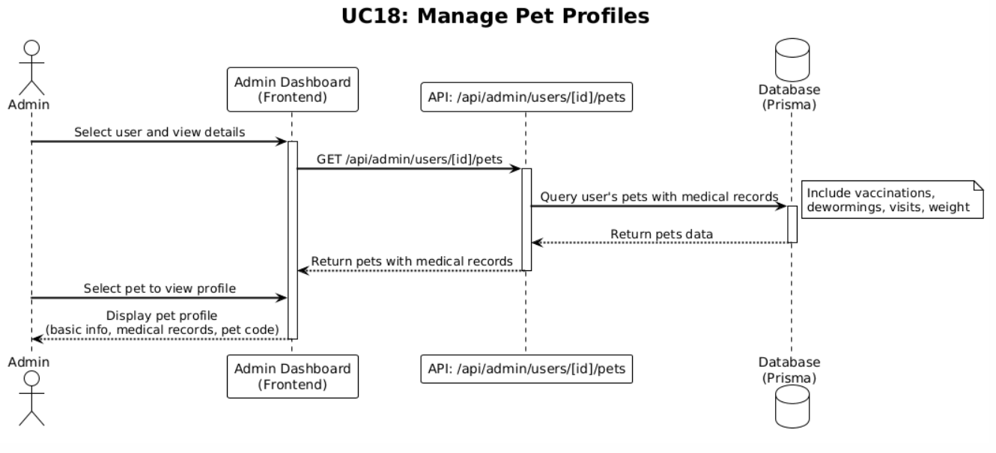

|  |  |
| --- | --- |
| **Use Case Name : Add Medical Records** | |
| **Actor** | Clinic Administrator (ST1) |
| **Description** | he administrator adds medical records to any pet profile including vaccinations, dewormings, clinic visits, and weight records with appropriate details. |
| **Data** | Pet ID, record type (vaccination/deworming/clinic visit/weight), record details (name, date, next due date, notes for vaccinations/dewormings; visit date, reason, diagnosis, treatment, prescriptions, notes, next appointment for visits; date, weight, notes for weight) |
| **Stimulus** | Administrator selects a pet profile, clicks "Add Vaccination", "Add Deworming", "Add Clinic Visit", or "Add Weight Record" button, fills in record details form, and clicks "Add Record" or "Save" button |
| **Response** | System validates input data, creates medical record in database, associates record with pet, displays success message, adds record to pet's medical history, refreshes medical records display (most recent first), and updates pet profile view |
| **Comments** | Medical records are added chronologically and displayed with most recent first. Records are linked to the pet and user for tracking. Clinic visits can include comprehensive information about diagnosis and treatment. Next due dates help track future care needs |

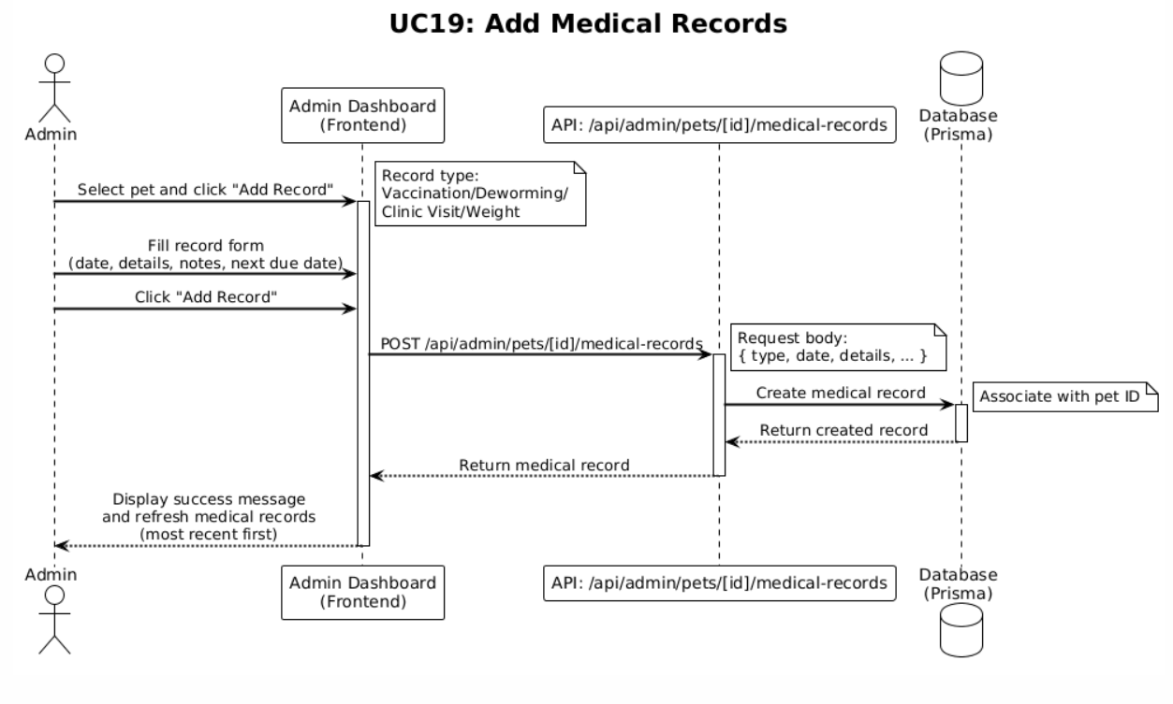

### 4.2.3 Use Case Diagram for Pet Owners

**Stakeholder 2 : Pet Owners**

The diagram represents ST3: Pet Owners as the primary stakeholder interacting with a wide range of system functionalities. These include managing Notifications, Email Communication, and a Feedback System for seamless communication. Pet owners can explore Clinic Details, Appointment History, and Health Records, while utilizing tools like Filtering, Basic Search, and a Clinic Directory for ease of navigation. Additionally, features like User Sign-Up, Login, and Password Recovery ensure secure access. Pet owners can benefit from services such as Health Tips, SMS Notifications, Manual Calendar Entry, and Emergency Contact Listing, ensuring comprehensive support for their pets' health and well-being.

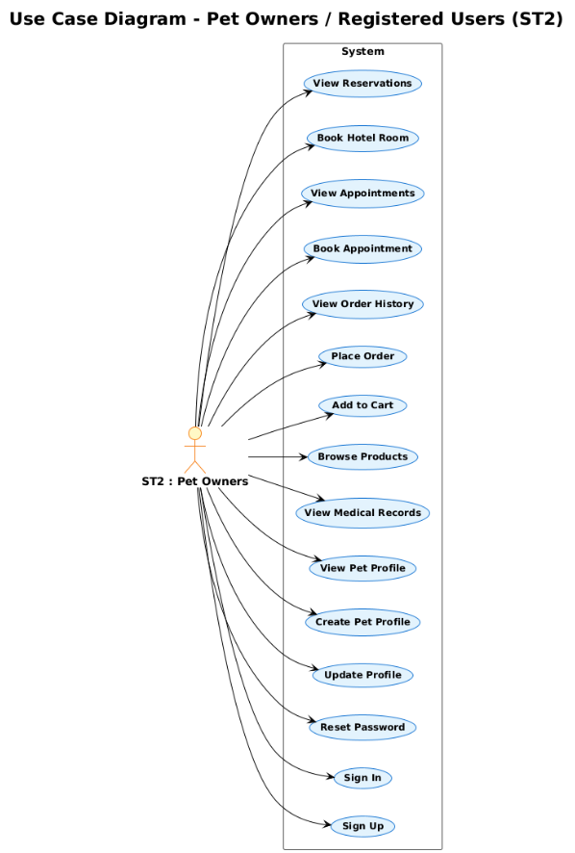

*4.2.3.1 Use Case Scenarios and Sequence Diagrams for Pet Owners*

|  |  |
| --- | --- |
| **Use Case Name :  Sign Up** | |
| **Actor** | Pet Owners / Registered Users (ST2) |
| **Description** | A new user registers an account with name, email, password, and phone number. The system validates email format and password strength (min 8 chars, uppercase, lowercase, number) and hashes the password |
| **Data** | User name, email address, password, phone number, session information, rate limiting data (IP address, attempt count) |
| **Stimulus** | User navigates to sign up page, fills in registration form with name, email, password, and phone number, and clicks "Sign Up" or "Register" button |
| **Response** | System validates email format, validates password strength (min 8 chars, uppercase, lowercase, number), checks rate limiting (3 attempts per 10 minutes per IP), hashes password with bcrypt (12 rounds), creates user account in database, stores user session in localStorage, redirects to user dashboard, and displays success message |
| **Comments** | Password strength validation includes visual indicator. Rate limiting prevents abuse (3 attempts per 10 minutes per IP). Email must be unique. User role is set to 'user' by default. Password is never stored in plain text |

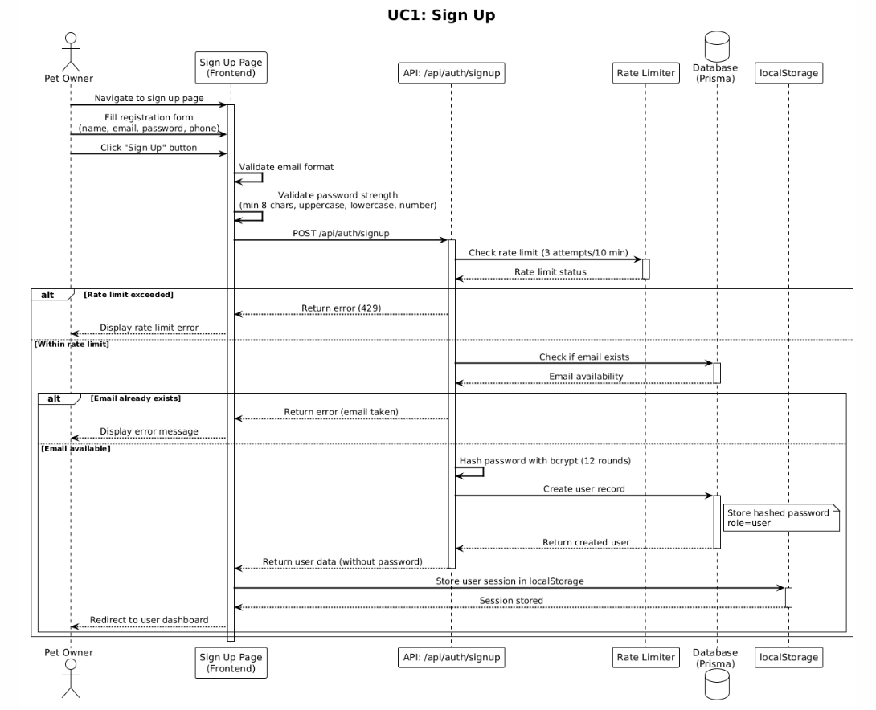

|  |  |
| --- | --- |
| **Use Case Name :  Sign In** | |
| **Actor** | Pet Owners / Registered Users (ST2) |
| **Description** | A registered user logs in with email and password. The system validates credentials, checks rate limiting, and stores user session in localStorage. Admin users are redirected to admin login. |
| **Data** | Email address, password, session information, rate limiting data (IP address, attempt count, timestamp), user role |
| **Stimulus** | User navigates to login page, enters email and password, and clicks "Login" or "Sign In" button |
| **Response** | System validates rate limiting (5 attempts per 15 minutes per IP), validates email format, retrieves user from database, compares password with bcrypt, checks user role, prevents user enumeration (same error for invalid email/password), stores user session in localStorage if login successful, redirects to user dashboard if user role, redirects to admin login page if admin role, or displays error message if credentials invalid |
| **Comments** | Rate limiting prevents brute force attacks (5 attempts per 15 minutes per IP). User enumeration protection ensures same error message for invalid email and invalid password. Admin users are prevented from logging in through regular user login. Session is stored in localStorage (security consideration for production). |

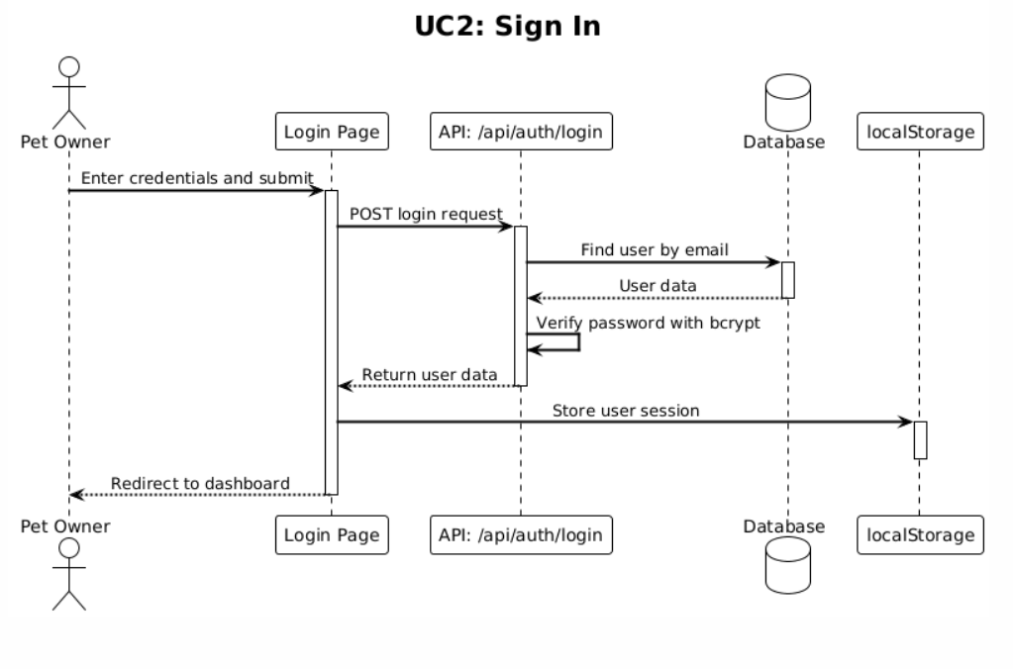

|  |  |
| --- | --- |
| **Use Case Name :  Reset Password** | |
| **Actor** | Pet Owners / Registered Users (ST2) |
| **Description** | A user requests password reset via email. The system sends a secure reset link that expires after 24 hours. User can then set a new password. |
| **Data** | Email address, reset token, token expiration timestamp, user ID, new password (hashed) |
| **Stimulus** | User clicks "Forgot Password" link on login page, enters email address, and clicks "Send Reset Link" button. Later, user clicks reset link in email, enters new password, and clicks "Reset Password" button |
| **Response** | System validates email exists (without revealing if email is registered for security), generates secure reset token, stores token with expiration (24 hours), sends email with reset link, displays confirmation message. When user clicks link, system validates token and expiration, prompts for new password, validates password strength, hashes new password with bcrypt, updates user password in database, invalidates reset token, and redirects to login page with success message |
| **Comments** | Reset link expires after 24 hours for security. Token should be cryptographically secure and single-use. Email validation should not reveal whether email exists in system. Password strength requirements apply to new password |

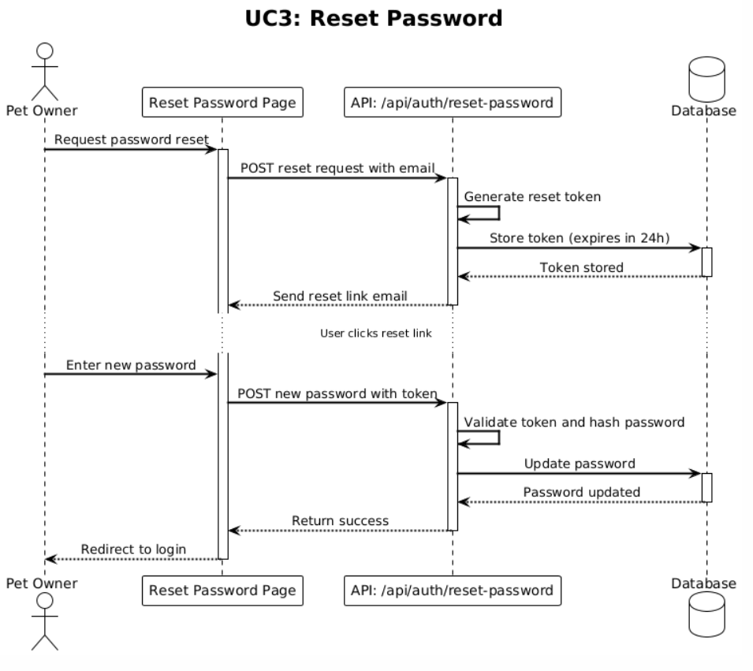

|  |  |
| --- | --- |
| **Use Case Name :  Update Profile** | |
| **Actor** | Pet Owners / Registered Users (ST2) |
| **Description** | A logged-in user updates their profile information including name, phone, governorate, area, and address. |
| **Data** | User ID, updated name, phone number, governorate, area, address, current user session |
| **Stimulus** | User navigates to profile settings page, modifies profile information in the form, and clicks "Update Profile" or "Save Changes" button |
| **Response** | System validates input data, updates user record in database, updates user session in localStorage with new information, displays success message, refreshes profile information in the UI, and updates profile information used for order pre-filling |
| **Comments** | Profile updates are immediately reflected in user session. Address information is used to pre-fill checkout forms. Governorate and area are used for delivery address selection. Email and password updates may require separate flows for security. |

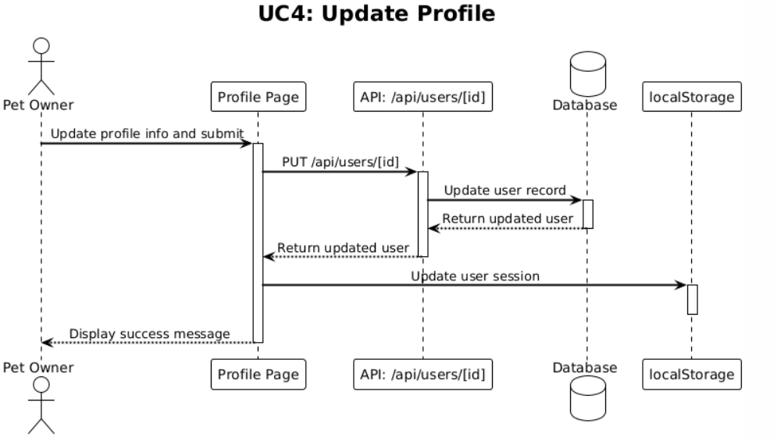

|  |  |
| --- | --- |
| **Use Case Name :  Create Pet Profile** | |
| **Actor** | Pet Owners / Registered Users (ST2) |
| **Description** | A logged-in user creates a pet profile with name, species, gender, and optional fields (breed, birth date, color, photo, medical information). The system auto-generates a unique pet code (PET-XXXXX format) and uploads photo to Cloudinary. |
| **Data** | User ID, pet name, species, gender, optional breed, birth date, color, photo file, optional allergies, medications, medical history, surgical history, chronic conditions, pet code (auto-generated) |
| **Stimulus** | User navigates to pets page, clicks "Add Pet" or "New Pet" button, fills in pet information form, optionally uploads pet photo, and clicks "Create Pet" or "Save" button |
| **Response** | System validates required fields (name, species), uploads photo to Cloudinary if provided, auto-generates pet code (PET-XXXXX format), creates pet record in database, stores photo URL, associates pet with user, displays success message, adds pet to pets list, and refreshes pets view |
| **Comments** | Photo upload to Cloudinary validates file type (JPEG, JPG, PNG, WebP, GIF) and file size (max 5MB). Pet code is unique and auto-generated sequentially. Medical information fields are optional but useful for future appointments and records. |

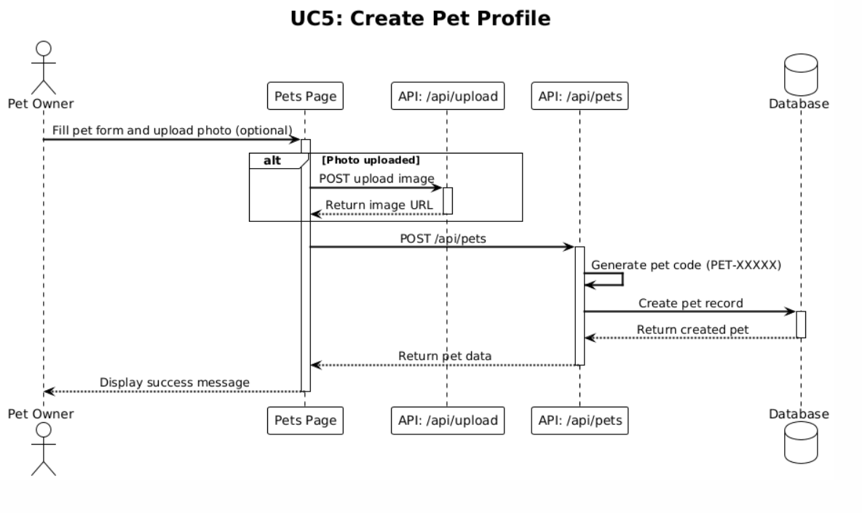

|  |  |
| --- | --- |
| **Use Case Name :  View Pet Profile** | |
| **Actor** | Pet Owners / Registered Users (ST2) |
| **Description** | A logged-in user views detailed information about their pet including basic information, photo, and medical records overview. |
| **Data** | Pet ID, user ID, pet information (name, species, breed, gender, birth date, color, photo), pet code, medical records summary |
| **Stimulus** | User navigates to pets page, clicks on a pet card or "View Details" button for a pet |
| **Response** | System retrieves pet information from database, displays pet profile with all basic information, shows pet photo, displays pet code (PET-XXXXX), shows medical records summary (vaccinations, dewormings, clinic visits, weight history), provides options to edit pet or add medical records, and displays pet in user-friendly format |
| **Comments** | Pet profile provides comprehensive view of pet information. Medical records are displayed chronologically with most recent first. Pet code is displayed for reference and tracking. |

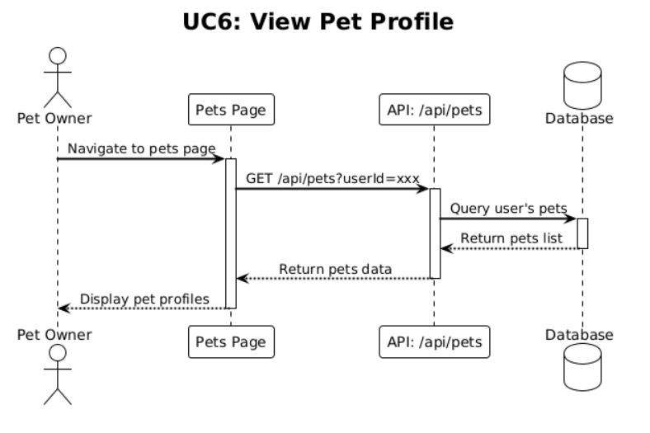

|  |  |
| --- | --- |
| **Use Case Name :  View Medical Records** | |
| **Actor** | Pet Owners / Registered Users (ST2) |
| **Description** | A logged-in user views detailed medical records for their pet including vaccinations, dewormings, clinic visits, and weight history, displayed chronologically. |
| **Data** | Pet ID, user ID, vaccination records, deworming records, clinic visit records, weight records, record dates and details |
| **Stimulus** | User navigates to pet profile, clicks "View Medical Records" or expands medical records section |
| **Response** | System retrieves all medical records for the pet from database, displays records organized by type (vaccinations, dewormings, clinic visits, weight), shows records chronologically (most recent first), displays record details (dates, names, notes, next due dates), limits display to 5-10 most recent per type, and provides option to view all records |
| **Comments** | Medical records are displayed with most recent first for easy access to latest information. Records are limited to prevent overwhelming display. Next due dates help users track upcoming care needs. Clinic visits show comprehensive information including diagnosis and treatment. |

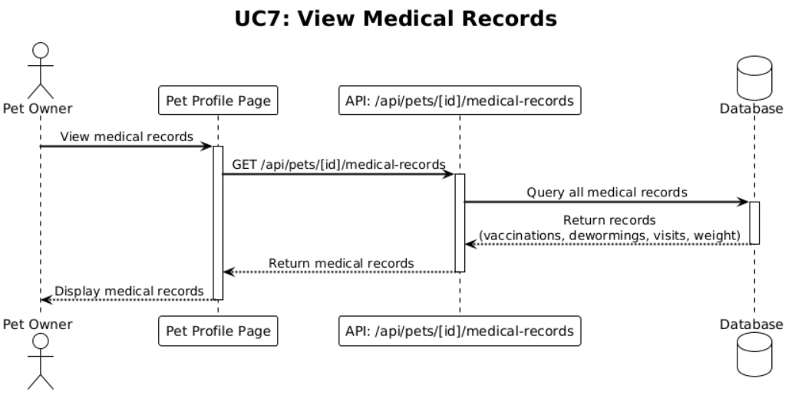

|  |  |
| --- | --- |
| **Use Case Name :  Browse Products** | |
| **Actor** | Pet Owners / Registered Users (ST2) |
| **Description** | A logged-in user browses shop products with category filtering, sorting options (newest, price, name), and pagination (24 products per page). |
| **Data** | Products list, category filter, sort option (newest/price/name), pagination state (page number, 24 per page), product details (name, price, image, stock status, category) |
| **Stimulus** | User navigates to shop page, selects category filter, selects sort option, or clicks pagination controls |
| **Response** | System retrieves products from database based on filters, applies sorting, paginates results (24 per page), displays product cards with images, names, prices, stock status, category badges, "Out of Stock" badges for unavailable products, and provides navigation controls |
| **Comments** | Products are displayed in responsive grid layout. Out of stock products show badges and cannot be added to cart. Sorting and filtering provide better product discovery. Pagination improves performance for large product catalogs. |

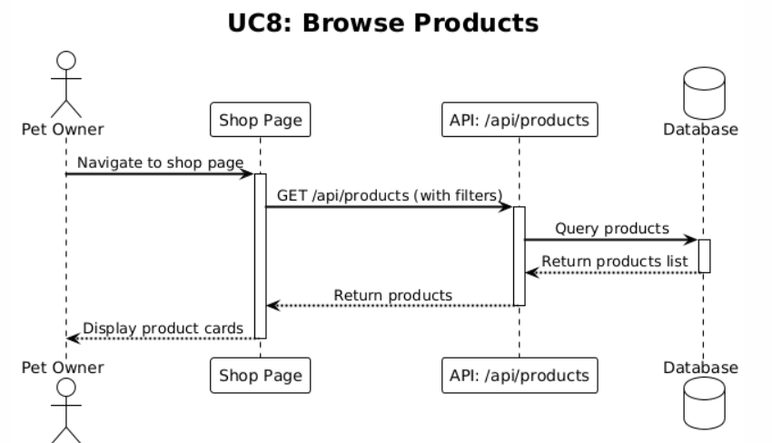

|  |  |
| --- | --- |
| **Use Case Name :   Add to Cart** | |
| **Actor** | Pet Owners / Registered Users (ST2) |
| **Description** | A logged-in user adds a product to their shopping cart. The system uses Recoil state management to maintain cart state and prevents adding out-of-stock products. |
| **Data** | Product ID, product details (name, price, image), quantity, cart state (Recoil atom), stock quantity |
| **Stimulus** | User views product details, clicks "Add to Cart" button, optionally adjusts quantity |
| **Response** | System checks product stock availability, prevents adding if out of stock (displays error message), adds product to cart with quantity, updates Recoil cart state, updates cart item count in header, displays success message or feedback, and maintains cart state during session |
| **Comments** | Cart state is maintained using Recoil state management until logout or order completion. Out of stock products cannot be added to cart. Cart item count is displayed in header for easy access. Cart persists during session but is cleared on logout. |

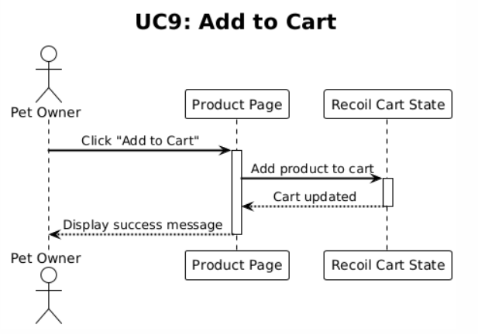

|  |  |
| --- | --- |
| **Use Case Name :   Place Order** | |
| **Actor** | Pet Owners / Registered Users (ST2) |
| **Description** | A logged-in user places an order through checkout process with customer information, delivery method, payment method, and address (if delivery). The system creates order with status "pending" and decreases product stock. |
| **Data** | User ID, cart items, customer name, phone number, delivery method (home delivery/pickup), payment method (cash/click), address (governorate, area, address if delivery), order total, product stock quantities |
| **Stimulus** | User navigates to checkout page (cart is pre-filled from profile if logged in), reviews order, fills in or confirms customer information, selects delivery method and payment method, enters address if delivery, and clicks "Place Order" or "Confirm Order" button |
| **Response** | System validates all required fields, validates cart has items, validates stock availability for all items, creates order record with status "pending", associates order with user, decreases product stock quantities, clears cart (Recoil state), redirects to order success page, displays order confirmation. |
| **Comments** | Profile information is pre-filled for logged-in users. Stock is immediately decreased when order is created. Order status is "pending" until admin updates it. Address is required only for home delivery. Payment method selection affects checkout flow. |

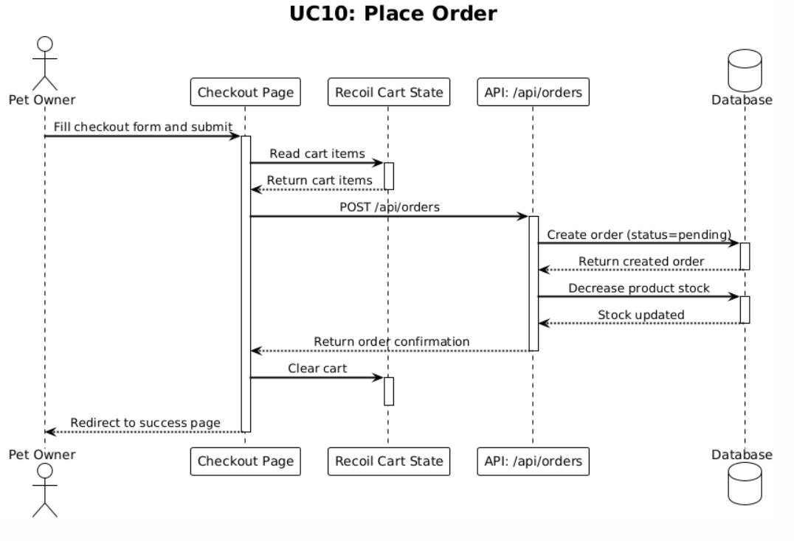

|  |  |
| --- | --- |
| **Use Case Name :   View Order History** | |
| **Actor** | Pet Owners / Registered Users (ST2) |
| **Description** | A logged-in user views their order history with status filtering (pending, completed, cancelled) and order details. |
| **Data** | User ID, orders list, status filter (pending/completed/cancelled), order details (items, total, status, date, delivery method, payment method) |
| **Stimulus** | User navigates to orders page or "My Orders" section, selects status filter (optional), clicks on an order to view details |
| **Response** | System retrieves user's orders from database, applies status filter if selected, displays orders list with status badges (color-coded), shows order details (items, total, date, delivery method, payment method, status), provides reorder functionality for previous orders, and displays orders in chronological order (most recent first) |
| **Comments** | Orders are filtered by user ID automatically. Status filtering helps users track order progress. Reorder functionality allows quick repurchase. Order details show comprehensive information for reference. |

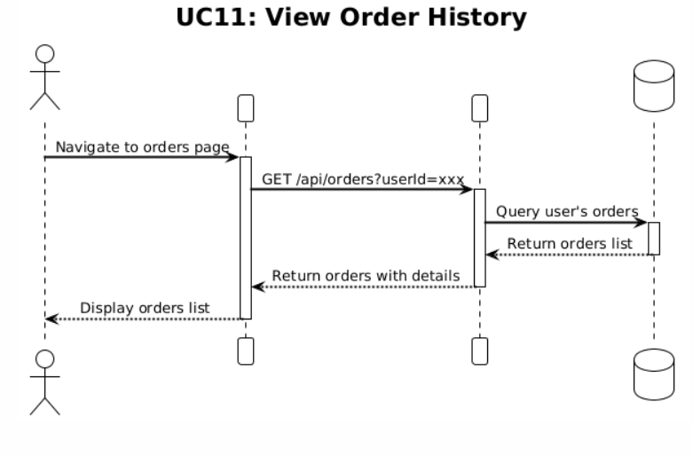

|  |  |
| --- | --- |
| **Use Case Name :   Book Appointment** | |
| **Actor** | Pet Owners / Registered Users (ST2) |
| **Description** | A logged-in user books a veterinary appointment by selecting a pet from their pets, appointment date, time, reason, and optional notes. The system creates appointment with status "upcoming". |
| **Data** | User ID, pet ID (from user's pets), appointment date, appointment time, reason, optional notes |
| **Stimulus** | User navigates to appointments page, clicks "Book Appointment" button, selects pet from dropdown (user's pets), selects appointment date and time, enters reason for visit, optionally adds notes, and clicks "Book Appointment" or "Confirm" button |
| **Response** | System validates required fields (pet, date, time, reason), creates appointment record with status "upcoming", associates appointment with user and pet, stores appointment in database, displays success message, adds appointment to user's appointments list, and refreshes appointments view |
| **Comments** | Appointments are associated with user account for easy tracking. Pet selection is limited to user's registered pets. Appointment status is "upcoming" by default. Optional notes provide additional context for the veterinarian. |

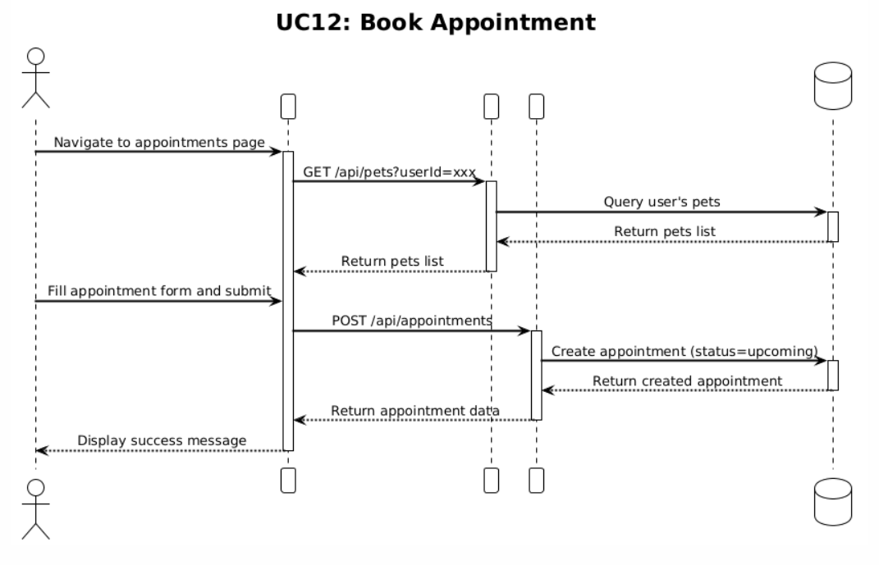

|  |  |
| --- | --- |
| **Use Case Name :   View Appointments** | |
| **Actor** | Pet Owners / Registered Users (ST2) |
| **Description** | A logged-in user views their appointment history with filtering by status (upcoming, completed, cancelled) and appointment details. |
| **Data** | User ID, appointments list, status filter (upcoming/completed/cancelled), appointment details (date, time, pet, reason, status, notes, completion price if completed) |
| **Stimulus** | User navigates to appointments page or "My Appointments" section, selects status filter (optional) |
| **Response** | System retrieves user's appointments from database, applies status filter if selected, displays appointments list with status color coding (upcoming=blue, completed=green, cancelled=red), shows appointment details (date, time, pet name, reason, status, notes), displays completion price and payment method if completed, and displays appointments in chronological order |
| **Comments** | Appointments are filtered by user ID automatically. Status color coding provides quick visual feedback. Completed appointments show pricing information. Upcoming appointments are highlighted for easy identification. |

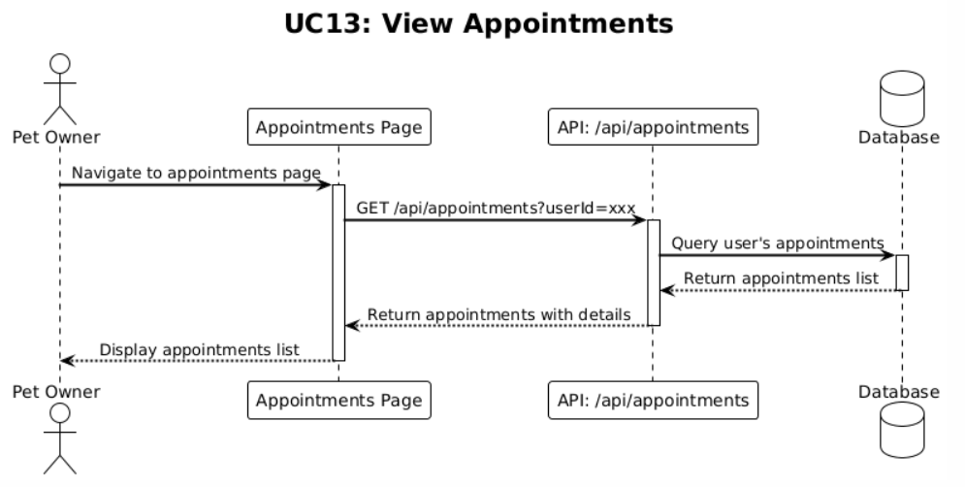

|  |  |
| --- | --- |
| **Use Case Name :   Book Hotel Room** | |
| **Actor** | Pet Owners / Registered Users (ST2) |
| **Description** | A logged-in user books a hotel room for their pet by selecting pet, room type, check-in date, check-out date, pickup/dropoff service options, and optional notes. The system checks room availability and creates reservation with status "booked". |
| **Data** | User ID, pet ID (from user's pets), room type (DOG/CAT/BIRD), check-in date, check-out date, pickup service (boolean), dropoff service (boolean), extra services (array of service names), optional notes, available rooms list |
| **Stimulus** | User navigates to hotel booking page, selects pet from dropdown, selects room type, selects check-in and check-out dates, optionally selects pickup/dropoff services, adds extra services by name, adds optional notes, and clicks "Book Room" or "Confirm Booking" button |
| **Response** | System validates required fields (pet, room type, dates), checks room availability for selected dates, calculates booking cost breakdown (nights, room rate, subtotal, pickup fee, dropoff fee, total), displays cost breakdown, creates reservation record with status "booked", marks room as "OCCUPIED", associates reservation with user and pet, displays success message, adds reservation to user's reservations list, and refreshes reservations view |
| **Comments** | Room availability is checked before booking to prevent overlapping reservations. Cost breakdown is displayed before confirmation. Room rate is 20 JOD per night. Pickup and dropoff fees are 5 JOD each if selected. Extra services are added by name only; amounts are set by admin at checkout. |

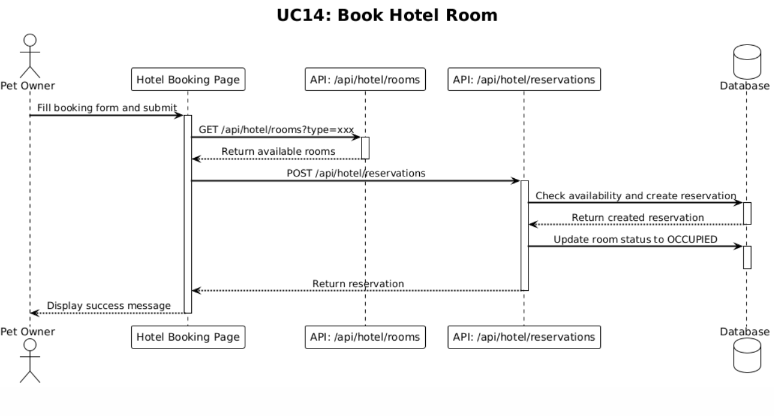

|  |  |
| --- | --- |
| **Use Case Name :    View Reservations** | |
| **Actor** | Pet Owners / Registered Users (ST2) |
| **Description** | A logged-in user views their hotel reservations with filtering by status and display of pickup/dropoff options and extra services. |
| **Data** | User ID, reservations list, status filter, reservation details (pet, room type, room number, dates, pickup/dropoff options, extra services, status, cost breakdown, payment information if checked-out) |
| **Stimulus** | User navigates to reservations page or "My Reservations" section, selects status filter (optional), clicks on a reservation to view details |
| **Response** | System retrieves user's reservations from database, applies status filter if selected, displays reservations list with status information, shows reservation details (pet name, room type, room number, check-in/check-out dates, pickup/dropoff options, extra services, status), displays cost breakdown and payment information if checked-out, and displays reservations in chronological order |
| **Comments** | Reservations are filtered by user ID automatically. Status filtering helps users track reservation progress. Cost breakdown shows all fees and services. Checked-out reservations show payment information. Pickup and dropoff options are clearly displayed. |

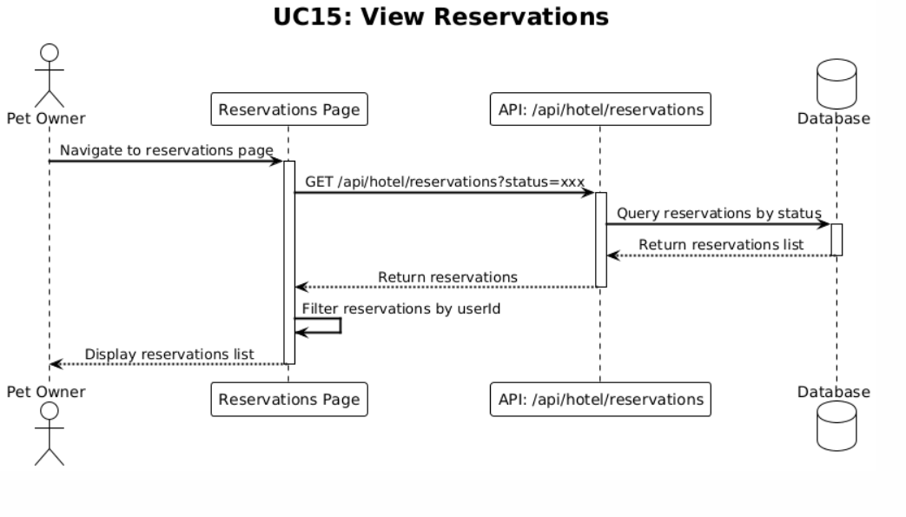

### 4.2.4 Use Case Diagram for gest users

**Stakeholder 3 : guest users**

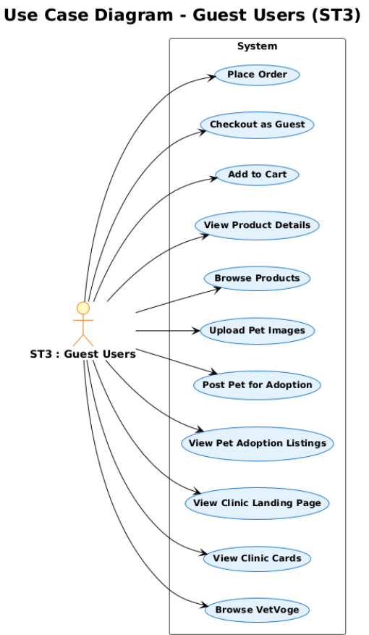

|  |  |
| --- | --- |
| **Use Case Name :    Browse VetVoge** | |
| **Actor** | Guest Users (ST3) |
| **Description** | A guest user accesses the VetVoge marketplace welcome page at the root URL (/) which serves as the entry point, featuring navigation to clinics, pet adoption, and shop sections. |
| **Data** | Page content, navigation links, session ID for analytics, page view tracking data |
| **Stimulus** | Guest user navigates to root URL (/) or clicks on VetVoge logo/branding |
| **Response** | System displays VetVoge welcome page with header navigation (Clinics, Pet Adoption, Shop), shows hero section, displays clinic cards section, displays pet adoption section, displays shop selection section, tracks page view with session ID for analytics, and provides smooth scrolling navigation to sections via anchor links |
| **Comments** | VetVoge page serves as marketplace entry point. Header shows "VetVoge" branding (not clinic branding). Smooth scrolling enables easy navigation between sections. Page views are tracked for analytics but admin pages are excluded. Session ID is generated and stored in localStorage. |

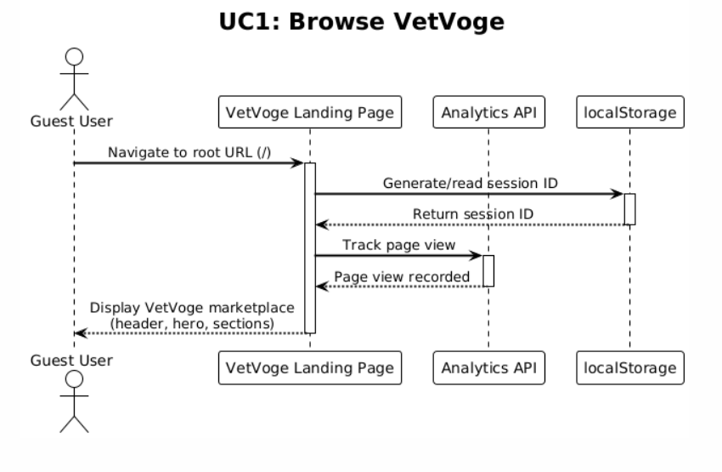

|  |  |
| --- | --- |
| **Use Case Name :    View Clinic Cards** | |
| **Actor** | Guest Users (ST3) |
| **Description** | A guest user views clinic cards on the VetVoge marketplace showing clinic name, location, specialties, description, and a link to the clinic's landing page. |
| **Data** | Clinic information (name, location, specialties, description), clinic cards data, clinic landing page URL |
| **Stimulus** | Guest user scrolls to clinics section on VetVoge page or clicks on "Clinics" navigation link |
| **Response** | System displays clinic cards with clinic name, location information, specialties list, description text, and link to clinic landing page. Cards are displayed in responsive grid layout with hover effects |
| **Comments** | Clinic cards provide overview of available veterinary clinics in the marketplace. Each card links to the specific clinic's landing page (e.g., /clinic/eagles for Eagle's Vet Clinic). Cards are visually appealing with hover effects for better UX. |

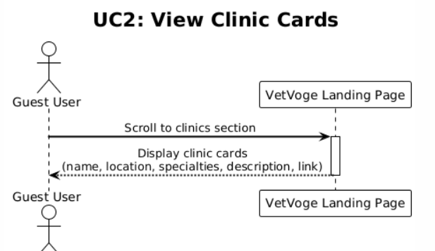

|  |  |
| --- | --- |
| **Use Case Name :    View Clinic Landing Page** | |
| **Actor** | Guest Users (ST3) |
| **Description** | A guest user browses a clinic's landing page (e.g., Eagle's Vet Clinic) with Hero section, Services, Staff, and Contact information. The header displays clinic branding. |
| **Data** | Clinic landing page content (hero section, services, staff, contact information), clinic branding, header context |
| **Stimulus** | Guest user clicks on a clinic card from VetVoge marketplace or navigates directly to clinic URL (e.g., /clinic/eagles) |
| **Response** | System displays clinic landing page with clinic-specific header (e.g., "Eagle's Vet Clinic"), shows hero section with clinic introduction, displays services section, shows staff section, displays contact information section, provides navigation links, and shows clinic-specific footer |
| **Comments** | Header changes from "VetVoge" to clinic branding (e.g., "Eagle's Vet Clinic") when on clinic pages. Landing page provides comprehensive information about the clinic. Services, staff, and contact sections help users learn about the clinic. |

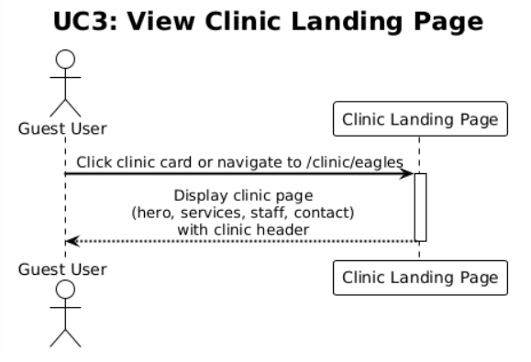

|  |  |
| --- | --- |
| **Use Case Name :   View Pet Adoption Listings** | |
| **Actor** | Guest Users (ST3) |
| **Description** | A guest user views pet adoption listings on the VetVoge marketplace with image carousel, clickable phone numbers, and full-size image modal for viewing all photos. Listings are filtered to show active posts only (default). |
| **Data** | Adoption listings data (pet name, description, phone number, area, images), status filter (active by default), image URLs, session ID for analytics |
| **Stimulus** | Guest user scrolls to pet adoption section on VetVoge page, clicks on "Pet Adoption" navigation link, or navigates to adoption section via anchor link (#adoption) |
| **Response** | System retrieves adoption listings from database (status='active', limit 50 most recent), displays adoption cards in responsive grid layout, shows image carousel with navigation arrows and indicators, displays pet name, description, area, and clickable phone number (tel: link), provides full-size image modal on image click, tracks page view for analytics, and allows browsing between images in carousel |
| **Comments** | Only active adoption posts are displayed by default. Listings are limited to 50 most recent posts. Image carousel allows easy browsing of multiple photos. Clickable phone numbers enable direct contact. Full-size modal provides detailed image viewing. Phone numbers are prominently displayed without "Contact Owner" button. |

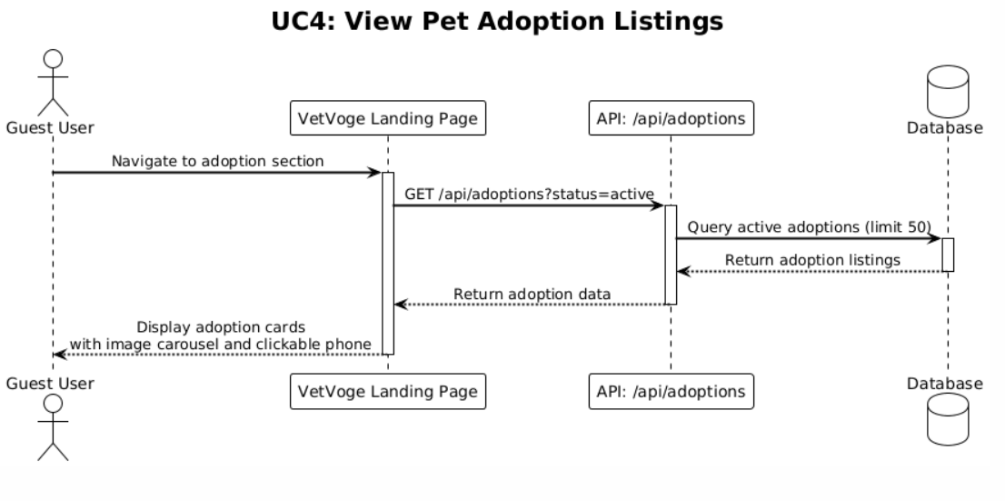

|  |  |
| --- | --- |
| **Use Case Name :   Post Pet for Adoption** | |
| **Actor** | Guest Users (ST3) |
| **Description** | A guest user posts a pet for adoption without requiring authentication. The post includes pet name, description, phone number, area, and multiple photos. No sign-in is required. |
| **Data** | Pet name, description, phone number, area, image files (multiple), image URLs (after upload to Cloudinary), adoption post status (default: 'active') |
| **Stimulus** | Guest user scrolls to pet adoption section, clicks "Post Pet for Adoption" button or form trigger, fills in adoption form (pet name, description, phone number, area), uploads one or more pet images, and clicks "Submit" or "Post" button |
| **Response** | System validates required fields (pet name, description, phone number, area), validates at least one image is uploaded, uploads images to Cloudinary, stores image URLs as JSON array in database, creates adoption post record with status 'active', displays success message, resets form, refreshes adoption listings, and shows new post in listings |
| **Comments** | No authentication required - anyone can post pets for adoption. Images are uploaded to Cloudinary with validation (file type: JPEG, JPG, PNG, WebP, GIF; max size: 5MB). Images are stored as JSON array of URLs. Post status is 'active' by default. Form validation ensures all required fields are provided. |

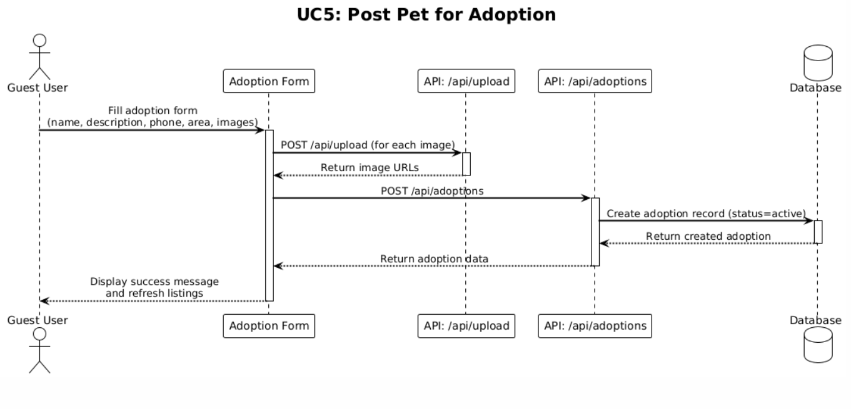

|  |  |
| --- | --- |
| **Use Case Name :   Upload Pet Images** | |
| **Actor** | Guest Users (ST3) |
| **Description** | A guest user uploads one or more pet images when posting a pet for adoption. Images are uploaded to Cloudinary and stored as JSON array of URLs in the database. |
| **Data** | Image files (JPEG, JPG, PNG, WebP, GIF), file size (max 5MB), Cloudinary upload response (URLs), image URLs array (JSON string in database) |
| **Stimulus** | Guest user fills in adoption post form, clicks "Upload Images" or file input, selects one or more image files from device, confirms file selection |
| **Response** | System validates file type (JPEG, JPG, PNG, WebP, GIF only), validates file size (max 5MB per file), uploads each image to Cloudinary, receives image URLs from Cloudinary, stores URLs in form state, displays image previews, allows removing images before submission, stores image URLs as JSON array when form is submitted, and saves JSON array string in database |
| **Comments** | File type and size validation prevents invalid uploads. Multiple images can be uploaded per post. Images are uploaded to Cloudinary for reliable storage and delivery. URLs are stored as JSON array string in database for easy retrieval and parsing. Image previews help users verify uploaded images before submission. |

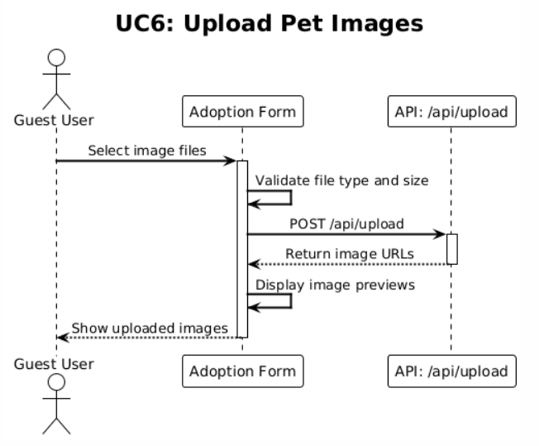

|  |  |
| --- | --- |
| **Use Case Name :   Browse Products** | |
| **Actor** | Guest Users (ST3) |
| **Description** | A guest user browses shop products with category filtering, sorting options (newest, price, name), and pagination (24 products per page). Products are displayed with stock status and "Out of Stock" badges. |
| **Data** | Products list, category filter, sort option (newest/price/name), pagination state (page number, 24 per page), product details (name, price, image, stock status, category), session ID for analytics |
| **Stimulus** | Guest user navigates to shop page from VetVoge marketplace or clinic landing page, selects category filter, selects sort option, or clicks pagination controls |
| **Response** | System retrieves products from database based on filters, applies sorting, paginates results (24 per page), displays product cards with images, names, prices, stock status, category badges, "Out of Stock" badges for unavailable products, tracks product views for analytics, and provides navigation controls |
| **Comments** | Products are displayed in responsive grid layout. Out of stock products show badges and cannot be added to cart. Sorting and filtering provide better product discovery. Pagination improves performance for large product catalogs. Product views are tracked for analytics. Shop page header shows clinic branding (e.g., "Eagle's Vet Clinic") when accessed from clinic context. |

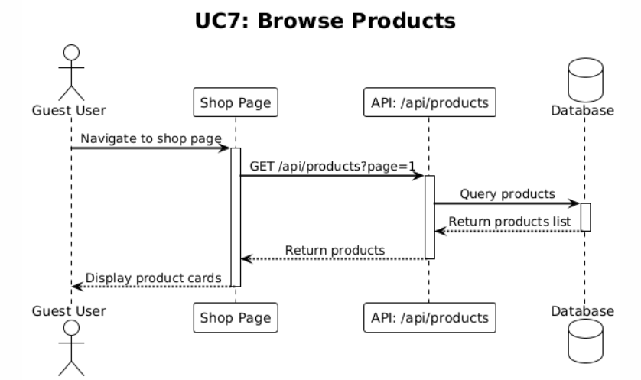

|  |  |
| --- | --- |
| **Use Case Name :   View Product Details** | |
| **Actor** | Guest Users (ST3) |
| **Description** | A guest user views detailed product information including name, description, price, multiple images in a gallery, stock status, and category information. |
| **Data** | Product ID, product details (name, description, price, images, stock quantity, category), product slug, image URLs (comma-separated), session ID for analytics |
| **Stimulus** | Guest user clicks on a product card from shop page or product listing, navigates to product detail page |
| **Response** | System retrieves product details from database using product slug, displays product name and description, shows product price, displays image gallery with multiple images (if available), shows stock status and "Out of Stock" badge if unavailable, displays category information, tracks product view for analytics, provides "Add to Cart" button (disabled if out of stock), and displays product in user-friendly layout |
| **Comments** | Product images are displayed in gallery format for multiple images. Stock status is clearly displayed. Out of stock products cannot be added to cart. Product views are tracked for analytics to identify popular products. Product detail page header shows clinic branding when accessed from clinic shop context. |

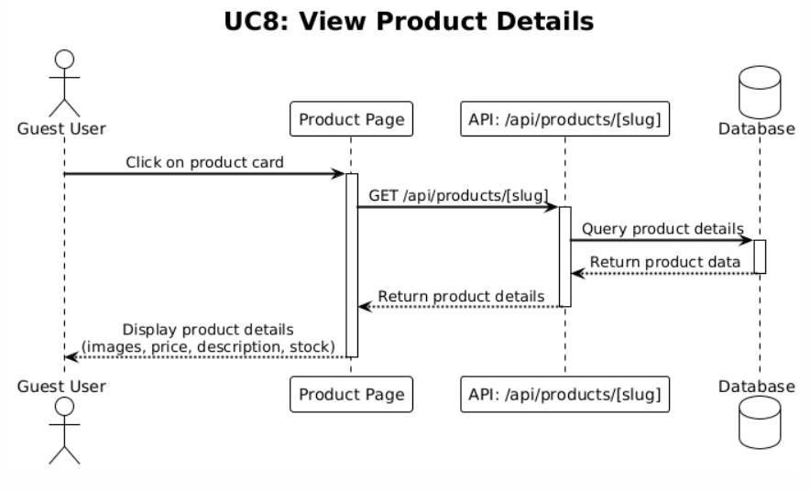

|  |  |
| --- | --- |
| **Use Case Name :   Add to Cart** | |
| **Actor** | Guest Users (ST3) |
| **Description** | A guest user adds a product to their shopping cart. The system uses Recoil state management to maintain cart state and prevents adding out-of-stock products. Cart item count is displayed in header. |
| **Data** | Product ID, product details (name, price, image), quantity, cart state (Recoil atom), stock quantity, session information |
| **Stimulus** | Guest user views product details, clicks "Add to Cart" button, optionally adjusts quantity |
| **Response** | System checks product stock availability, prevents adding if out of stock (displays error message), adds product to cart with quantity, updates Recoil cart state, updates cart item count in header, displays success message or feedback, maintains cart state during session, and persists cart until logout or order completion |
| **Comments** | Cart state is maintained using Recoil state management during session. Out of stock products cannot be added to cart. Cart item count is displayed in header for easy access. Cart persists during session but is cleared on logout or order completion. Guest users can add items to cart without authentication. |

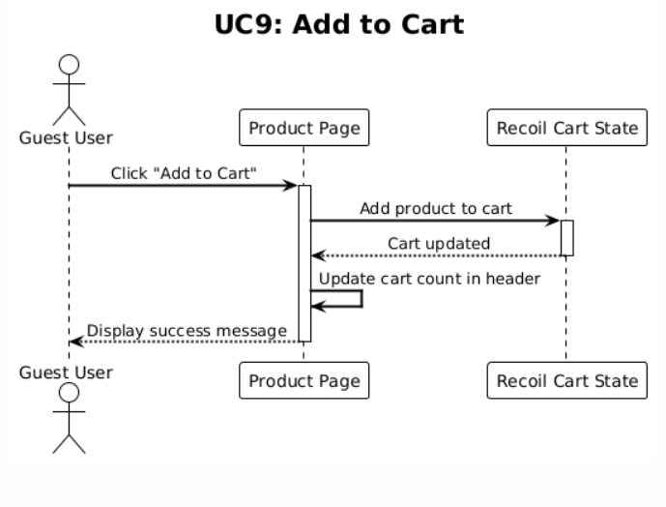

|  |  |
| --- | --- |
| **Use Case Name :   Checkout as Guest** | |
| **Actor** | Guest Users (ST3) |
| **Description** | A guest user proceeds to checkout without creating an account. The checkout process requires customer name, phone, delivery method (home delivery or pickup), payment method (cash or click), and address information (if delivery). |
| **Data** | Cart items, customer name, phone number, delivery method (home delivery/pickup), payment method (cash/click), address information (governorate, area, address if delivery), Jordanian governorates and areas list, order total |
| **Stimulus** | Guest user clicks "Checkout" or "Proceed to Checkout" button from cart, fills in customer information form, selects delivery method, selects payment method, enters address if delivery selected, and clicks "Place Order" or "Confirm Order" button |
| **Response** | System validates all required fields, validates cart has items, validates stock availability for all items, displays delivery address fields if home delivery selected, hides address fields if pickup selected, supports Jordanian governorate and area selection for addresses, validates address format if delivery, displays order summary and total, creates order record with status "pending", associates order with guest (no user ID), decreases product stock quantities, clears cart (Recoil state), redirects to order success page, and displays order confirmation |
| **Comments** | Guest checkout allows ordering without account creation. Address is required only for home delivery, not for pickup. Jordanian governorates and areas are supported for address selection. Order is created without user association (user ID is null). Stock is immediately decreased when order is created. Payment method selection affects checkout flow. |

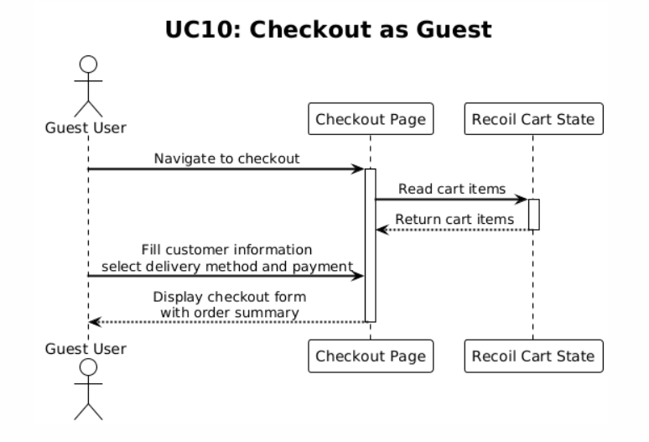

|  |  |
| --- | --- |
| **Use Case Name :   Place Order** | |
| **Actor** | Guest Users (ST3) |
| **Description** | A guest user completes the order placement process. The system creates an order with status "pending", decreases product stock quantities, and provides order confirmation. |
| **Data** | Order details (items, customer information, delivery method, payment method, address), product stock quantities, order status (pending), order ID |
| **Stimulus** | Guest user completes checkout form with all required information, reviews order summary, and clicks "Place Order" or "Confirm Order" button |
| **Response** | System performs final validation of all fields, validates stock availability for all cart items, creates order record in database with status "pending", stores customer information (name, phone, address if delivery), records delivery method and payment method, associates order items with product IDs and quantities, calculates order total, decreases product stock quantities immediately, clears cart (Recoil state), generates order confirmation, redirects to order success page, displays order confirmation with order details, and stores order in database for admin management |
| **Comments** | Order is created with "pending" status and will be managed by admin. Stock is immediately decreased to prevent overselling. Order confirmation provides reference for customer. Guest orders are stored without user ID association. Order success page shows confirmation and next steps. |

# 5. Chapter Five (Project Implementation)

## 5.1 Website Application

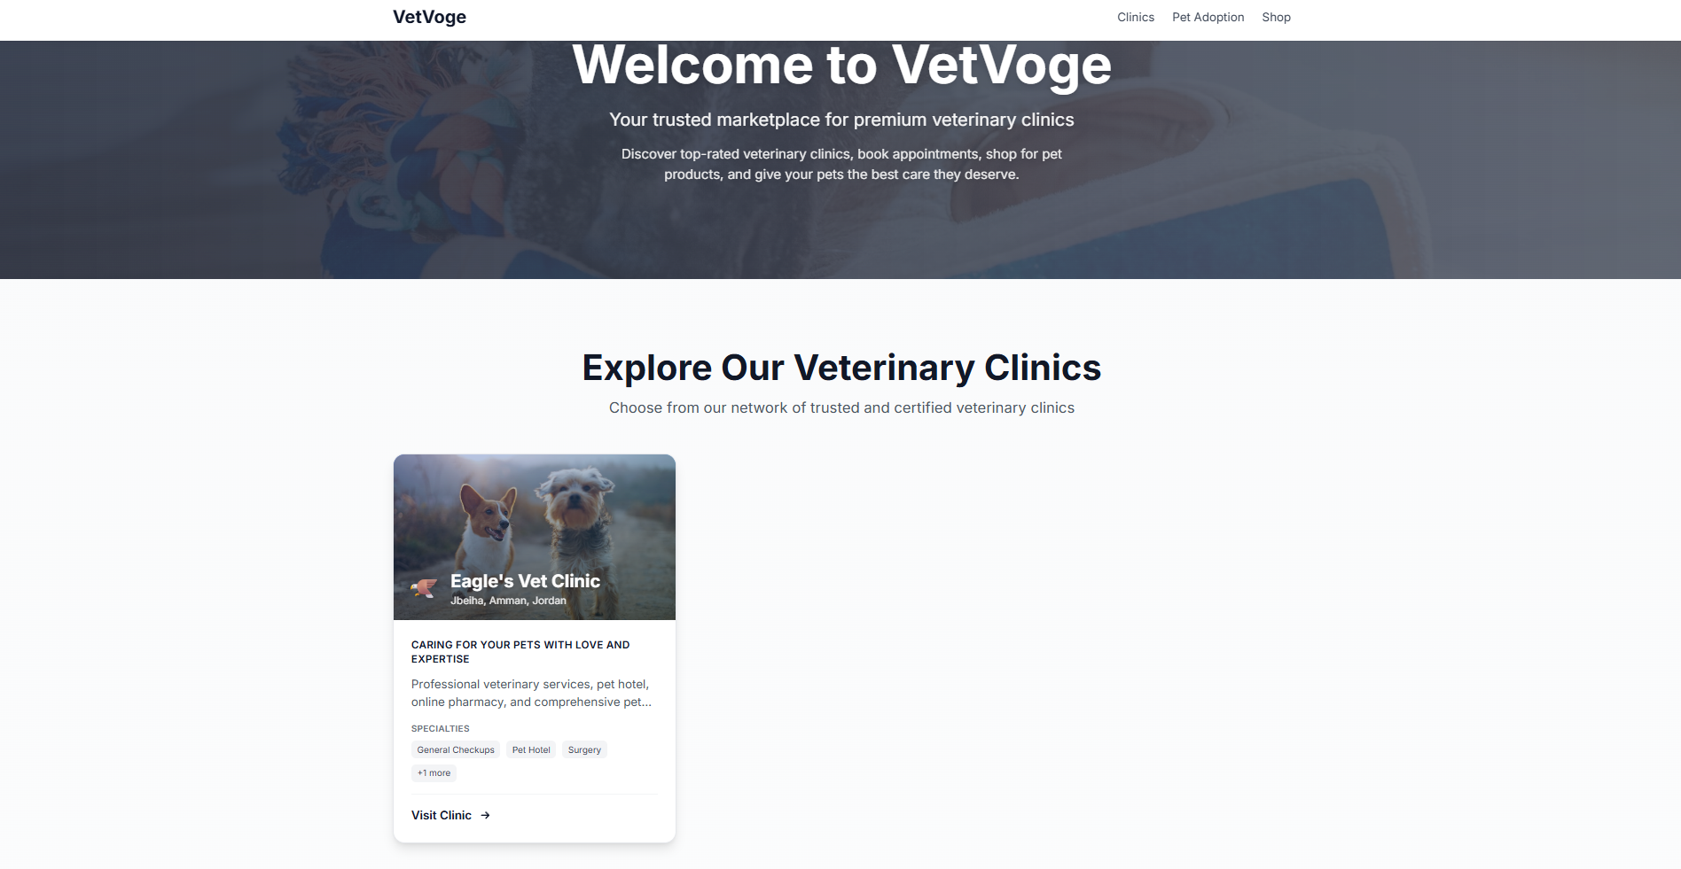

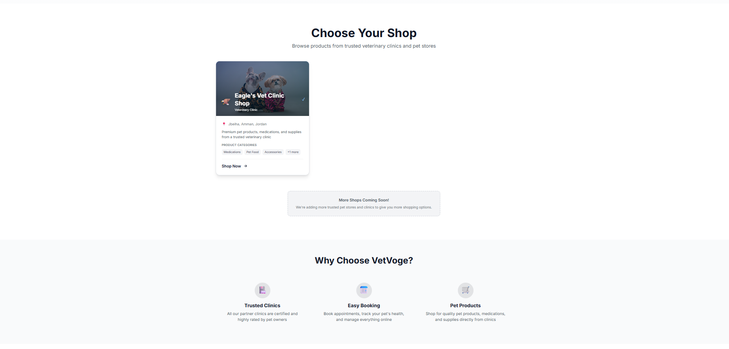

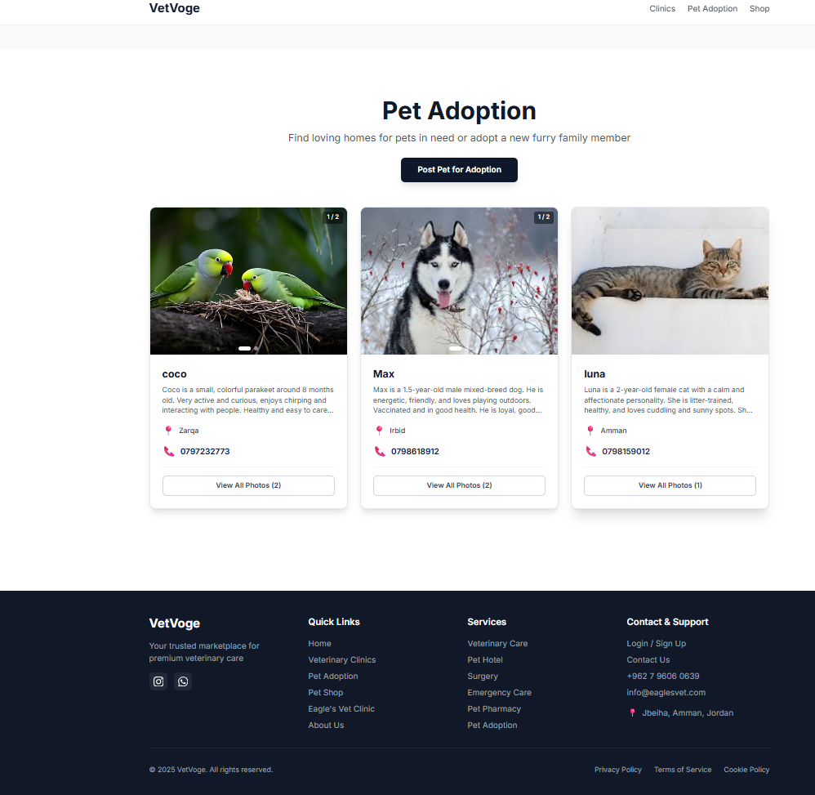

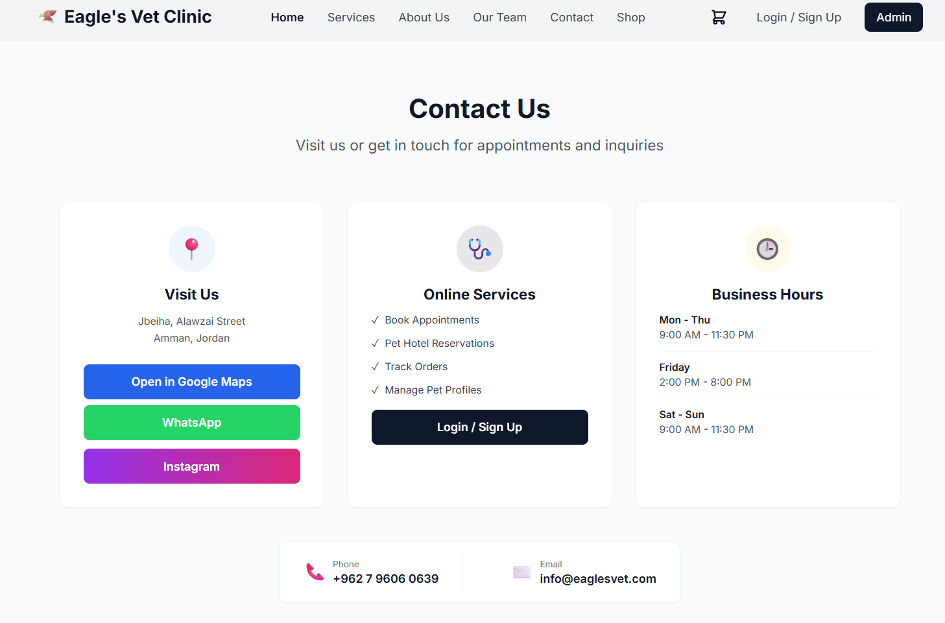

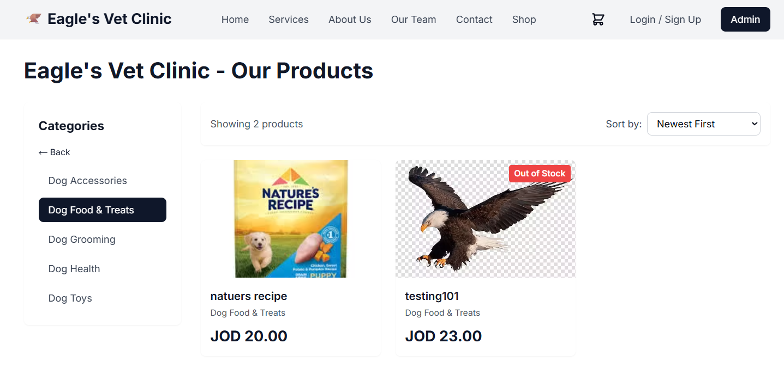

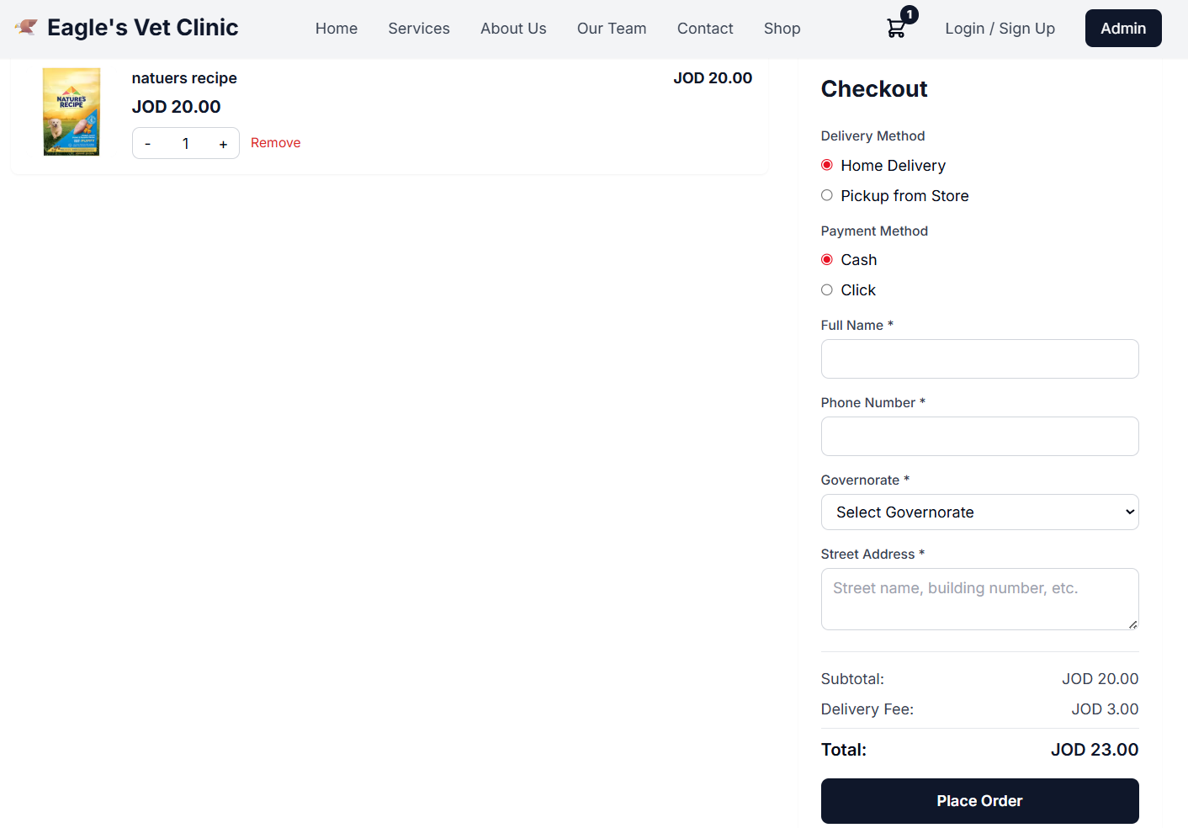

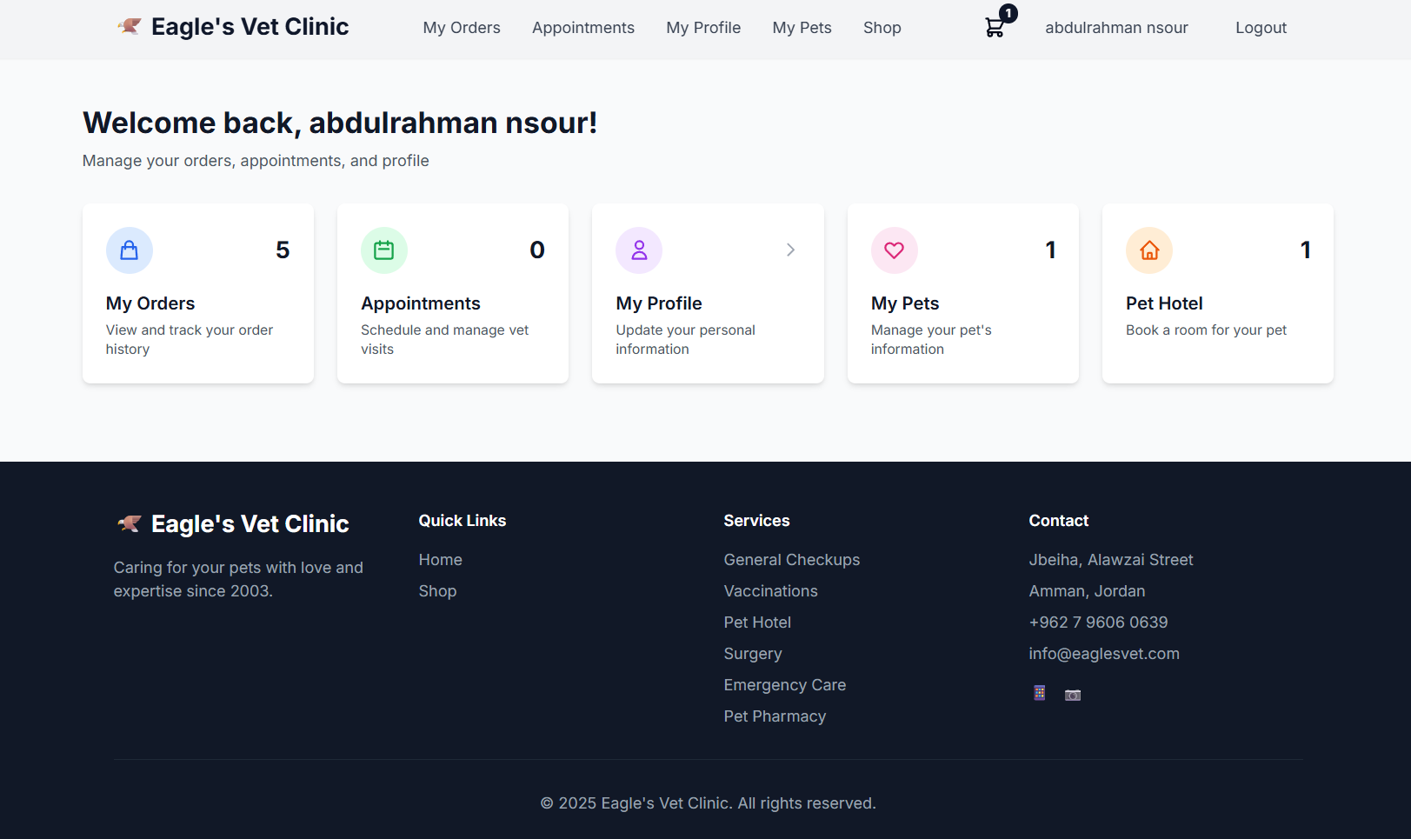

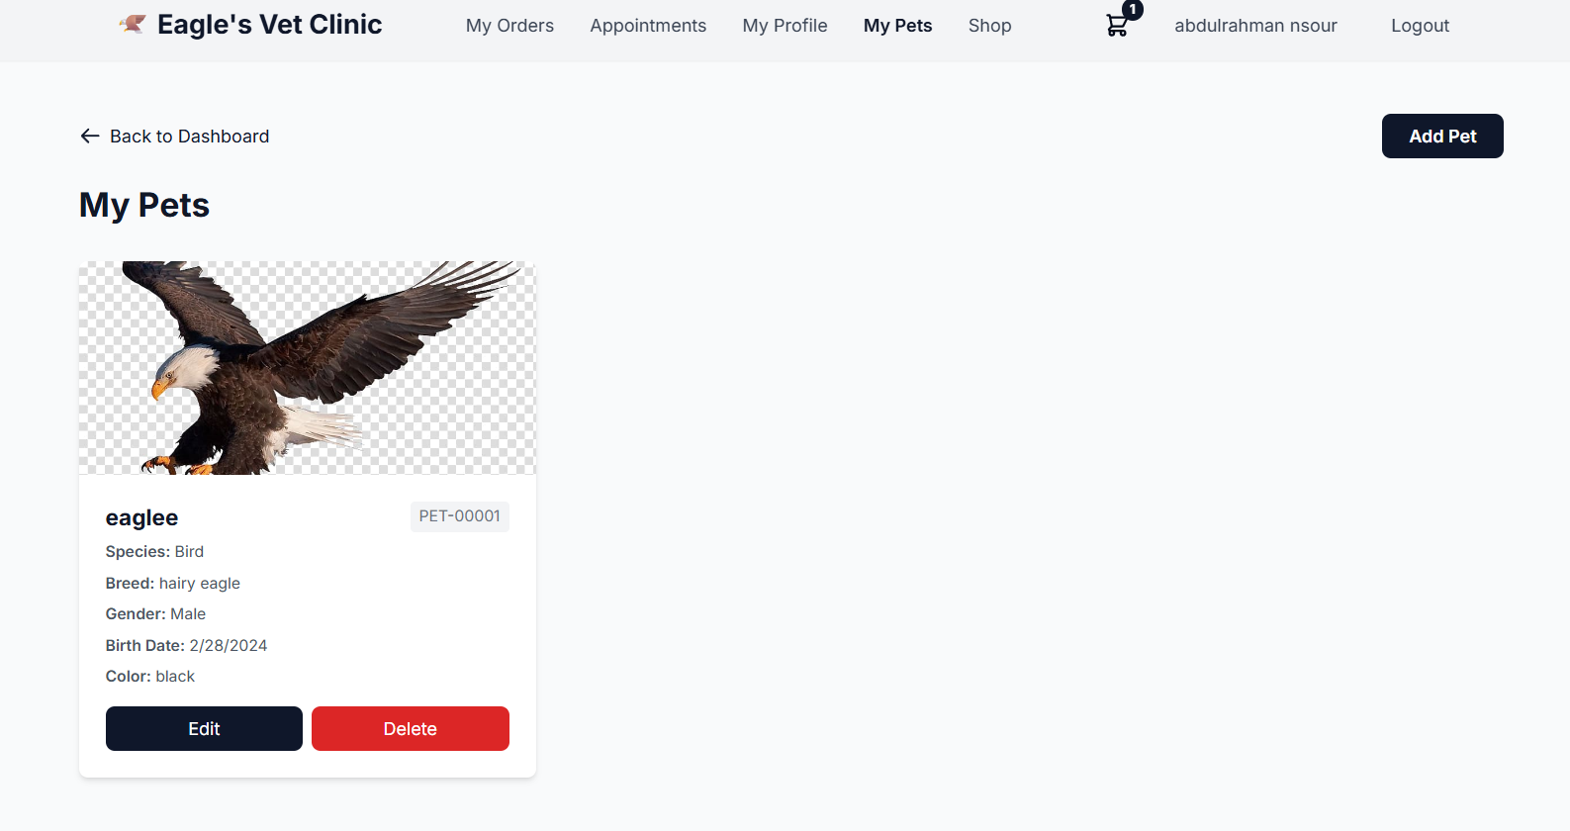

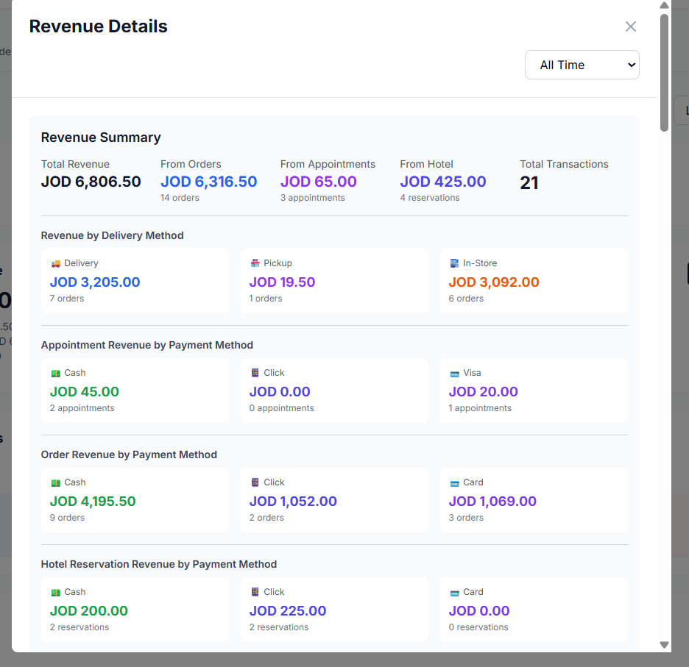

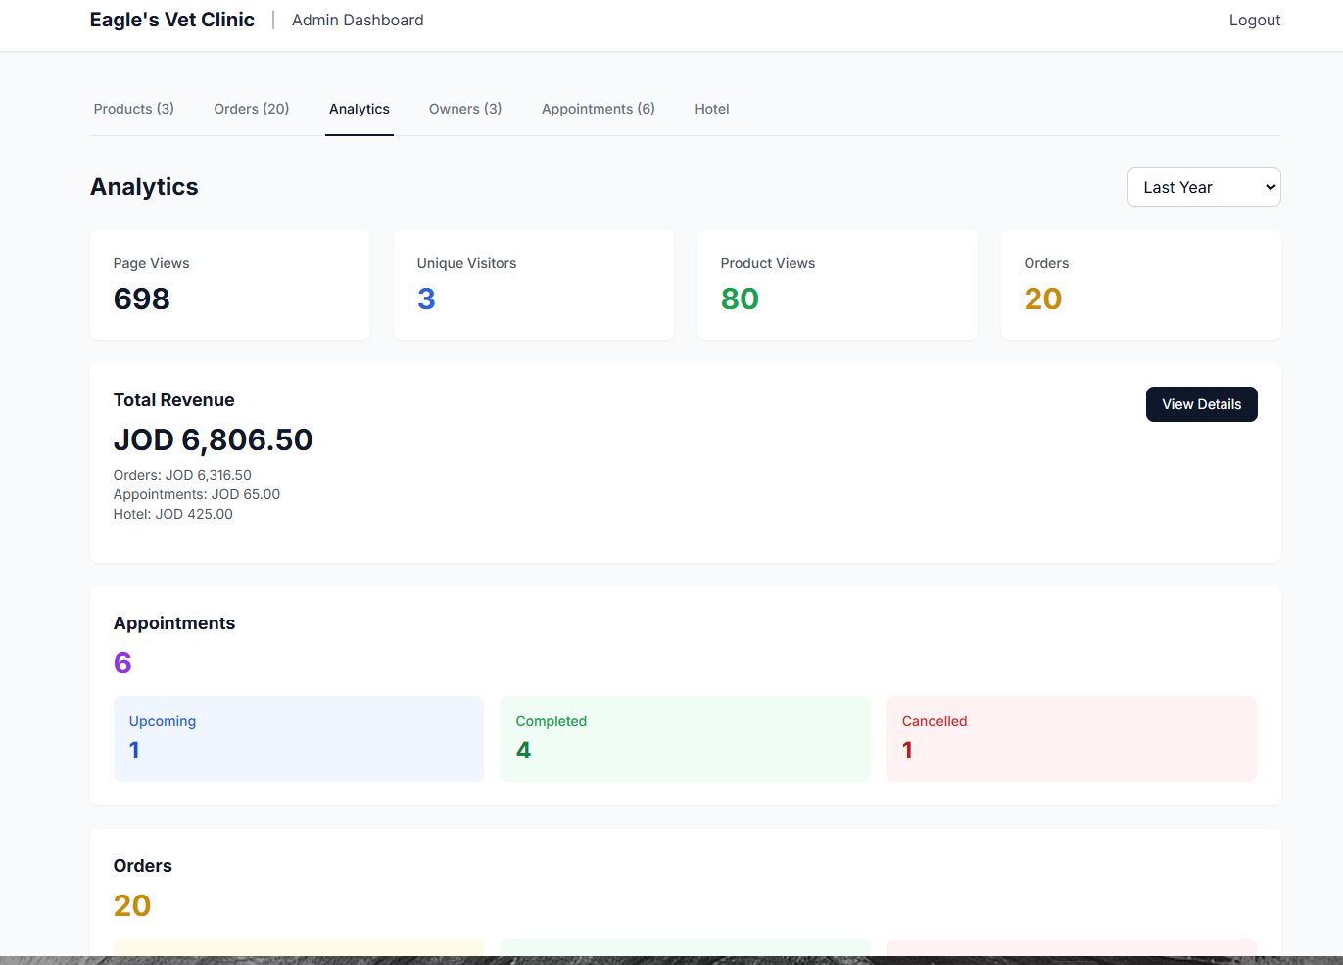

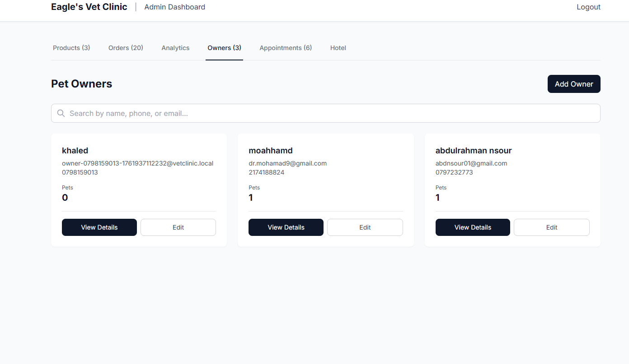

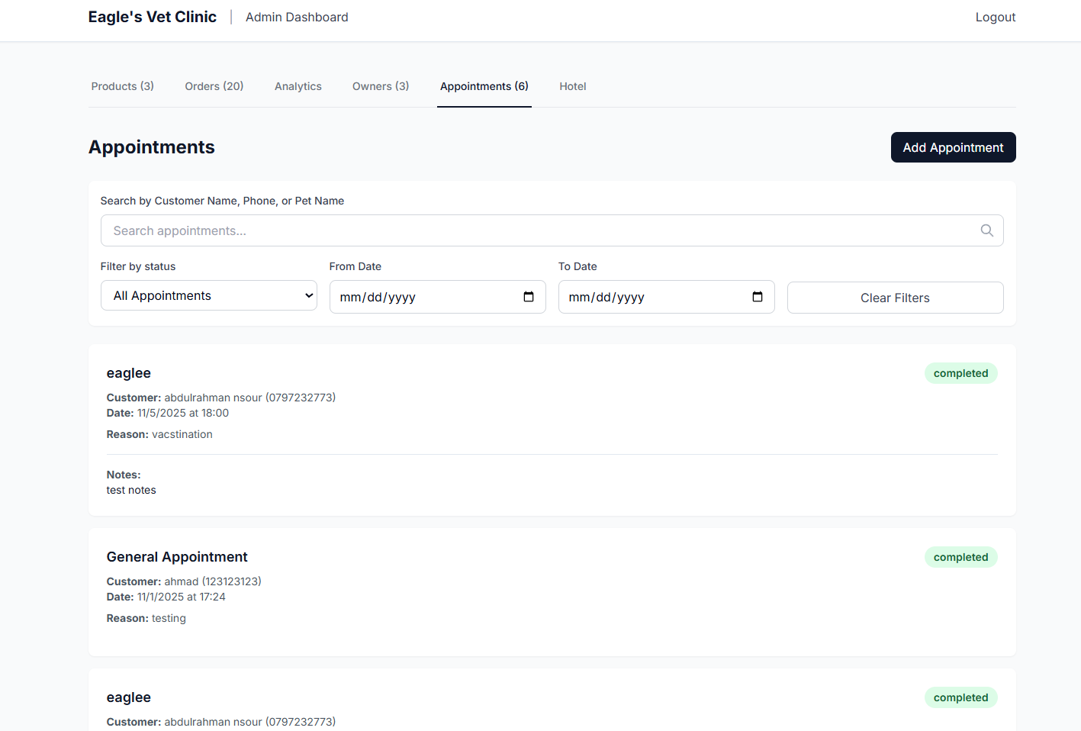

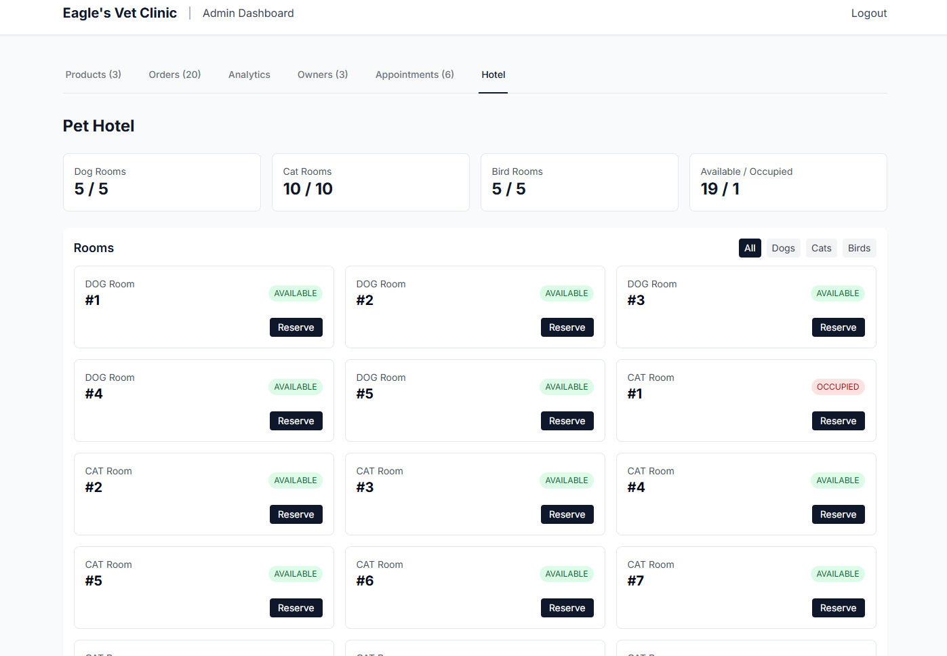

# 6.Chapter Six (Project Testing)

In this chapter, we outline the comprehensive testing processes undertaken to validate the functionality, usability, and performance of the system. This ensures that the system meets the requirements specified during the design and development phases.

## 6.1 Test Cases

The testing phase involved the development of detailed test cases to systematically evaluate the system’s features and functionality. These test cases were designed to cover all major components of the system, including:

1. **User Authentication:**
   * Test secure login, user registration, and password recovery processes. o Verify edge cases such as incorrect credentials and multiple failed attempts.
2. **Interface Usability:**
   * Validate the responsiveness and accessibility of the Figma-based user interface.
   * Ensure all navigation paths are functional and intuitive.
3. **Core Functionalities:**
   * Evaluate features such as the appointment booking system, notifications, clinic directory, and user feedback submissions.
   * Test search, filtering, and data retrieval functionalities for robustness.
4. **Performance Testing:**
   * Simulate high-traffic scenarios to evaluate system performance under load. o Ensure that data retrieval and rendering remain efficient for all user interactions.

1. **Security:**
   * Test data security mechanisms, including access control for various stakeholders. o Validate encryption for sensitive data like user credentials and audit logs.

## 6.2 Test Methodologies

To ensure the system's quality, we applied a combination of the following testing methodologies:

1. **Unit Testing:**
   * Each individual component and functionality was tested independently to confirm proper operation.
2. **Integration Testing:**
   * The interaction between interconnected components, such as user actions triggering backend processes, was tested to ensure seamless integration.
3. **System Testing:**
   * The entire system was tested as a whole to verify end-to-end functionality and compliance with project requirements.
4. **Usability Testing:**
   * The user interface was tested to ensure that the design meets user expectations for clarity, ease of use, and accessibility.
5. **Acceptance Testing:**
   * The final system was reviewed against the original requirements to ensure it meets stakeholder expectations and is ready for deployment.

# Appendix A :

## Interview Script :

**Pet Clinic Owners Interview Script**

* **Introduction:**

Briefly introduce yourself and explain the purpose of the interview.

Mention that their input is crucial for improving pet healthcare services through digital solutions.

* **Questions:**

1. Can you tell us about your clinic and the **services** you offer?
2. What are the biggest **challenges** you face in managing your clinic operations on a daily basis?
3. Do you currently use any **digital tools or platforms** for appointment booking, patient records, or communication? If so, what do you like or dislike about them?
4. How do you manage **scheduling** appointments and keeping track of patient health records?
5. Do you find it difficult to attract and **retain** clients? How do you currently **reach** **out** to pet owners?
6. What **features would you want to see** in an ideal digital platform to improve clinic management and client interaction?
7. What role do you think technology could play in enhancing the quality of care and efficiency in your clinic?
8. How do you handle emergency situations or last-minute changes in appointments? Would you benefit from a more flexible scheduling system?
9. What **suggestions** do you have for making veterinary services more accessible to pet owners through a digital platform?

**Veterinarians Interview Script**

• **Introduction:**

Briefly introduce yourself and explain the purpose of the interview.

Highlight that their expertise in pet healthcare is key to understanding what tools would benefit them in their practice.

1. **Questions:**
2. How do you currently **manage your patients’ health records**, and what tools do you use for this?
3. What **challenges** do you face in terms of communication with pet owners and managing their pets' medical needs?
4. How do you **handle appointments**, especially for follow-ups and regular check-ups?
5. Do you feel there is **a need for a digital platform** to help you track medical histories, treatment schedules, and reminders for vaccines or appointments?
6. How do you **stay connected with pet owners** after an appointment, and would you benefit from a digital solution to track post-visit care?
7. What are **some features** you would want in a platform to improve the overall pet care experience for both the pet owner and you?
8. How do you manage **emergencies** or sudden changes in appointment schedules? Would a digital tool help in these situations?

**Pet Owners Interview Script**

• **Introduction:**

Briefly introduce yourself and explain the purpose of the interview.

Emphasize that their experiences will help design a platform that caters to their needs for better managing their pets' health.

1. **Questions:**
2. How do you currently **manage** your pet’s health and medical appointments?
3. What **challenges** have you faced when trying to book an appointment or visit a veterinary clinic?
4. Do you find it **difficult to track your pet's medical records**, vaccination history, and health updates?
5. How do you prefer to **book appointments** with veterinarians? Do you use any online booking systems, or do you prefer calling the clinic directly?
6. How important is it for you to have **access to your pet’s medical records and appointment history online**?
7. Would you find it helpful **to receive reminders** for vaccinations, check-ups, or other pet health needs through a digital platform?
8. How would you feel about using an app or website to track your pet’s health, book appointments, and communicate with your vet?
9. What **features** would you like to see in a platform to make managing your pet’s health easier and more convenient?
10. Do you face any challenges when trying to access a veterinarian during an emergency, and would you find a platform with **emergency** contact options useful?

# References

* Hudaib, Amjad. Lecture Notes on Introduction to Software Engineering.
* Sommerville, I. (2015). *Software Engineering* (10th Edition).

Pearson Global Edition.

* Canva. (n.d.). Graphic Design Platform. Retrieved from [https://www.canva.com](https://www.canva.com/)
* Microsoft Word. (n.d.). Word Processing Software. Retrieved from <https://www.microsoft.com/en-us/microsoft-365/word>
* Figma. (n.d.). UI/UX Design Tool. Retrieved from [https://www.figma.com](https://www.figma.com/)
* LucidSpark. (n.d.). Collaborative Whiteboarding Tool for Project Ideation. Retrieved from [https://lucidspark.com](https://lucidspark.com/)
* Microsoft Teams. (n.d.). Communication and Project Management Tool. Retrieved from [https://www.microsoft.com/en-us/microsoftteams/group-chat-software](https://www.microsoft.com/en-us/microsoft-teams/group-chat-software)
* PetsApp. (n.d.). Features and Benefits. Retrieved from [https://petsapp.com](https://petsapp.com/) • PetDesk. (n.d.). Online Veterinary Management. Retrieved from [https://petdesk.com](https://petdesk.com/)

These references provided valuable insights and best practices in software engineering, project management, user experience design, and other relevant areas throughout the development process of VetVogue.